

**DESIGN GRID SHEET A**

|  |
| --- |
| 17 |
| 16 |
| 15 |
| 14 |
| 13 |
| 12 |
| 11 |
| 10 |
| 9 |
| 8 |
| 7 |
| 6 |
| 5 |
| 4 |
| 3 |
| 2 |
| 1 |
| 0 |

TAPE/GLUE SHEET D 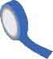

TAPE/GLUE SHEET D

**METRIC BRIDGE LAYOUT SHEET A**

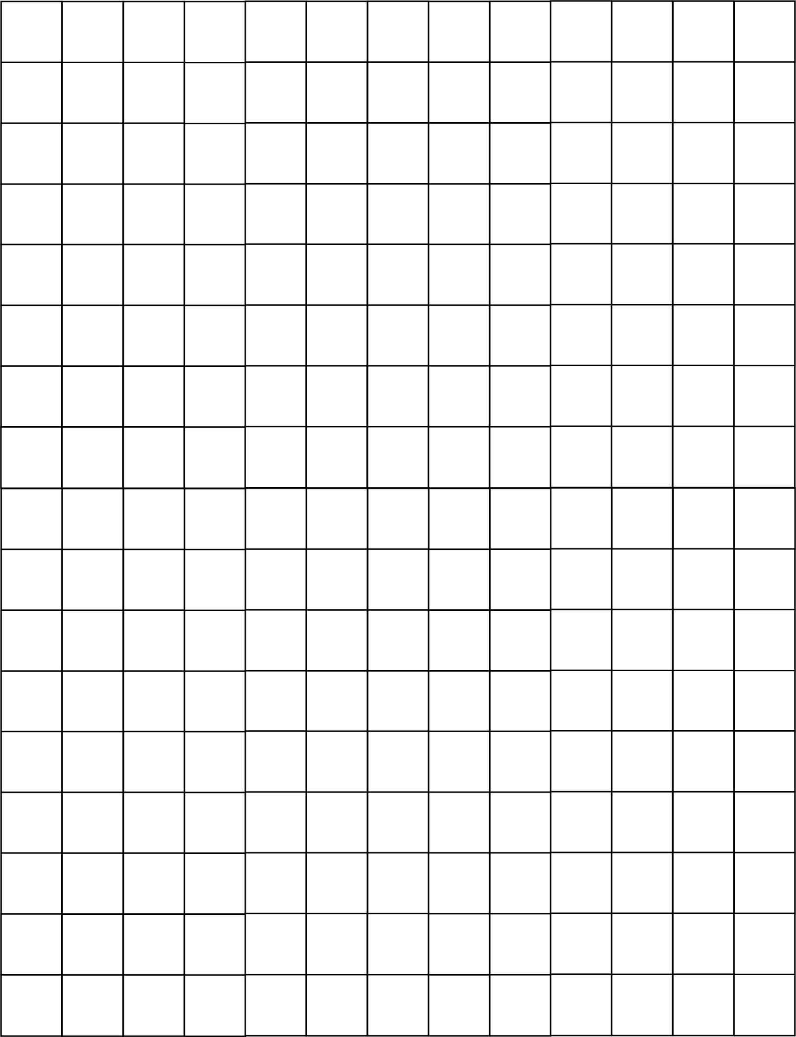

|  |  |  |  |  |  |  |  |  |  |  |  |  |  |
| --- | --- | --- | --- | --- | --- | --- | --- | --- | --- | --- | --- | --- | --- |
| 0 | 1 | 2 | 3 | 4 | 5 | 6 | 7 | 8 | 9 | 10 | 11 | 12 | 13 |

CUT ALONG EDGE OF GRID AND ATTACH TO SHEET B

**ABUTMENT**

**Your bridge must sit on abutments.**



**DESIGN GRID SHEET B**

TAPE/GLUE SHEET E

TAPE/GLUE SHEET E 



CUT ALONG EDGE OF GRID AND ATTACH TO SHEET C

|  |  |  |  |  |  |  |  |  |  |  |  |  |  |
| --- | --- | --- | --- | --- | --- | --- | --- | --- | --- | --- | --- | --- | --- |
| 13 | 14 | 15 | 16 | 17 | 18 | 19 | 20 | 21 | 22 | 23 | 24 | 25 | 26 |

**METRIC BRIDGE LAYOUT SHEET A**

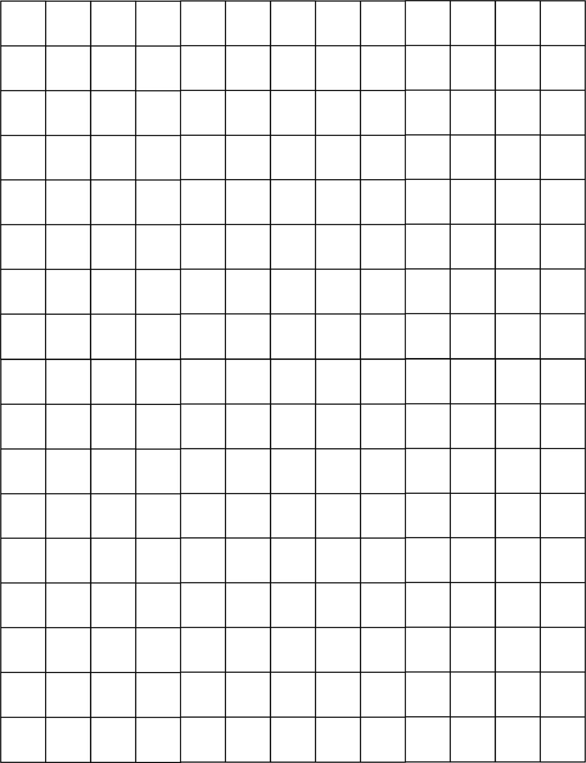

TAPE/GLUE SHEET A

TAPE/GLUE SHEET A



**DESIGN GRID SHEET C**

|  |
| --- |
| 17 |
| 16 |
| 15 |
| 14 |
| 13 |
| 12 |
| 11 |
| 10 |
| 9 |
| 8 |
| 7 |
| 6 |
| 5 |
| 4 |
| 3 |
| 2 |
| 1 |
| 0 |

|  |  |  |  |  |  |  |  |  |  |  |  |  |  |
| --- | --- | --- | --- | --- | --- | --- | --- | --- | --- | --- | --- | --- | --- |
| 26 | 27 | 28 | 29 | 30 | 31 | 32 | 33 | 34 | 35 | 36 | 37 | 38 | 39 |

**METRIC BRIDGE LAYOUT SHEET A**



TAPE/GLUE SHEET B

TAPE/GLUE SHEET B

TAPE/GLUE SHEET F

TAPE/GLUE SHEET F 

**ABUTMENT**

**Your bridge must sit on abutments.**



|  |
| --- |
| 34 |
| 33 |
| 32 |
| 31 |
| 30 |
| 29 |
| 28 |
| 27 |
| 26 |
| 25 |
| 24 |
| 23 |
| 22 |
| 21 |
| 20 |
| 19 |
| 18 |
| 17 |

CUT ALONG EDGE OF GRID AND ATTACH TO SHEET E

|  |  |  |  |  |  |  |  |  |  |  |  |  |  |
| --- | --- | --- | --- | --- | --- | --- | --- | --- | --- | --- | --- | --- | --- |
| 0 | 1 | 2 | 3 | 4 | 5 | 6 | 7 | 8 | 9 | 10 | 11 | 12 | 13 |

**METRIC BRIDGE LAYOUT SHEET A**



**DESIGN GRID SHEET D**

CUT ALONG EDGE OF GRID AND ATTACH TO SHEET A



CUT ALONG EDGE OF GRID AND ATTACH TO SHEET F

|  |  |  |  |  |  |  |  |  |  |  |  |  |  |
| --- | --- | --- | --- | --- | --- | --- | --- | --- | --- | --- | --- | --- | --- |
| 13 | 14 | 15 | 16 | 17 | 18 | 19 | 20 | 21 | 22 | 23 | 24 | 25 | 26 |

**METRIC BRIDGE LAYOUT SHEET A**



**DESIGN GRID SHEET E**

TAPE/GLUE SHEET D

TAPE/GLUE SHEET D

CUT ALONG EDGE OF GRID AND ATTACH TO SHEET B



|  |
| --- |
| 34 |
| 33 |
| 32 |
| 31 |
| 30 |
| 29 |
| 28 |
| 27 |
| 26 |
| 25 |
| 24 |
| 23 |
| 22 |
| 21 |
| 20 |
| 19 |
| 18 |
| 17 |
|  |

|  |  |  |  |  |  |  |  |  |  |  |  |  |  |
| --- | --- | --- | --- | --- | --- | --- | --- | --- | --- | --- | --- | --- | --- |
| 26 | 27 | 28 | 29 | 30 | 31 | 32 | 33 | 34 | 35 | 36 | 37 | 38 | 39 |

**METRIC BRIDGE LAYOUT SHEET A**



**DESIGN GRID SHEET F**

CUT ALONG EDGE OF GRID AND ATTACH TO SHEET C

TAPE/GLUE SHEET E

TAPE/GLUE SHEET E