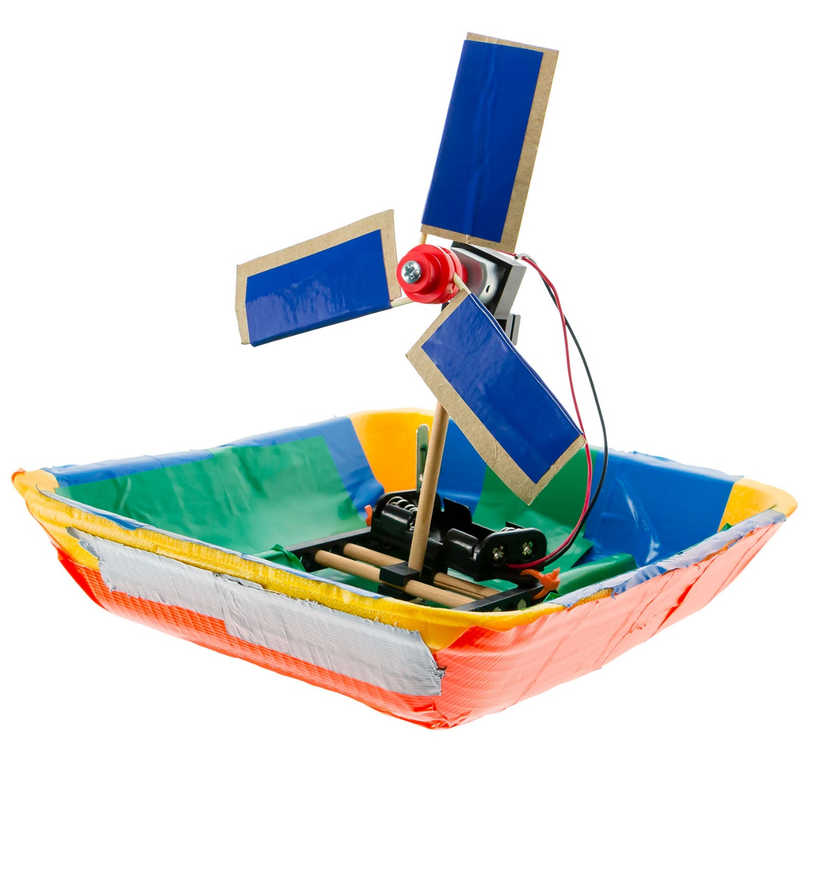

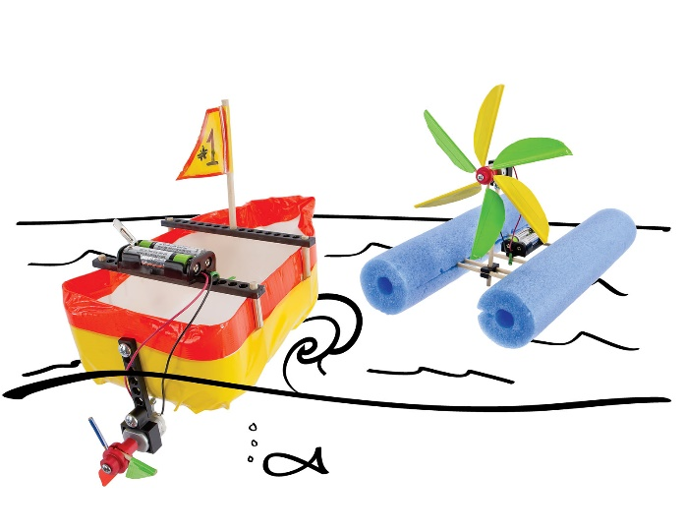

Start by building the example boat, then turn it into your own unique design.

For use with TeacherGeek [Build-a-Boat Activity](https://teachergeek.com/products/build-a-boat-activity-1?variant=27675218705), or [Maker Cart](https://teachergeek.com/products/maker-cart). Find documents and activity materials at [**teachergeek.com**](https://teachergeek.com/).

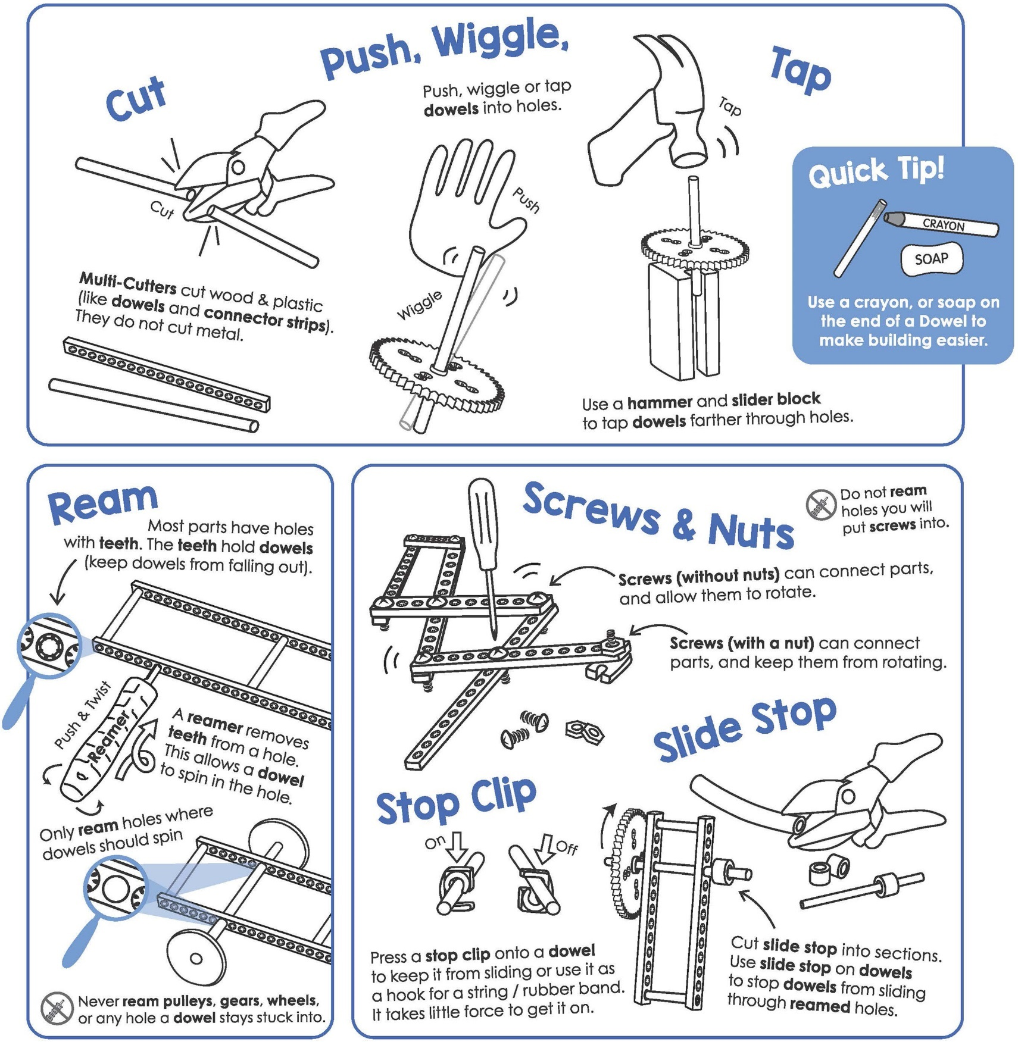



These are the TeacherGeek components for the example Boat,   
and extras to turn it into your own unique design.

|  |  |  |  |  |  |
| --- | --- | --- | --- | --- | --- |
|  |  |  |  |  | |
| [**2 - Blocks**](https://teachergeek.com/products/build-a-boat-activity-1?variant=27675218705) | [**4 - Dowels** 300mm (12″)](https://teachergeek.com/products/build-a-boat-activity-1?variant=27675218705) | [**3 - Connector Strips**](https://teachergeek.com/products/build-a-boat-activity-1?variant=27675218705) | **[4 - 25mm Screws](https://teachergeek.com/products/build-a-boat-activity-1?variant=27675218705)**  [25mm (1″) #10](https://teachergeek.com/products/build-a-boat-activity-1?variant=27675218705) | | **[4 - Nuts](https://teachergeek.com/products/build-a-boat-activity-1?variant=27675218705)**  [#10](https://teachergeek.com/products/build-a-boat-activity-1?variant=27675218705) |
|  |  |  |  |  | |
| [**10 - Toothpicks**](https://teachergeek.com/products/build-a-boat-activity-1?variant=27675218705) | [**1 - Hub Cover**](https://teachergeek.com/products/build-a-boat-activity-1?variant=27675218705) | [**1 - Hub Base**](https://teachergeek.com/products/build-a-boat-activity-1?variant=27675218705) | **[1 - Hub Screw](https://teachergeek.com/products/build-a-boat-activity-1?variant=27675218705)**  [⅝″ #6](https://teachergeek.com/products/build-a-boat-activity-1?variant=27675218705) | [**4 - Zip Ties**](https://teachergeek.com/products/build-a-boat-activity-1?variant=27675218705) | |
|  |  |  |  |  | |
| [**1 - Motor** 1.5V-3V](https://teachergeek.com/products/build-a-boat-activity-1?variant=27675218705) | [**1 - Motor Mount**](https://teachergeek.com/products/build-a-boat-activity-1?variant=27675218705) | [**1 - Battery Holder** w/ switch & leads](https://teachergeek.com/products/build-a-boat-activity-1?variant=27675218705) |  |  | |

Components available in the TeacherGeek [Build-a-Boat Activity](https://teachergeek.com/products/build-a-boat-activity-1?variant=27675218705), TeacherGeek [Maker Cart](https://teachergeek.com/products/maker-cart),   
or at [**teachergeek.com**](https://teachergeek.com/)



|  |  |  |
| --- | --- | --- |
|  |  |  |
| [**Multi-Cutter**](https://teachergeek.com/products/1823-81)[*SKU 1823-81*](https://teachergeek.com/products/1823-81) | [**Screwdriver**](https://teachergeek.com/products/stubby-2-screwdriver)[*SKU 1823-90*](https://teachergeek.com/products/stubby-2-screwdriver) | [**Hammer**](https://teachergeek.com/products/stubby-claw-hammer)[*SKU 1824-41*](https://teachergeek.com/products/stubby-claw-hammer) |

Tools available at [**teachergeek.com**](https://teachergeek.com/products/easy-engineering-tool-set?variant=344866731)



You will need these non-TeacherGeek supplies:

|  |  |  |  |
| --- | --- | --- | --- |
|  |  |  |  |
| **Tape**  Masking, Painter’s, Duct— Any kind of tape will work. | **Scissors**  For cutting blade materials  out of recycling materials. | **Safety Goggles**  Should be worn during the activity. Propeller blades spin very fast. | **2 - AA Batteries** |

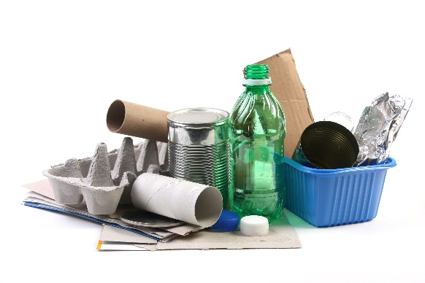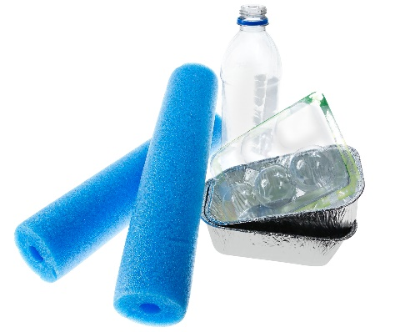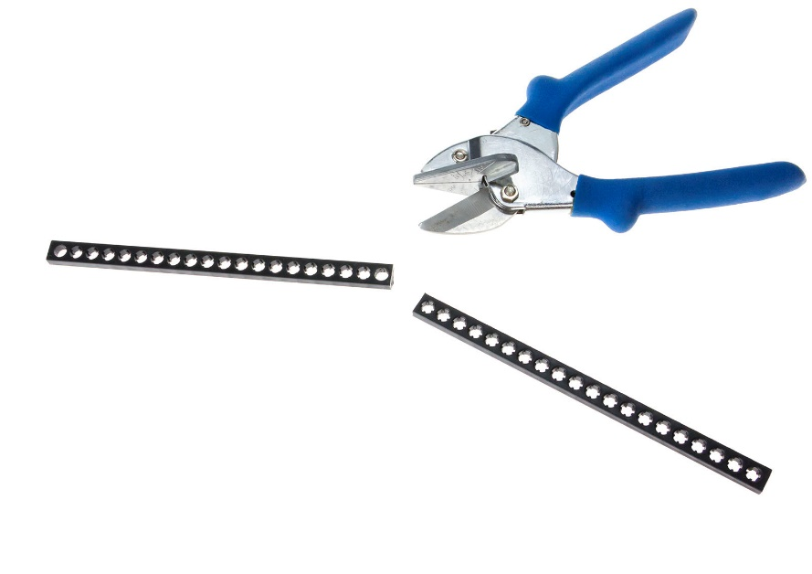

**Recycling Materials**

Blades can be made from cardboard, chipboard, clean food packaging, plastic, etc.

They should not be made from metal or anything sharp.

**Floating Materials**

Find materials that float.   
You’ll get to add these to your design to create a working boat.





|  |  |  |  |
| --- | --- | --- | --- |
|  | Cut two 8cm **dowels**.          8cm | | |
|  | Push or tap the 8cm **dowels** half way through a **block**.      block    8cm |  | **Quick Tip** *Use a tapping block  and hammer. It will things much easier.* |
|  | Cut a **connector strip** in half. | half  connector  strips | Push or tap the **connector strip** halves onto the dowels from Step 2. |
|  | Cut a 10cm **dowel**.  10cm |  | Push or tap the 10cm **dowel** through the center hole of the **block**.    10cm |
|  | | | |
|  | Push the outside hole of a **block** onto the **dowel**. |  | Push the **motor** into the **mount**  as shown.    *This is what it should like* |
|  | Attach the **motor mount** with a **25mm screw** and **nut**.    25mm screw  nut    Almost there!  Now, let’s add  the prop blades…  Almost there!  Now, let’s add  the prop blades… | | |

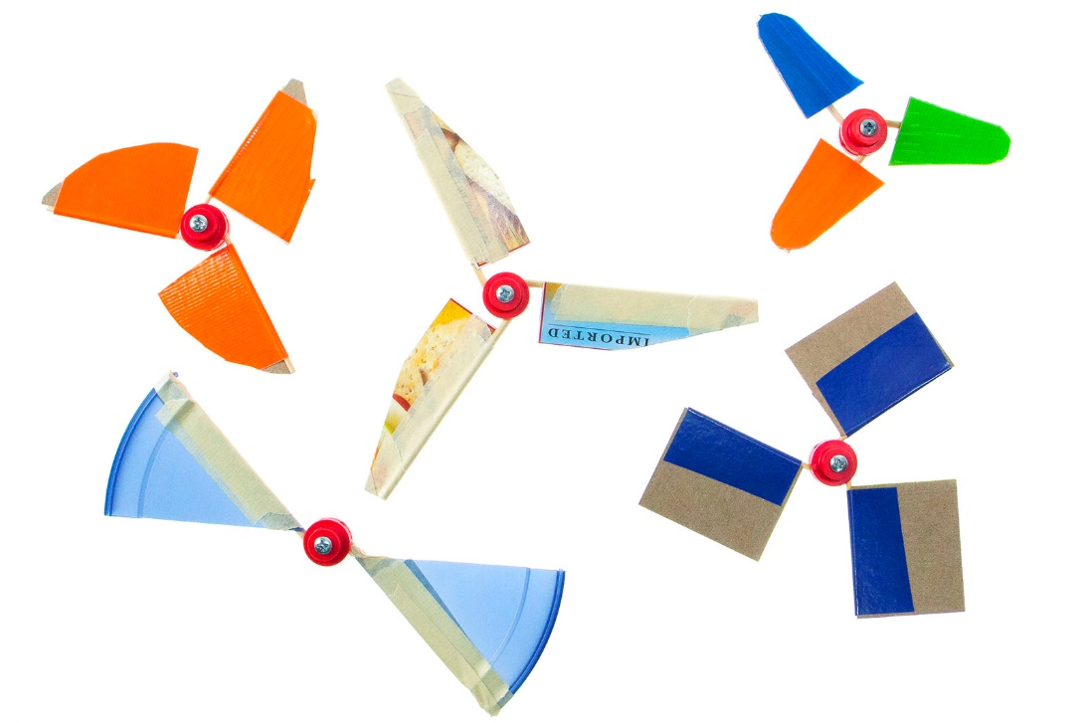

For this part of the build guide,   
you will need:

* Tape (any kind will work)
* Recycling Materials
* Mini Motor Hub Base & Cover
* Hub Screw
* Toothpicks (or skewers)

|  |  |  |  |
| --- | --- | --- | --- |
|  | Cut the both ends off the **toothpicks**.  **Skewers Option**  Cut to size and cut off the pointed ends of **skewers**. |  | Measure and cut three  3cm x 6cm strips of **recycling materials.**  3cm  6cm    These will be your blades. |
|  | Lay a piece of **tape** (sticky side up) and lay a **toothpick** in the middle.  *sticky side up* |  | Place the **blade** on one half of the **tape**.  6cm  3cm |
| Make sure the tape is creased tight around. | Fold over the **tape** (around  the **toothpick** and **blade**). |  | Measure 15mm from the end of **blade**… and cut.    **Congratulations!**  You made your first prop blade. Now, make two more.  You should have *three* when  you are finished. |

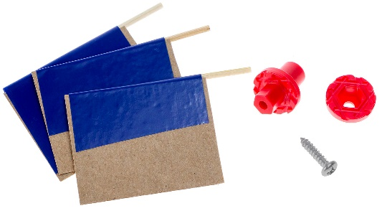

**Safety First**  
If you’re not already, wear eye protection during these steps and when operating your Boat.

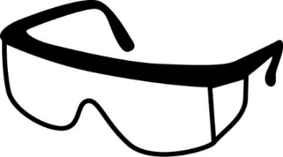

|  |  |  |  |  |  |
| --- | --- | --- | --- | --- | --- |
|  | Screw the **cover** to the **base** using a **hub** **screw**.  **Quick Tip** *Hold the base with pliers when turning in the screw.*      hub screw    cover  base | | |  | Loosen the **screw** ½ turn.    Front View |
|  | Push the **blade** ends into  the **hub**. When set, retighten the **screw**. |  | Once you have your **hub** assembled, push it onto your **motor** as shown on the left. | | |

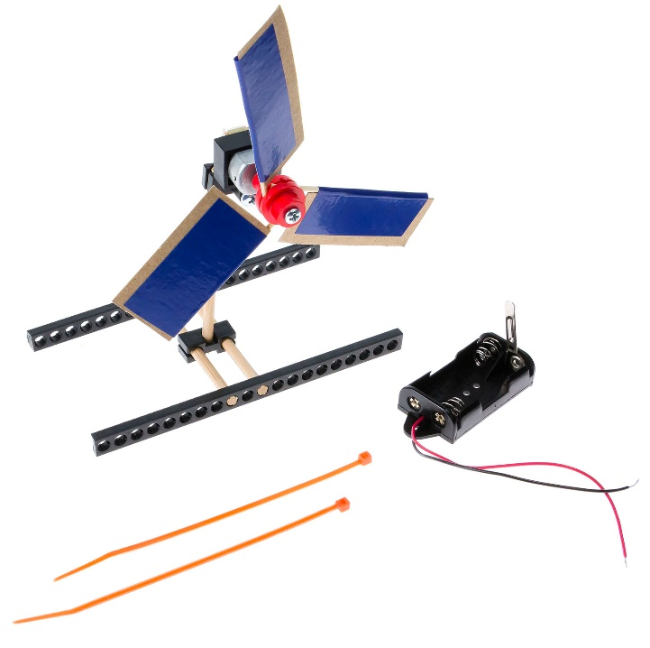



Put the **zip tie** through the **battery holder** and one of the holes on the **frame**.

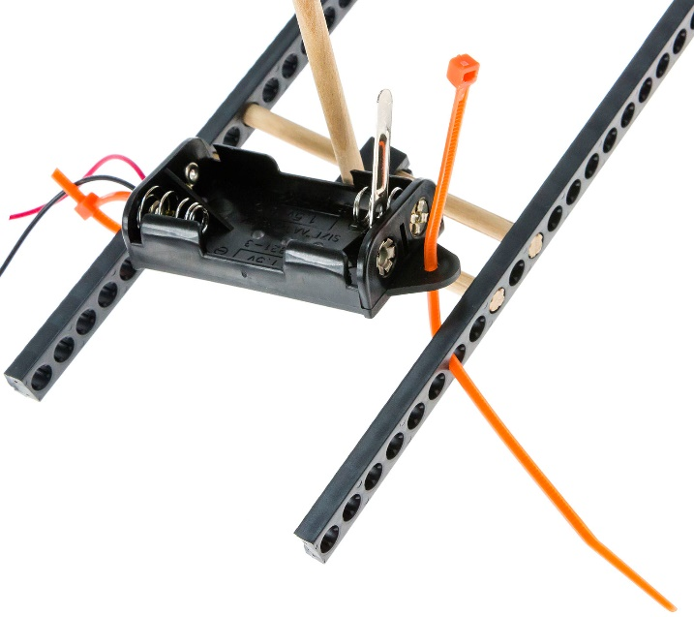

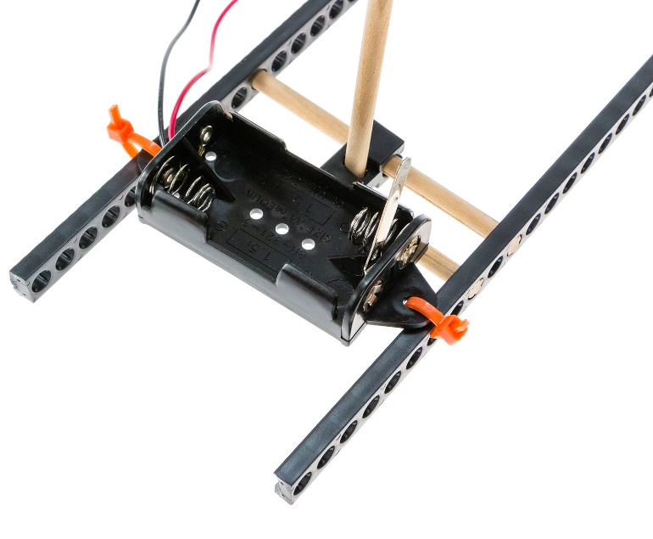

Tighten and trim **zip ties**.





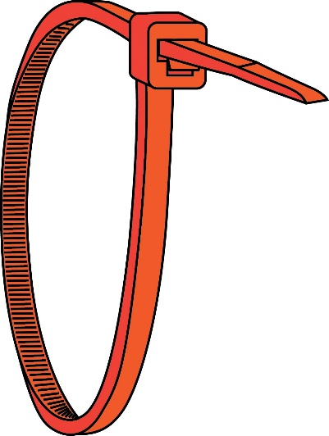

**Right!**

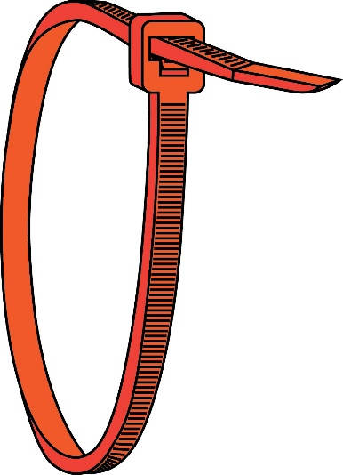

**Wrong**

**Quick Tip**  
Zip ties can be tricky. Make sure you put them on the right way.





Connect the **motor** to the **battery holder**. Put the **battery holder** wires through and wrapped around the **motor** terminals.

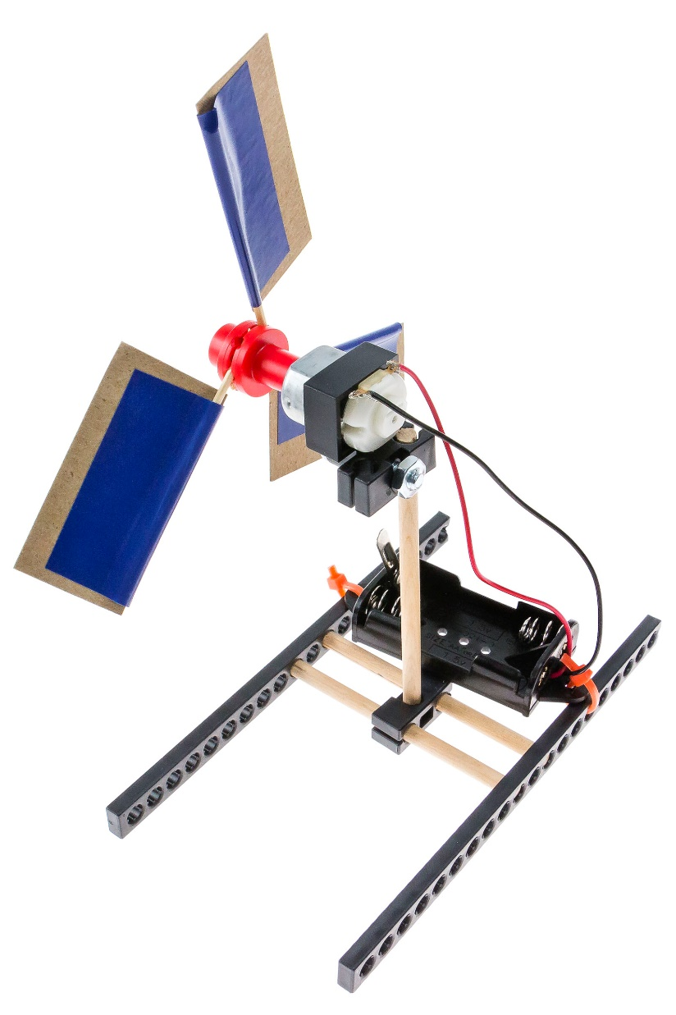

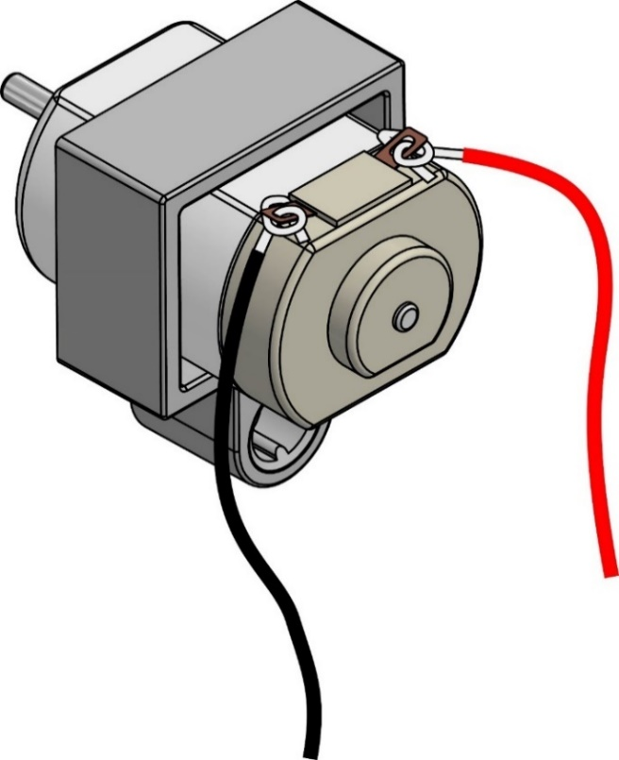

**Caution: No Short Circuiting**

Do not let the wires cross   
or touch the silver metal   
part of the motor.



Insert two AA batteries in the **battery holder**. Use the metal lever to turn your propeller on and off.

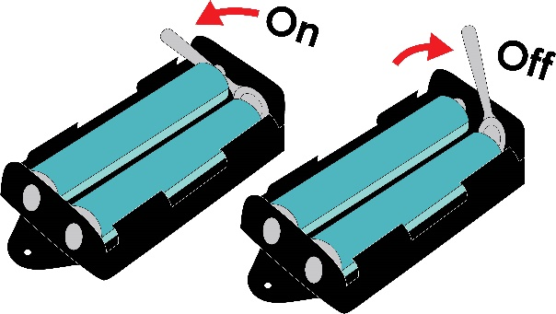



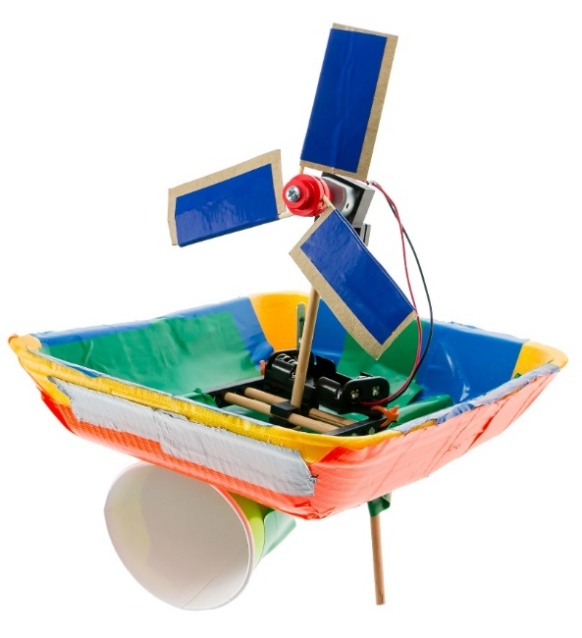

**Add a Rudder**  
Use the water’s current   
to your advantage   
and help push your boat along.



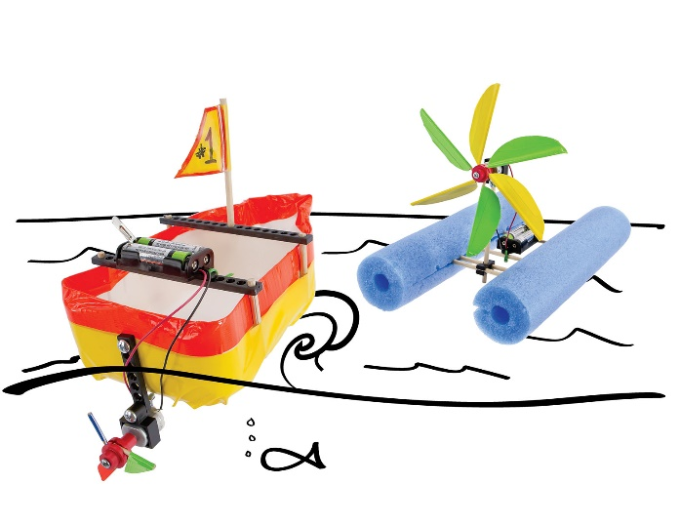

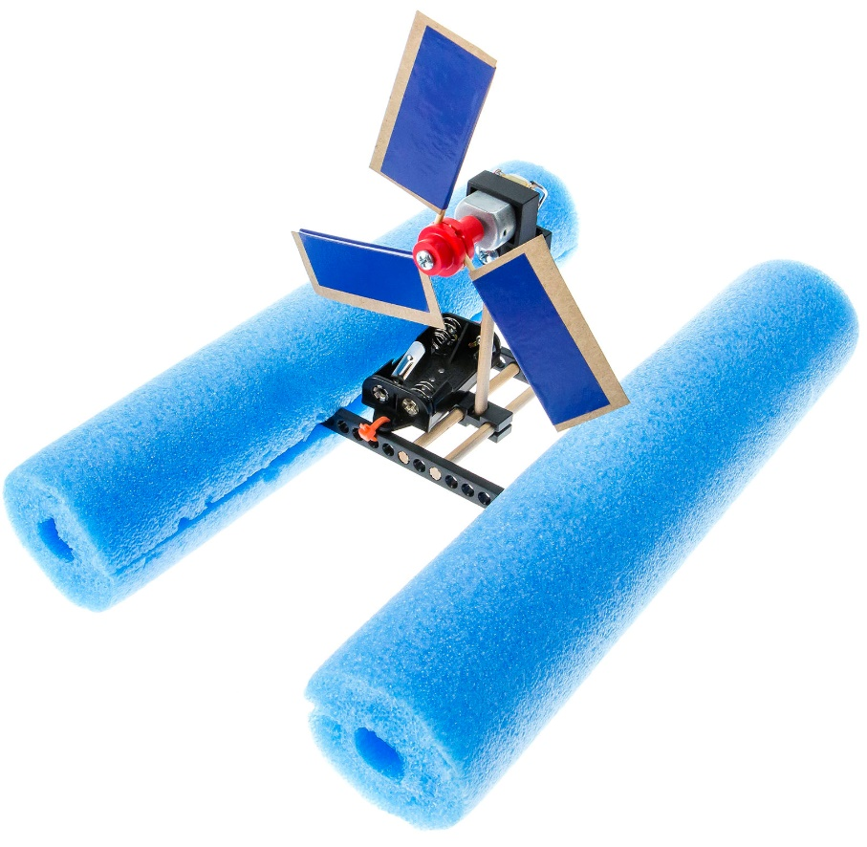

**Quick Tip**  
Cut slits in your noodles to slide the frame into.



**Congratulations!**  
Your example Boat is finished!   
The example isn’t the best design.  
*You can make it so much better.*

Find out how on the next page.



Add **floating materials** (foam trays, pool noodles, plastic bottles, food containers, etc.) to your design   
to make your boat float.



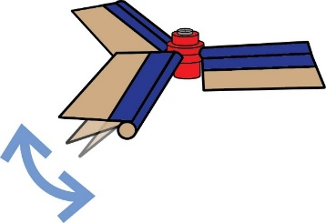

**Try Changing Blade Angle**

1. Loosen the hub screw a half turn.
2. Change the blade angle using   
   the protractor as shown.
3. Tighten the screw again.



**Try Changing Blade Shape & Size**

Blade designs come in all shapes and sizes.   
Try adding to your blades by taping on extra pieces or cutting them down into new shapes.

Or try using only two blades or six!

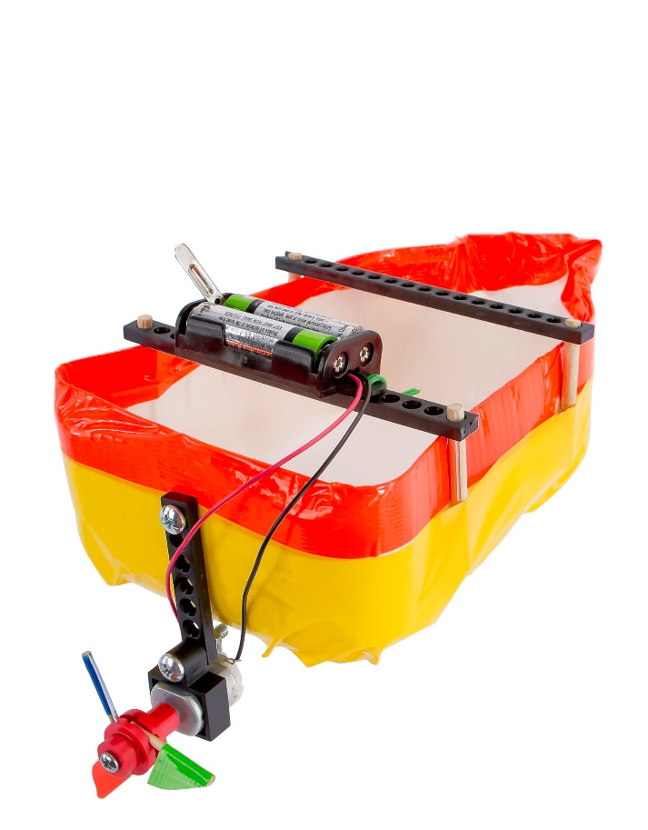

**Design an Underwater Propeller**

Use what you’ve learned about propellers pushing air, and design a boat that uses a propeller to push water.

**Quick Tips**

* Dowels swell when wet.
* Use a smaller blade design.

