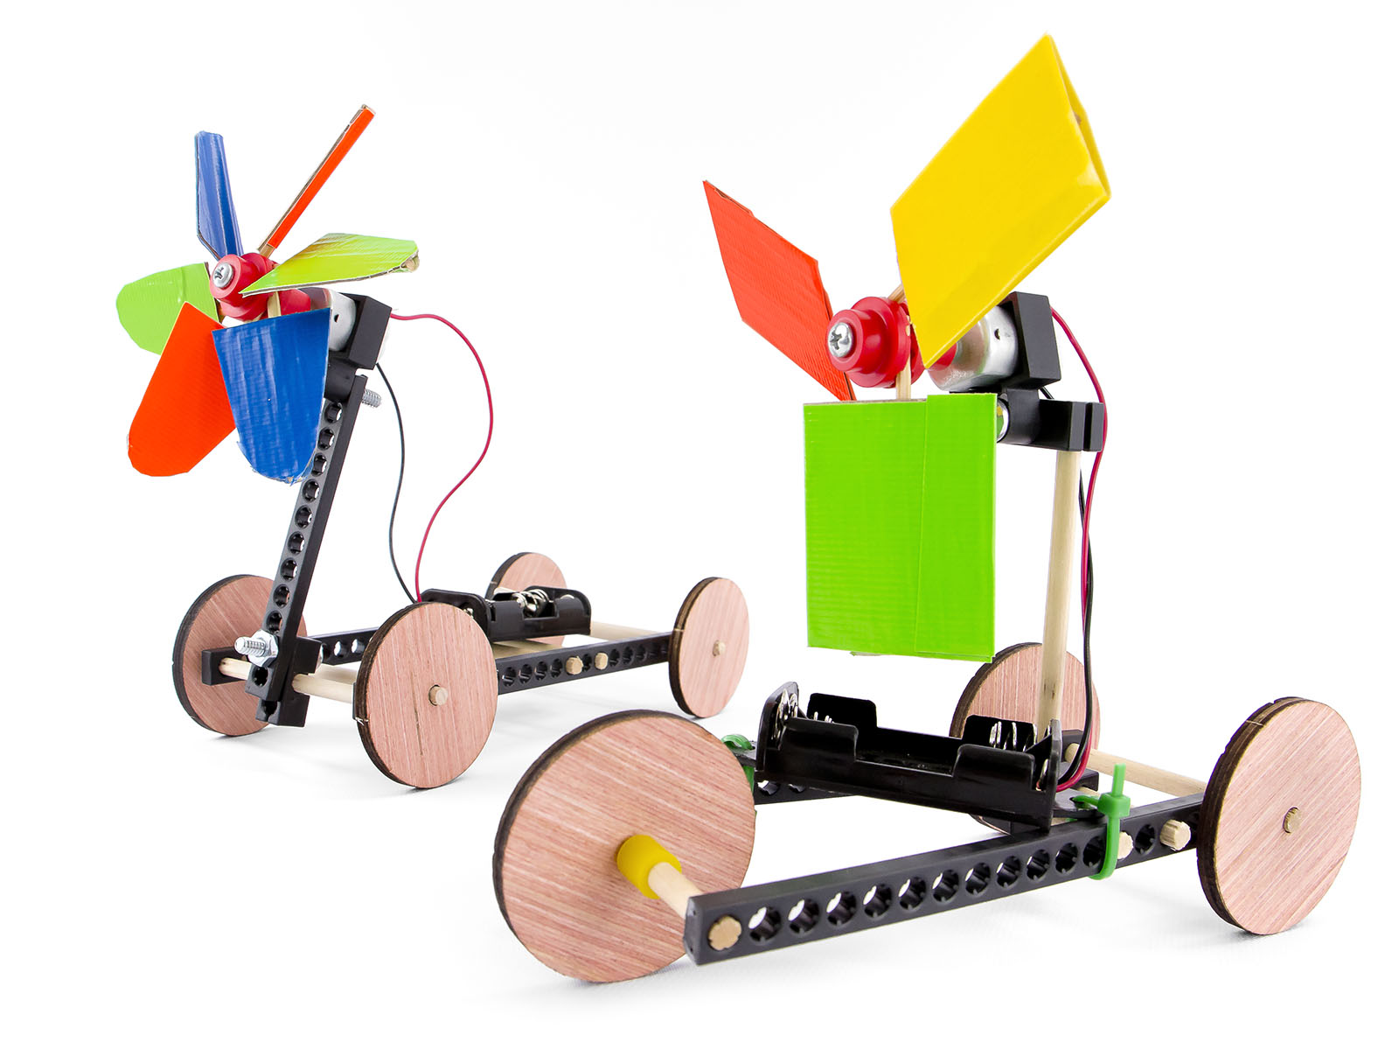

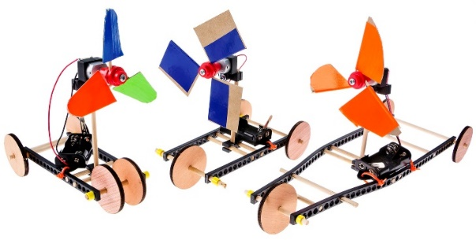

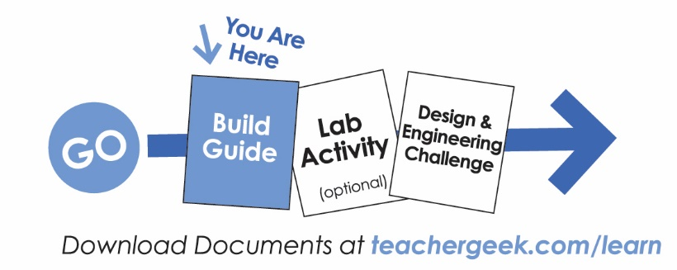

For use with TeacherGeek Air Racer Activity Pack, or Maker Cart. Find documents and activity materials at teachergeek.com.

Start by building the example racer, then turn it into your own unique design.

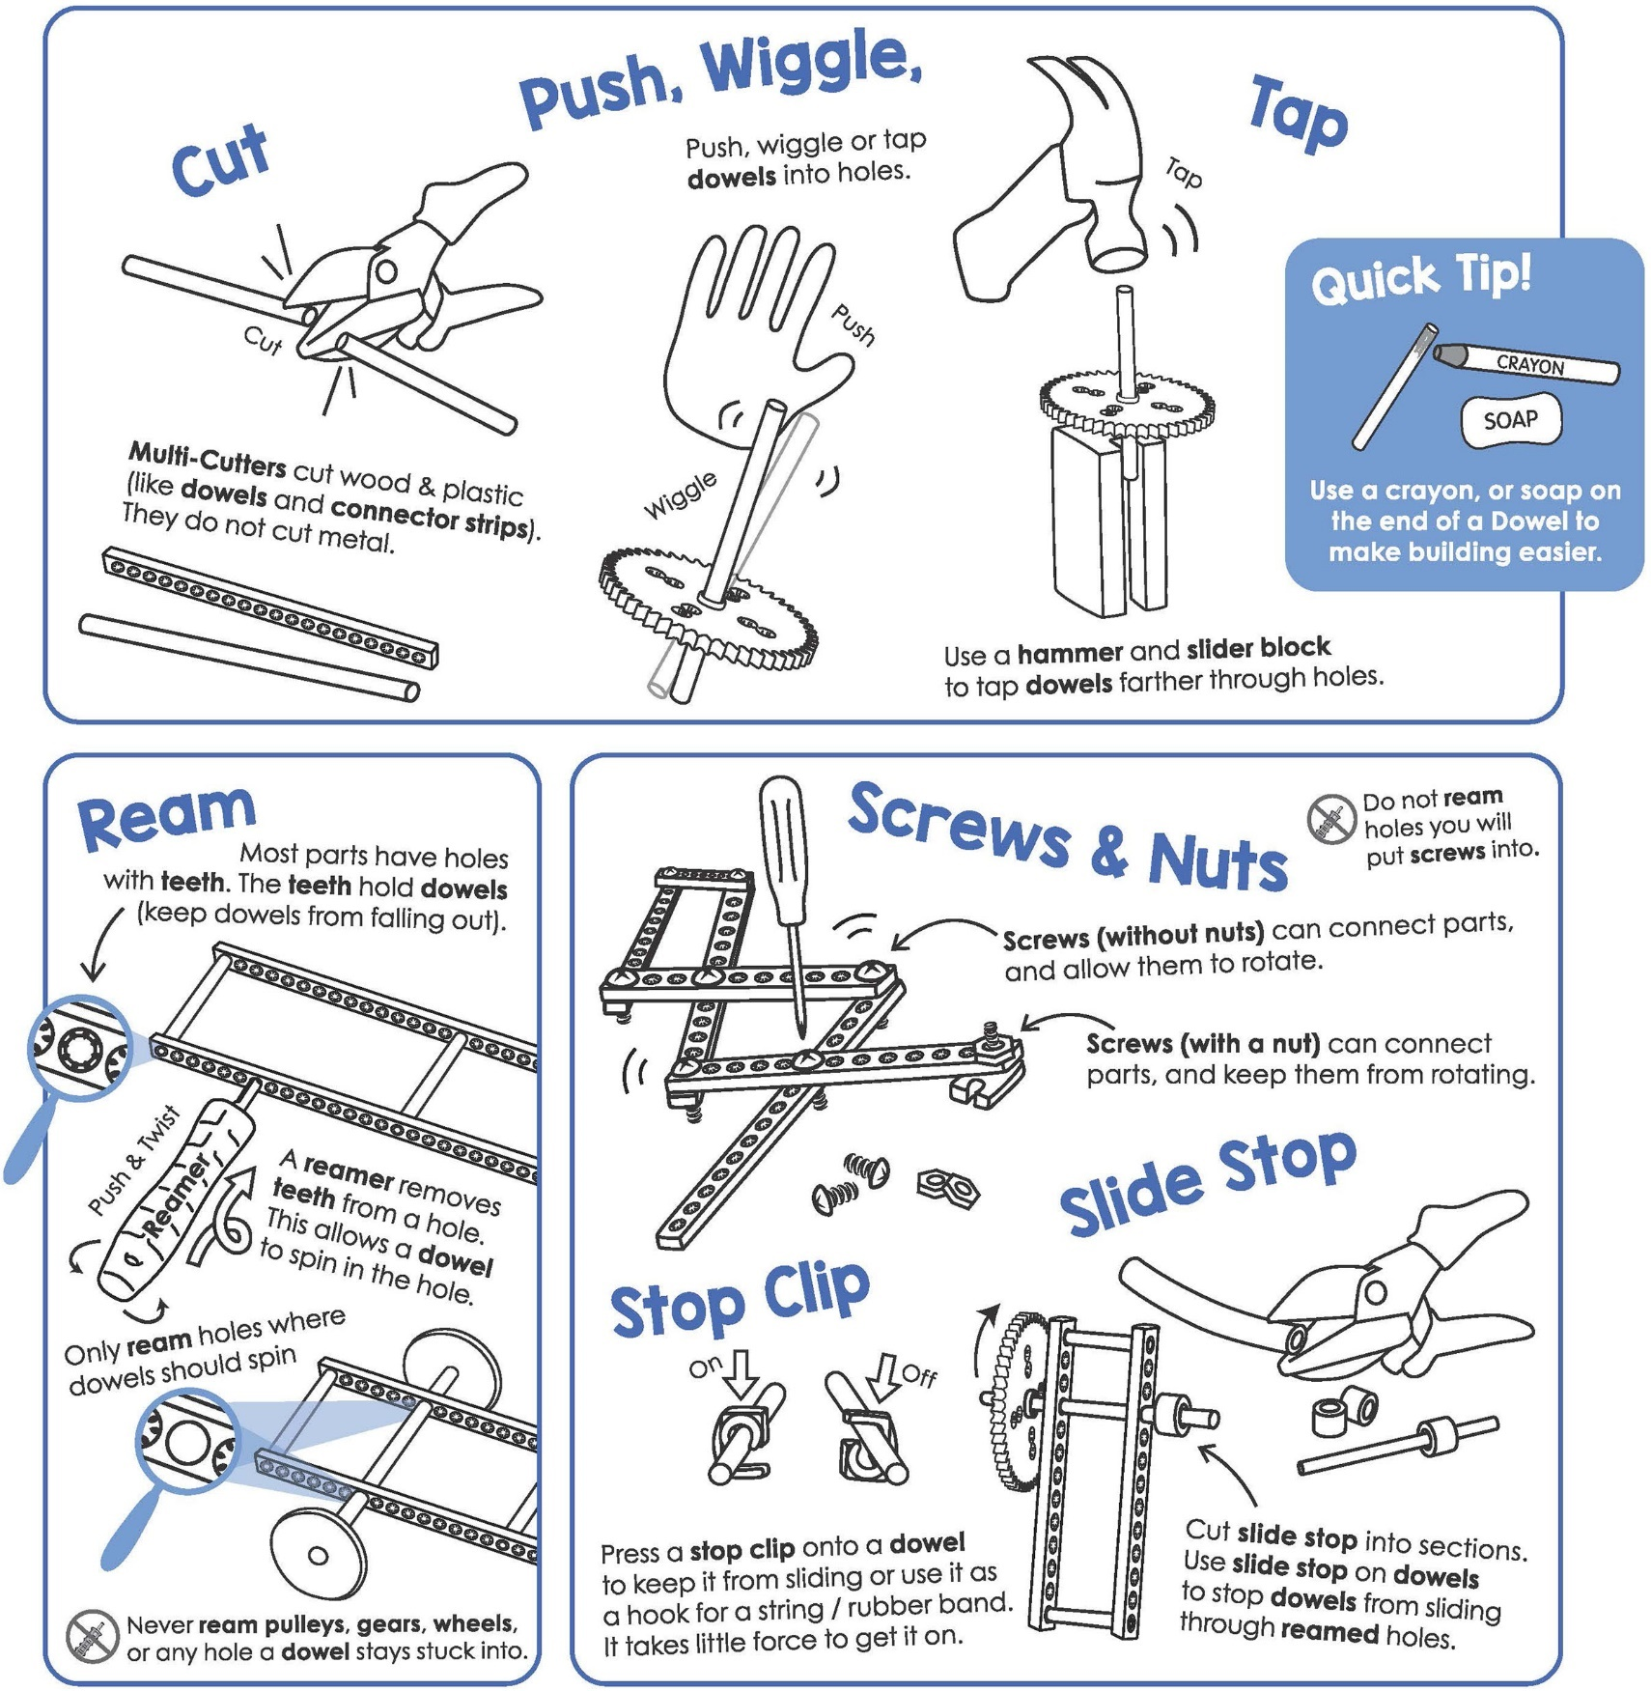



These are the TeacherGeek components for the example Air Racer,   
and extras to turn it into your own unique design.

|  |  |  |  |  |
| --- | --- | --- | --- | --- |
|  |  |  |  |  |
| [**2 - Blocks**](https://teachergeek.com/products/air-racer-activity) | [**3 - Dowels** 300mm (12″)](https://teachergeek.com/products/air-racer-activity) | [**3 - Connector Strip**](https://teachergeek.com/products/air-racer-activity) | [**3 - Wood Wheels**](https://teachergeek.com/products/air-racer-activity) | **[2 - Nuts](https://teachergeek.com/products/air-racer-activity)**  [#10](https://teachergeek.com/products/air-racer-activity) |
|  |  |  |  |  |
| [**10 - Skewers**](https://teachergeek.com/products/air-racer-activity) **(or toothpicks)** | [**1 - Hub Cover**](https://teachergeek.com/products/air-racer-activity) | [**1 - Hub Base**](https://teachergeek.com/products/air-racer-activity) | **[1 - Mini Hub Screw](https://teachergeek.com/products/air-racer-activity)**  [⅝″ #6](https://teachergeek.com/products/air-racer-activity) | **[2 - 25mm Screws](https://teachergeek.com/products/air-racer-activity)**  [25mm (1″) #10](https://teachergeek.com/products/air-racer-activity) |
|  |  |  |  |  |
| [**1 - Motor** 1.5V-3V](https://teachergeek.com/products/air-racer-activity) | [**1 - Motor Mount**](https://teachergeek.com/products/air-racer-activity) | [**1 - Battery Holder** w/ switch & leads](https://teachergeek.com/products/air-racer-activity) | [**4 - Zip Ties**](https://teachergeek.com/products/air-racer-activity) | [**1 - Slide Stop** 100mm (3″)](https://teachergeek.com/products/air-racer-activity) |



|  |  |  |  |
| --- | --- | --- | --- |
|  |  |  |  |
| [**Multi-Cutter**](https://teachergeek.com/products/1823-81) | [**Reamer**](https://teachergeek.com/collections/tools-resources/products/teachergeek-reamer) | [**Screwdriver**](https://teachergeek.com/products/stubby-2-screwdriver) | [**Hammer**](https://teachergeek.com/products/stubby-claw-hammer) |

Tools available at [**teachergeek.com**](https://teachergeek.com/products/easy-engineering-tool-set?variant=344866731)



You will need these non-TeacherGeek supplies:

|  |  |  |
| --- | --- | --- |
|  |  |  |
| **Tape**  Masking, Painter’s, Duct - Any kind of tape will work. | **Scissors**  For cutting blade materials  out of recycling materials. | **Safety Goggles**  Should be worn during the activity. Prop blades spin very fast. |

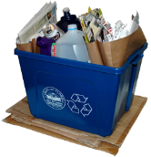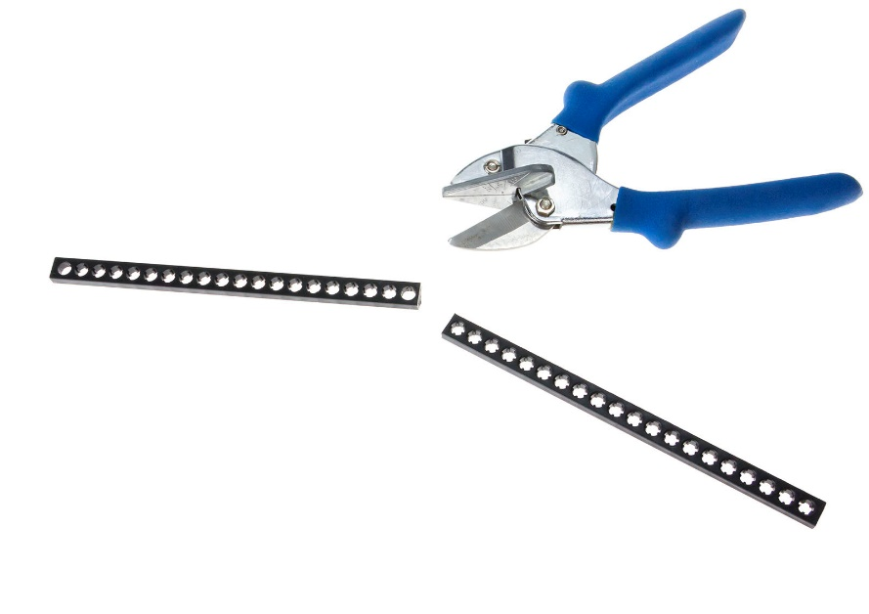

**Recycling Materials**

Blades can be made from cardboard, chipboard,   
clean food packaging, plastic, etc.

They should not be made from anything sharp or metal.





|  |  |  |  |
| --- | --- | --- | --- |
|  | **Cut** two **8cm** (3”) **dowels**.          8cm | | |
|  | **Push** or **tap** the 8cm (3”) **dowels** **half-way** through a **block**.      block    8cm |  | **Quick Tip** *Use a tapping block  and hammer. Things  will be much easier.* |
|  | **Cut** a **connector strip** in **half,** 15cm (6”). | half  connector  strips | **Push** or **tap** the **connector strip** halves **onto** the **dowels** from Step 2. |
| 10cm | **Cut** a **10cm** (4”) **dowel**. |  | **Push** or **tap** the 10cm **dowel** through the **center hole** of the **block**.    10cm |
|  | | | |
|  | **Ream** the four **outside holes** on the **frame**. This will allow the **dowels** to spin. | 12cm | **Cut** two 12cm **dowels**. These will become **axles** for the **wheels**. |
| wood wheel  **Quick Tip**  **Cut** and use **slide stop** pieces as **spacers** or to keep **wheels** from falling off.  Make sure there is still space to spin. | Tap or push one 12cm (4.7”)  **dowel** into a **wood wheel** to  make an **axle**.    12cm | 12cm  slide stop  slide stop | **Slide** the **axles** through the **reamed holes** and put on **wheels** as shown.  Use two **5mm** pieces of **slide stop** and **slide** on **axle** as shown. |
|  | | | |
|  | **Push** the **outside hole** of a **block** onto the **dowel**. |  | **Push** the **motor** into the **mount**  as shown.    *This is what it should like* |
|  | **Attach** the **motor mount**  with a **25mm** **screw** and **nut**.  25mm screw  nut      **Almost There!**  *Now, let’s add  the prop blades…* | | |

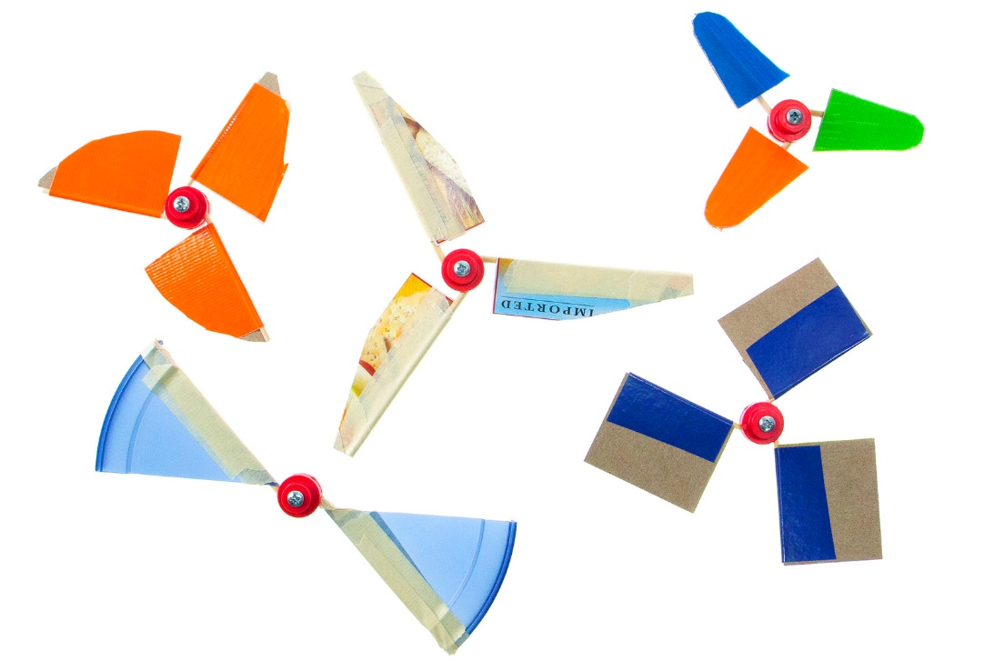

For this part of the build guide,   
you will need:

* Tape (any kind will work)
* Recycling Materials
* Mini Motor Hub Base & Cover
* Hub Screw
* Skewers (Toothpicks)

|  |  |  |  |
| --- | --- | --- | --- |
| **Skewers Option**  Cut to size and cut off the pointed ends of **skewers  (or toothpicks)**. | **Cut** both **ends** off the **skewers** |  | **Measure** and **cut** three  3cm (1”) x 6cm(2.5”) strips  of **recycling materials.**  3cm  6cm    These will be your **blades**. |
|  | **Lay** a piece of **tape** (sticky side up) and **lay** a **skewer (or toothpick)**  in the **middle**.  *sticky side up* |  | **Place** the **blade** on one **half** of the **tape**.  6cm  3cm |
| Make sure the tape is creased tight around. | **Fold** over the **tape** (around the **skewer (or toothpick)** and **blade**). |  | **Measure** 15mm from the **end** of **blade** to your **dowels** and **cut**.    **Congratulations!**  You made your first **prop blade**. Now, make two more.  You should have *three*  when you are finished. |

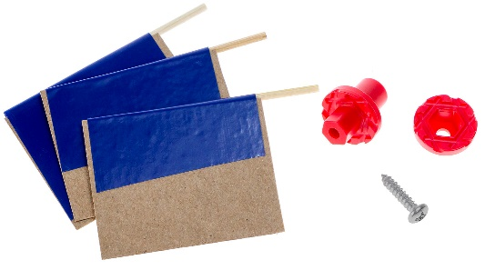

**Safety First**  
If you’re not already, wear eye protection during these steps and when operating your Air Racer.

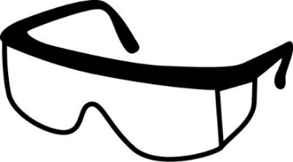

|  |  |  |  |  |  |
| --- | --- | --- | --- | --- | --- |
|  | **Screw** the **cover** to the **base** using  a **mini hub** **screw**.  **Quick Tip** *Hold the base with pliers when turning in the screw.*      mini hub screw      cover  base | |  | | Loosen the **screw** **½** turn.    Front View |
|  | Carefully **slide** the **skewers   (toothpicks)** into **mini hub’s** holes. |  | | When set, **retighten** the **screw**.  **Push** the **hub** onto your **motor**. | |

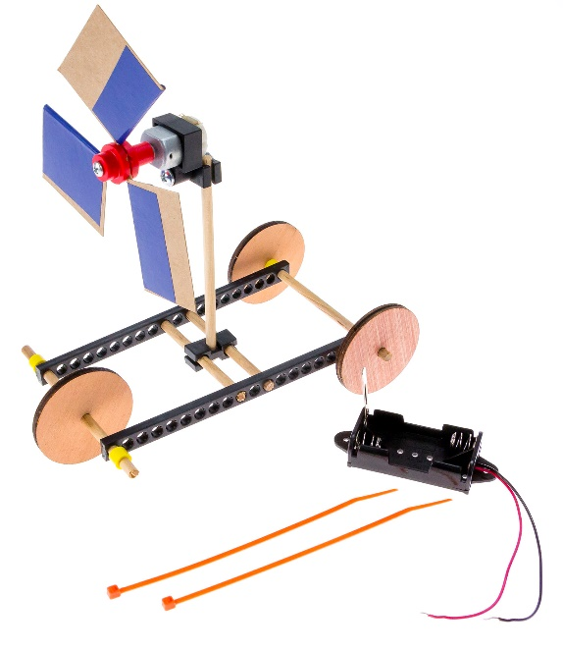



Put the **zip tie** through the **battery holder** and one of the **holes** on the **frame**.

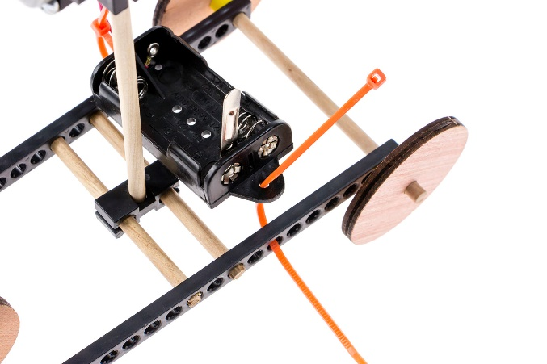



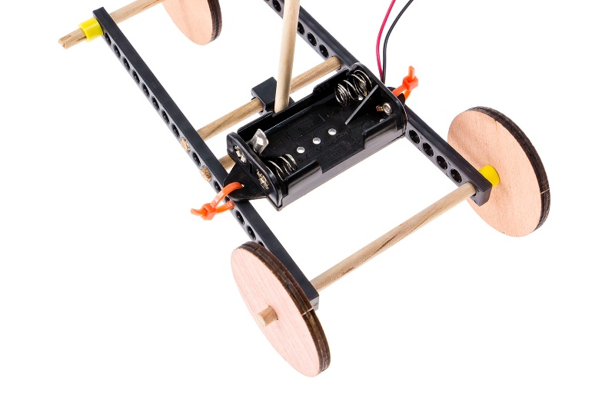

**Tighten** and trim **zip ties**.







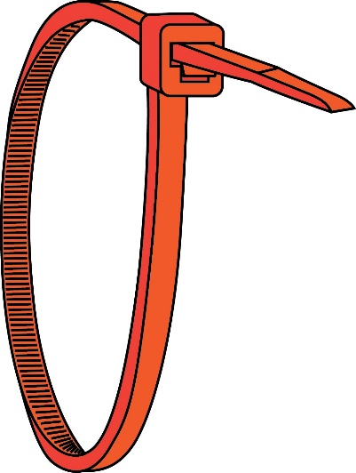

**Right!**

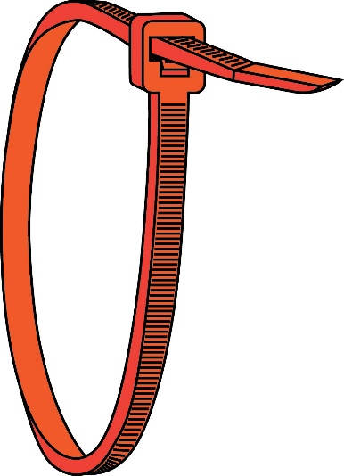

**Wrong**

**Quick Tip**  
Zip ties can be tricky. Make sure you put   
them on the right way.



**Connect** the **motor** to the **battery holder**. Put the **battery holder wires** through and **wrap** them around the **motor** terminals.

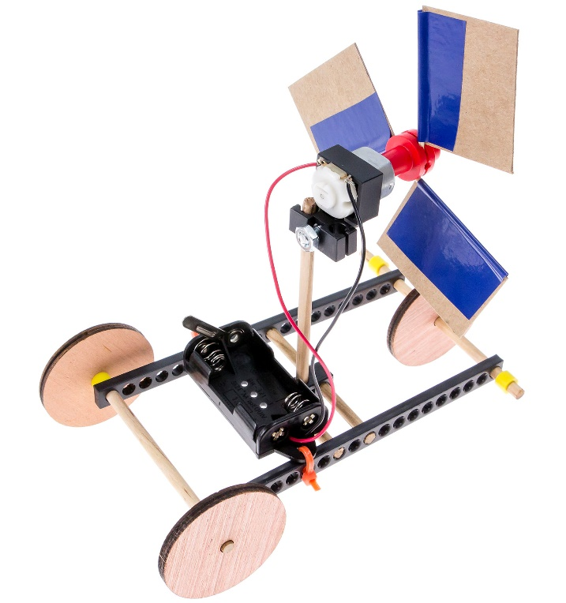

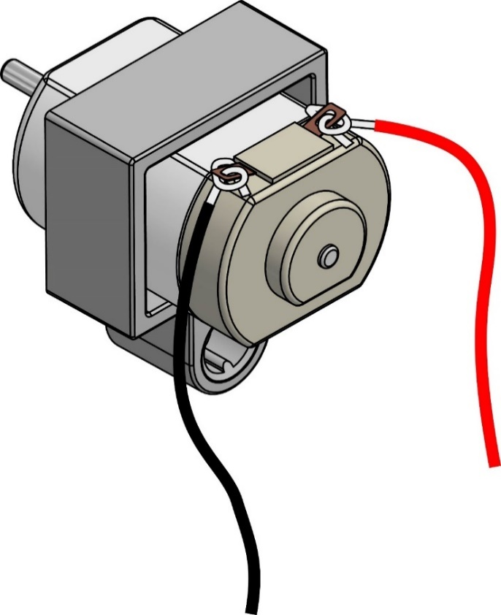





**Caution: No Short Circuiting**

**Do not** let the wires cross   
or touch the silver metal   
part of the motor.

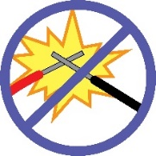

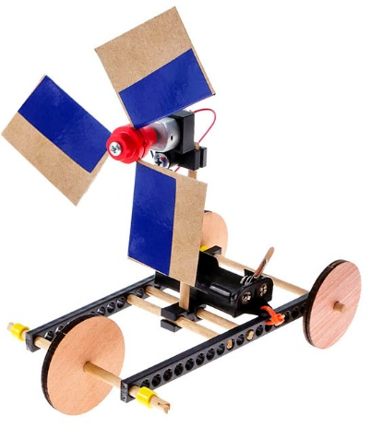



**Insert** two AA batteries in the **battery holder**. Use the **metal lever** to turn your Air Racer **on** and **off**.

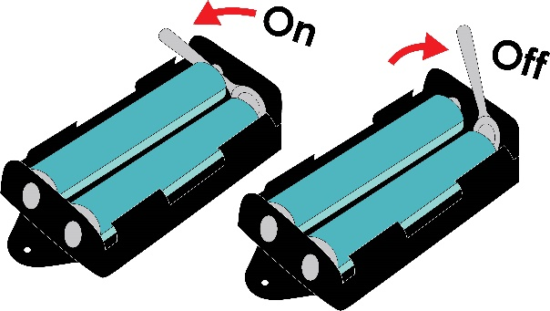

**Good News**  
Your example Air Racer is finished. Bad news, the example isn’t the best design, you can make it better.

Find out how on the next page.

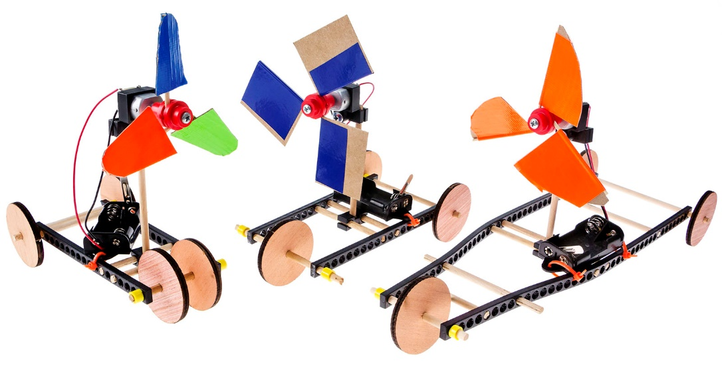

Make your Air Racer ***go***.

Does it already move?   
Make it go faster, go farther.   
Make it better. Change the blade,   
change the frame, the possibilities   
are endless!

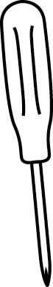

**Try Changing Blade Angle**

1. Loosen the hub screw a half turn.
2. Change the blade angle using   
   the protractor as shown.
3. Tighten the screw again.





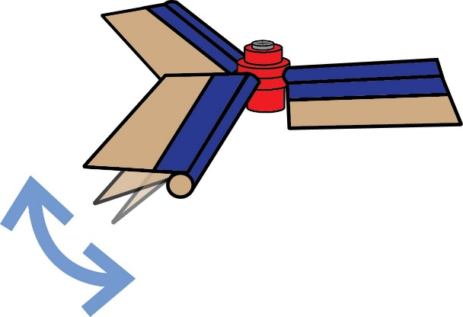

**Try Changing Blade Shape & Size**

Blade designs come in all shapes   
and sizes. Try adding to your blades   
by taping on extra pieces or cutting   
them down into new shapes.

Or try using only two blades.

