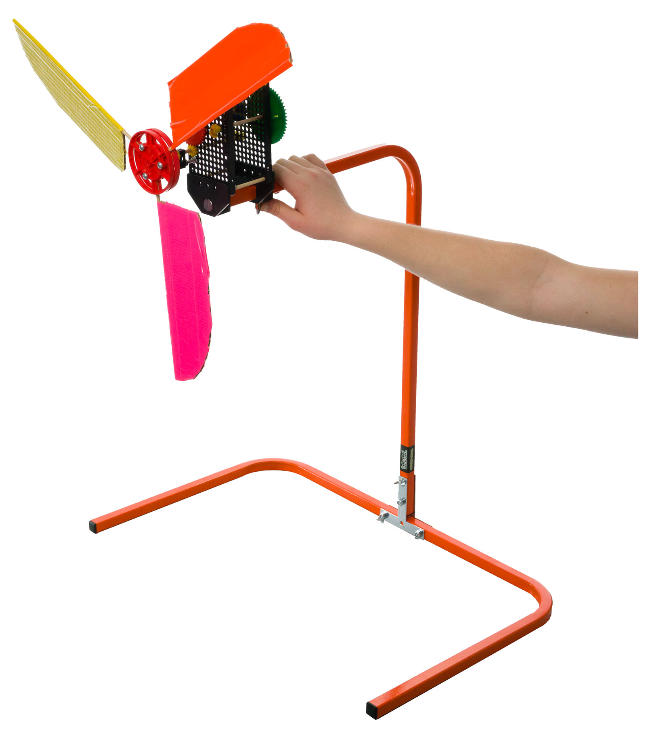  
  
  
  
  
  
  
  
  
  
  
  
  
  
  
  
  
  
  
  
  
  
  
  
  
  
  
  
  
  
  
  
  
  
  
  
  
  
  
  
  
  
  
  


A wind stand can hold up your wind turbine, wind lift, or other projects for testing.   
This guide will show you how to assemble it.

You’ll need these components to create one Wind Stand.

|  |  |  |  |  |
| --- | --- | --- | --- | --- |
|  |  |  |  |  |
| **Base and Upright**  (with clamp) | **2 – T-Plates** | **4 - Screws**  ¼” x 1 ¼” | **3 - Nuts** ¼” | **1 – Wing Nut**  ¼” |

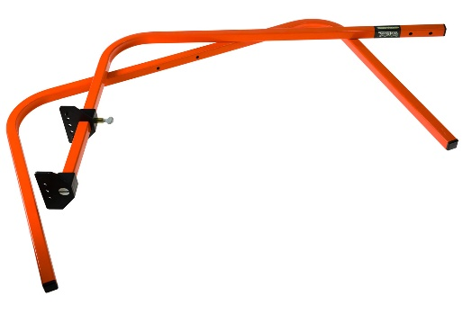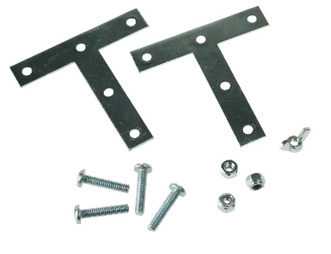

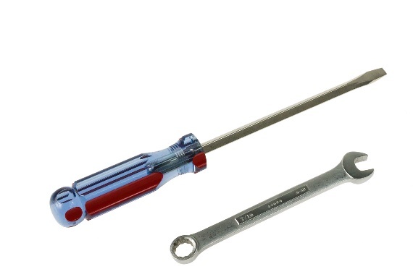

You’ll also need a few tools:

* **Straight Screwdriver**
* **Wrench** ( 7/16” or 14mm) or **Pliers**

or

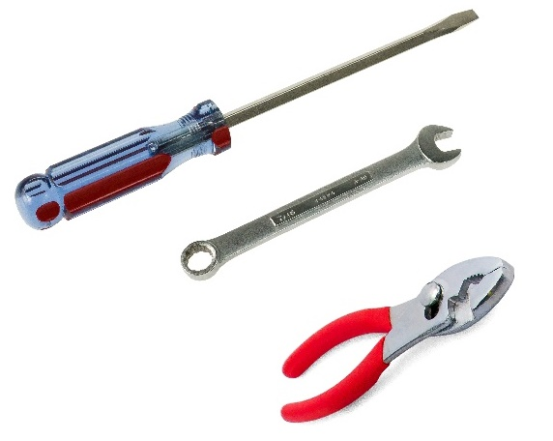

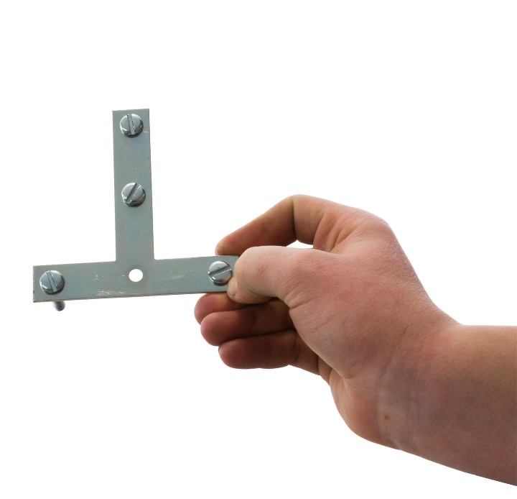





**Place** four **screws** into the **T-plate** as shown. Leave the center-bottom hole empty.



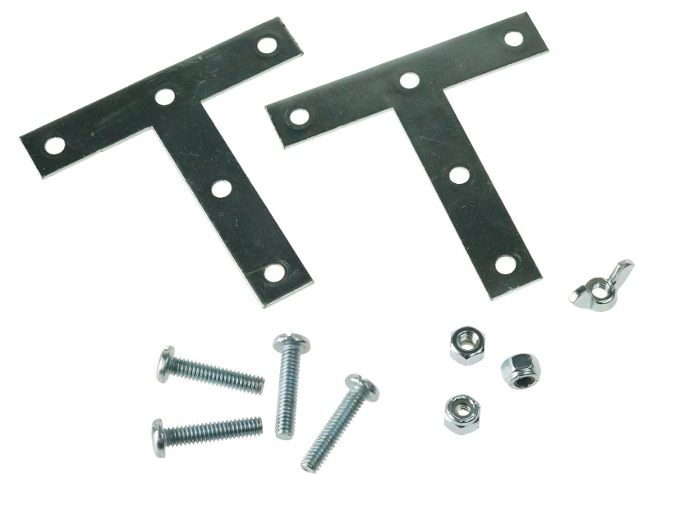

¼” Screws



Put the two bottom **T-plate screws** through the **base holes**.

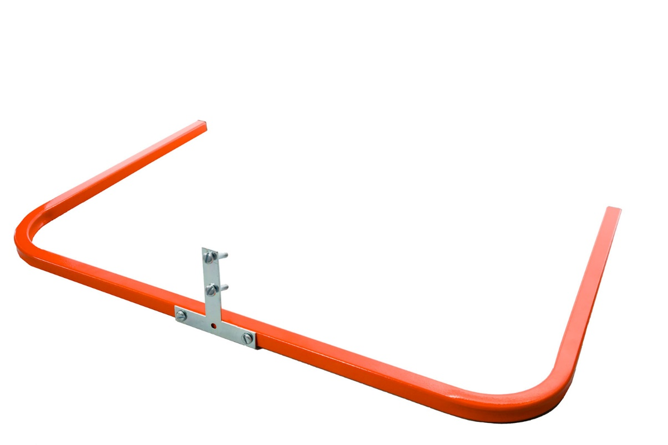

Base



T-Plate

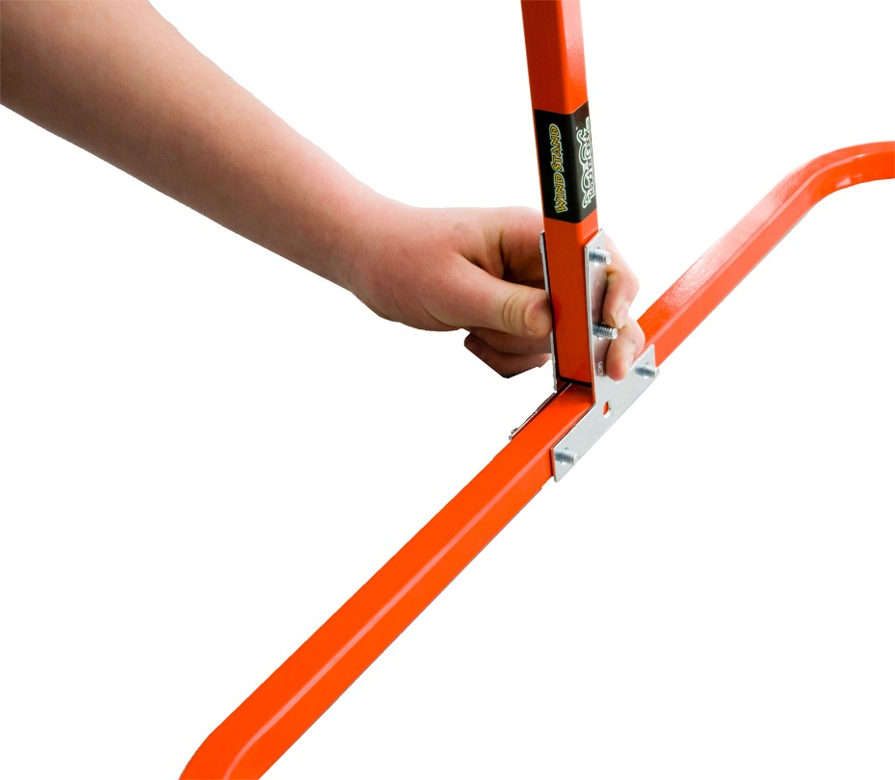

Upright



Place the two upper   
**T-plate screws** through   
the **upright** holes.

**Place** the second **T-plate**   
onto the four screws



*Second T-*Plate



**Twist** three **locking nuts** and one **wing nut**   
onto the screws, as shown. Tighten them up.

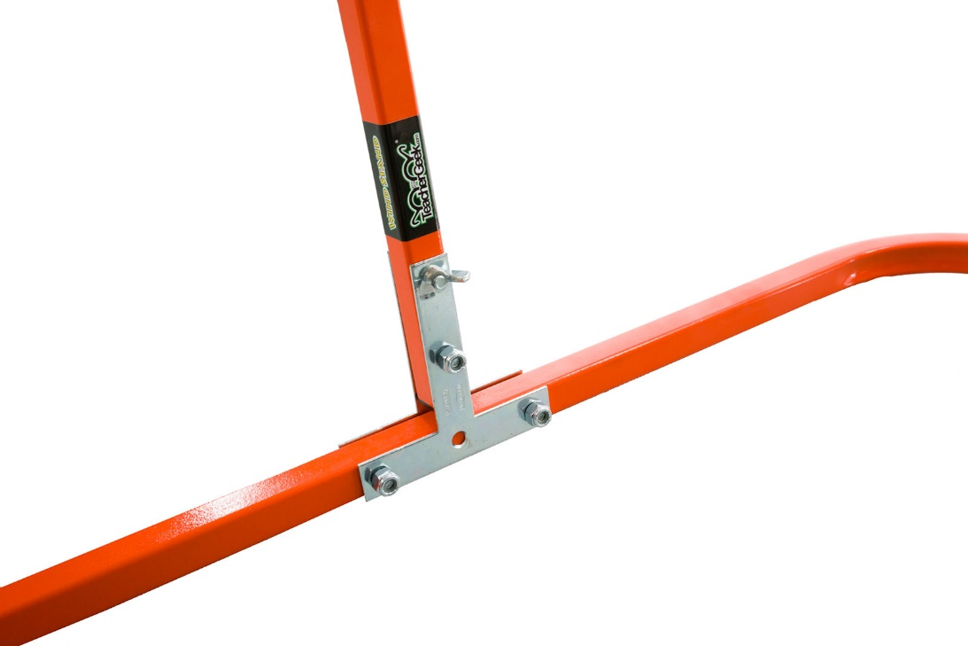

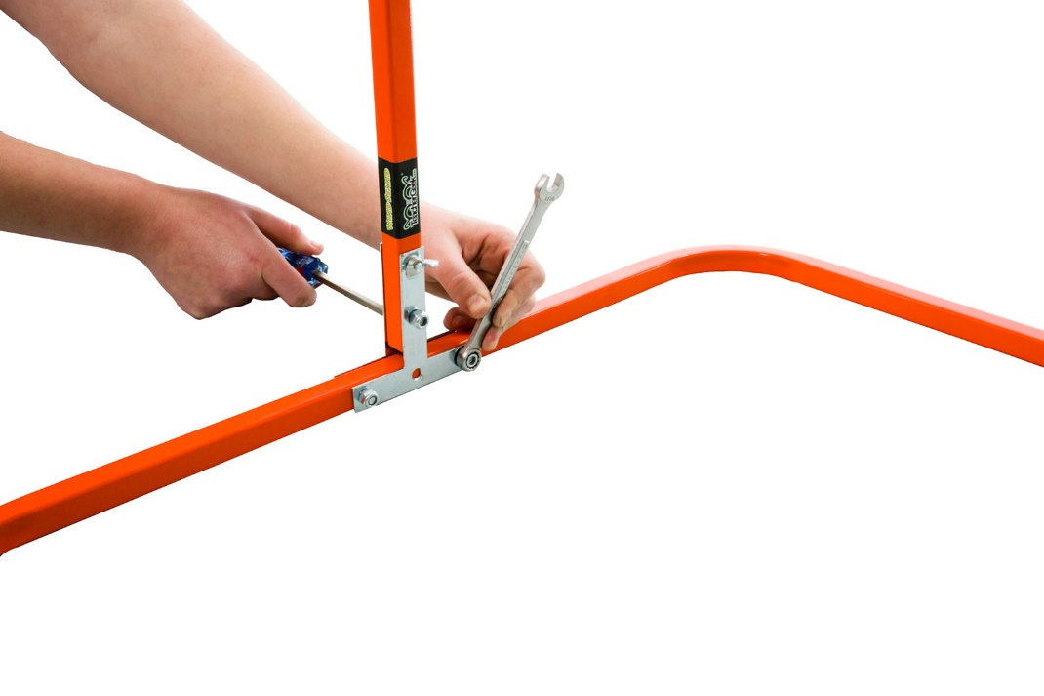

Wing Nut



*Use tools to tighten!*

¼” Nuts

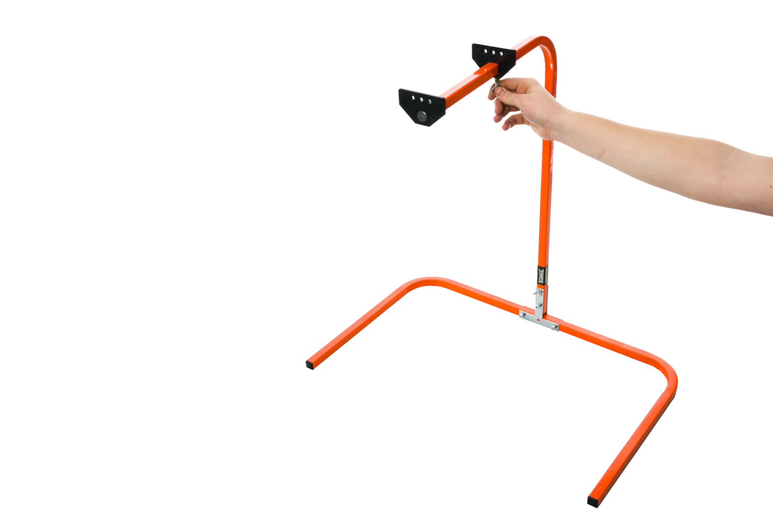



*Slide!*



Clamp

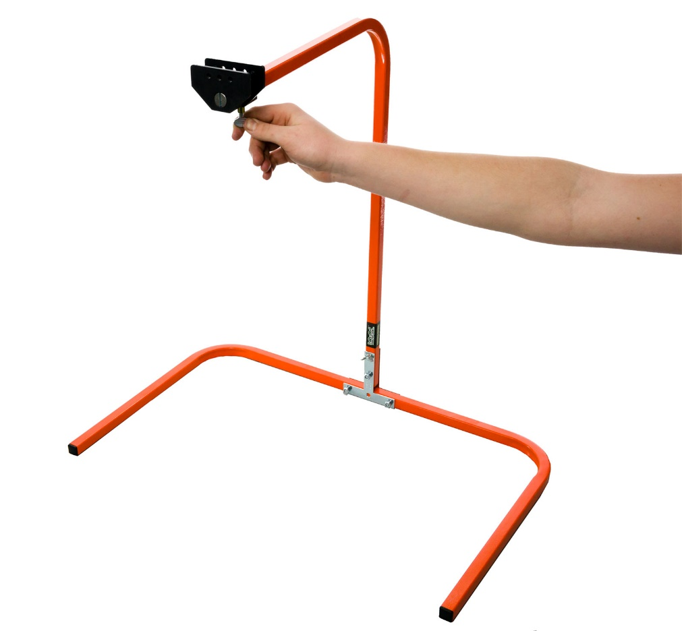



Wing Nut



The **black clamp** is used to mount your projects onto the wind stand. **Loosen** the **wing nut** to **slide** it open or closed.

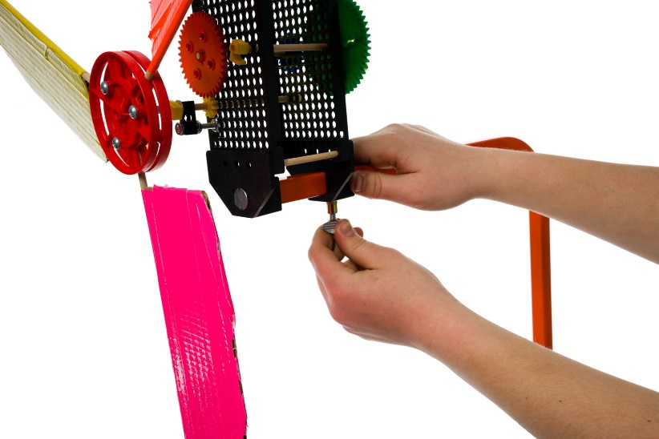

**Mount** your **project** onto the wind stand base by:

Placing the **pegs** (on the   
wind stand clamp) **into hole plate holes** on your project.

**Tightening** the clamp and **thumb** **screw.**

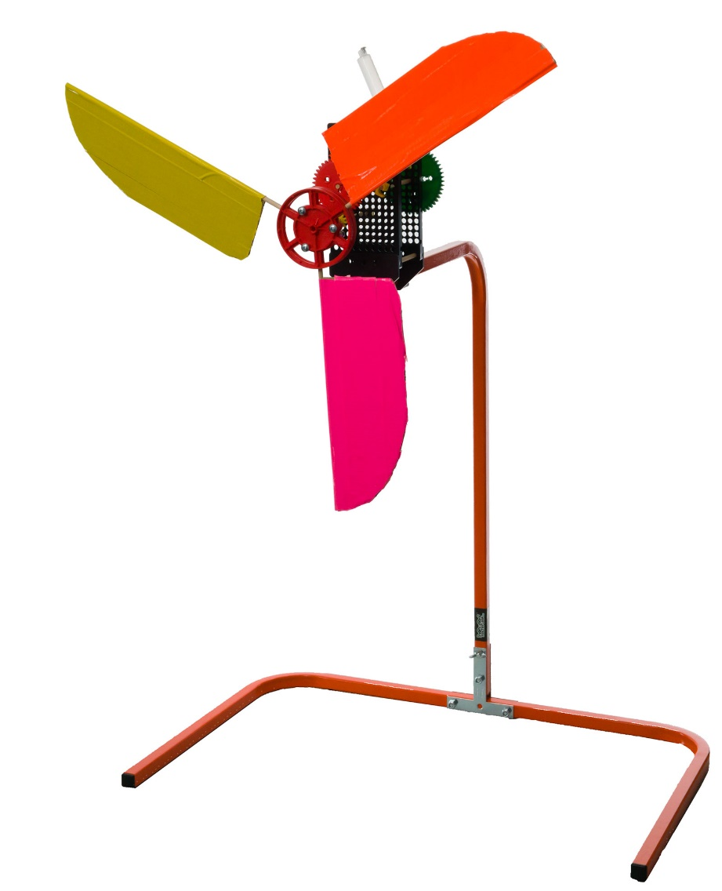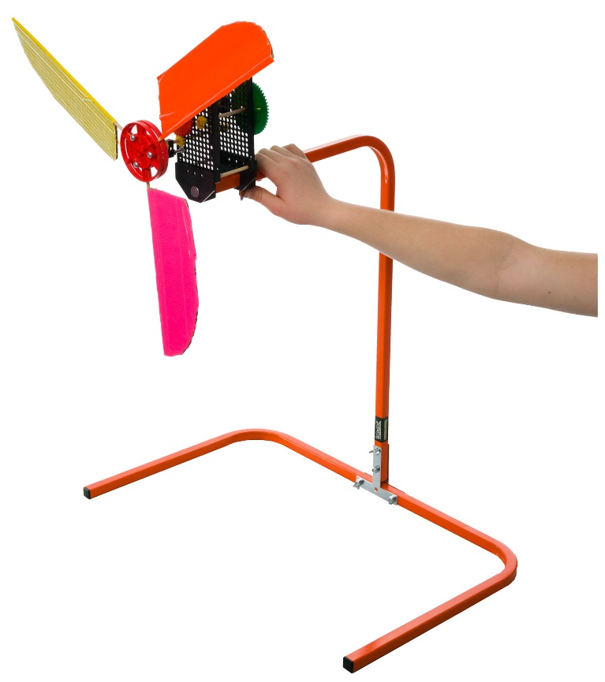

**B**

**A**

Geared   
Wind Turbine

**Congratulations!**Your Wind Stand is now done!  
For more wind turbine and pump activities,   
go to: *teachergeek.org/learn*

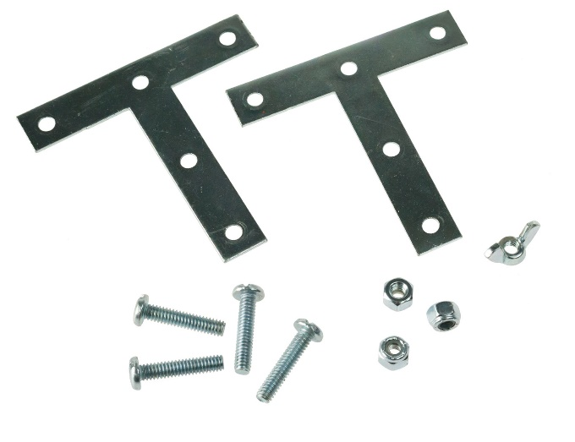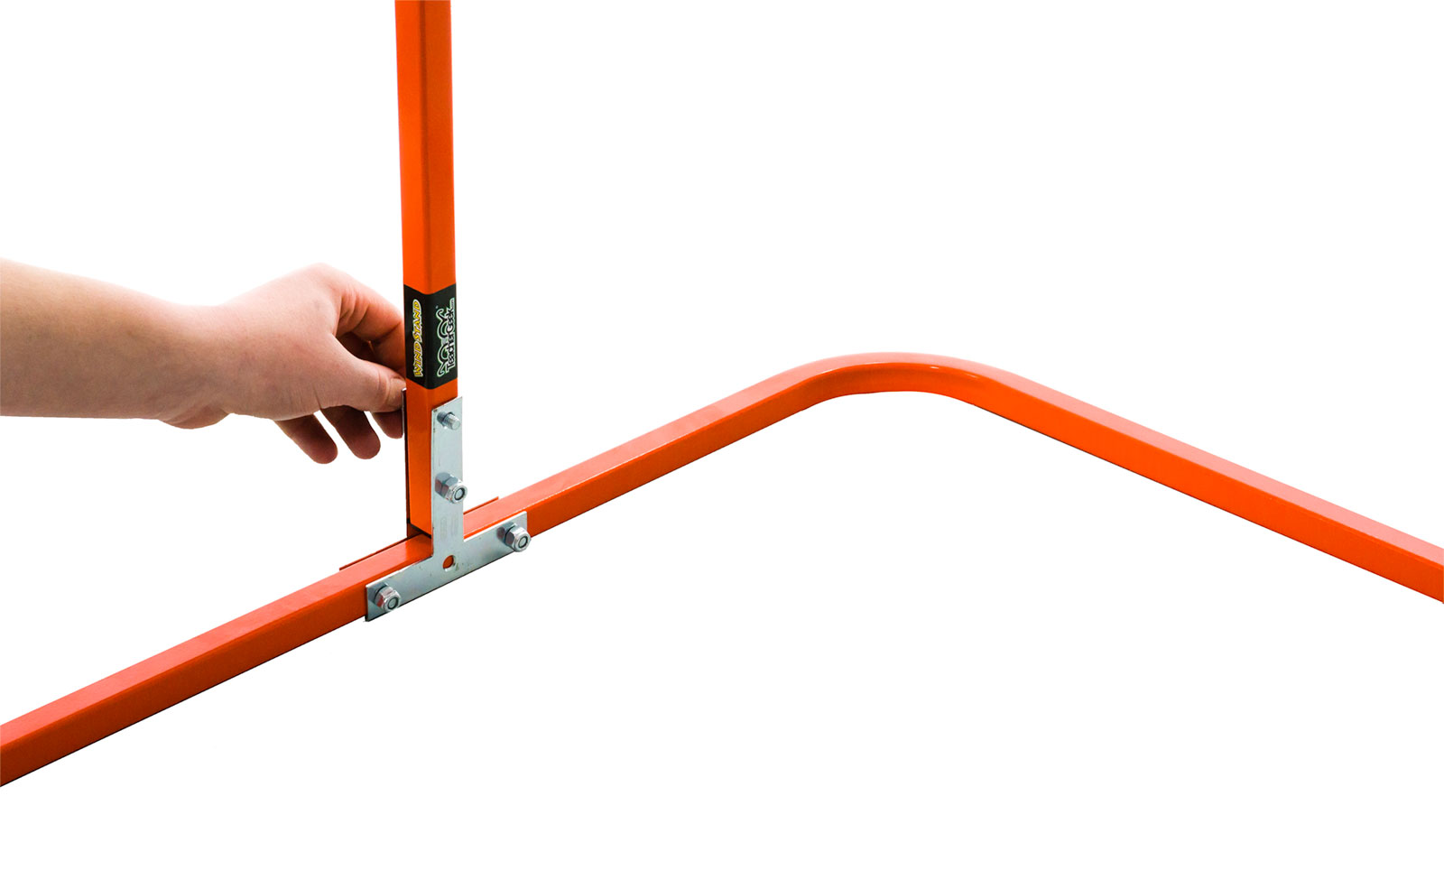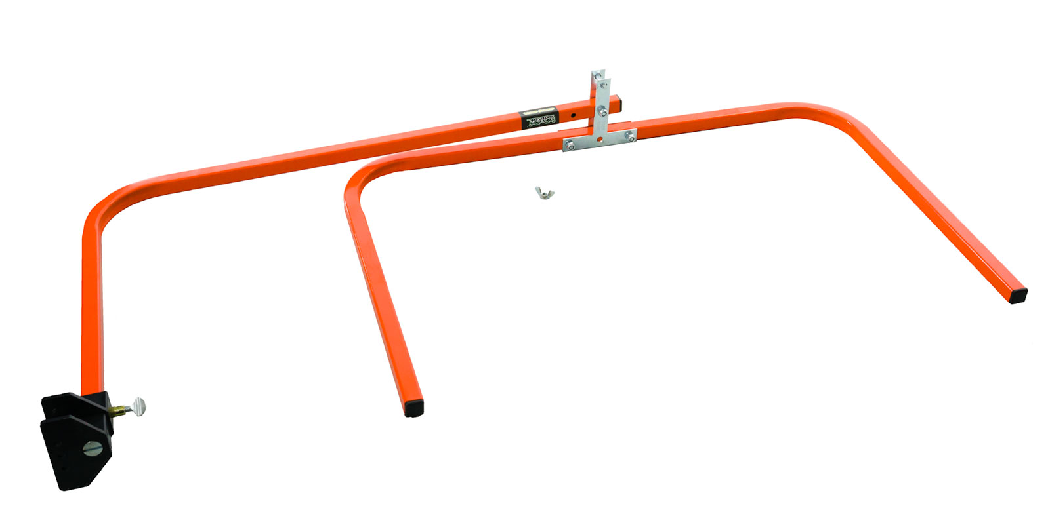****

*Folded!*

**B**

**C**

**A**

**Collapse** the wind stand for storage by:

Loosening and **removing** the **wing nut** and **top screw**.   
  
 **Folding** the **upright** over  
  
 **Reattaching** the **screw** and nut.