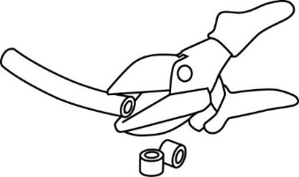



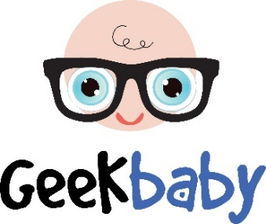

You have been hired by the Geek Baby Company to design and prototype a new pull/push toy. The toy should have features that move when it is rolled.

**Criteria:** (things your design can not, or must, do or be)

The toy should:

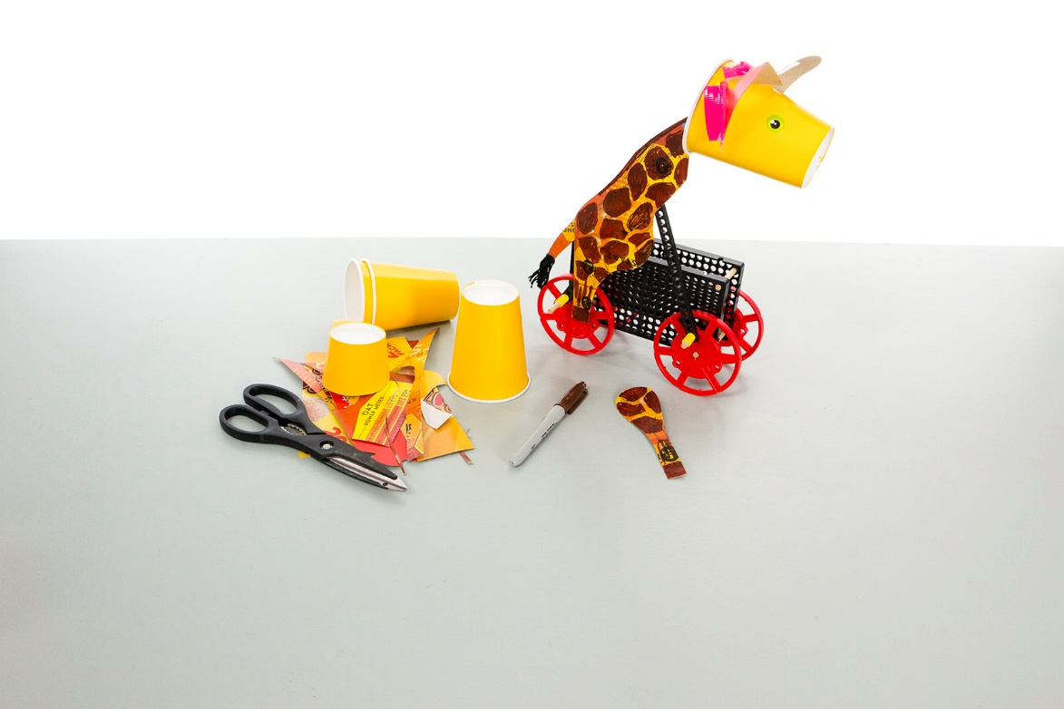

Use recycled packaging, tape, markers, and other materials to make your toy “good looks”.

**Materials:**

* Be fun and innovative
* Use TeacherGeek wheels & linkages
* Function properly and reliably
* Be easy to use
* Be decorated with recycled and other materials (*stickers, markers)*
* Be given a name

**Engineering Design Process:**

You will be using the Engineering Design Process. What does that mean? Your design is never finished (it can always be improved). There is no such thing as a perfect design.

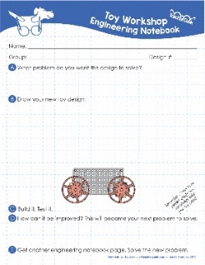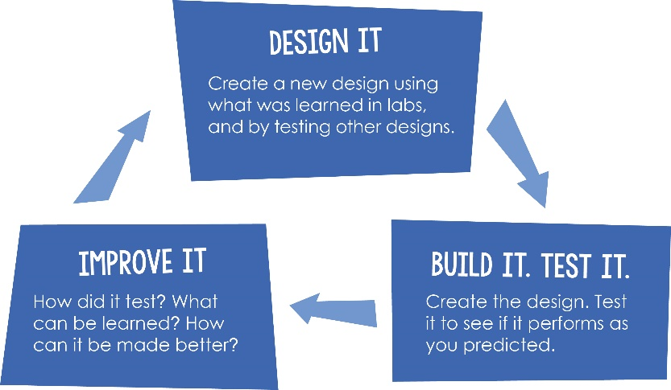

**Page 1**

Fill out a new *Engineering Notebook* page each time you design/redesign your push/pull toy.

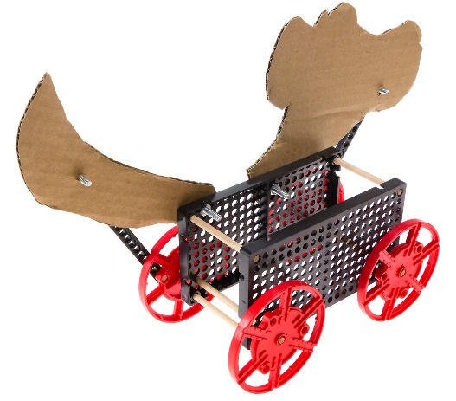

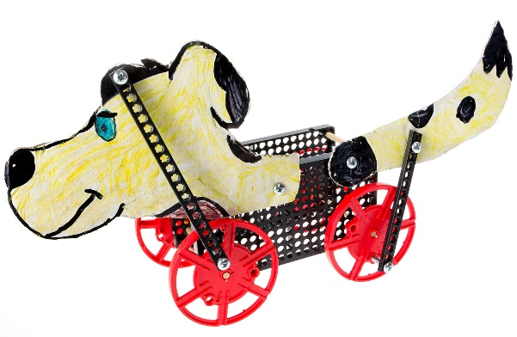

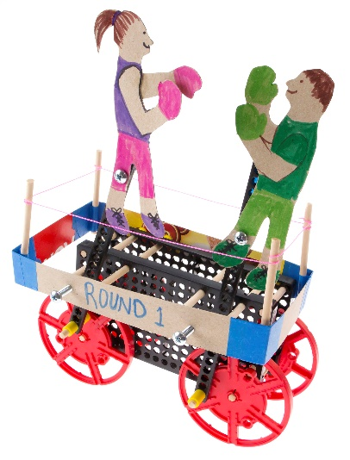

Dog bobs head and wags tail

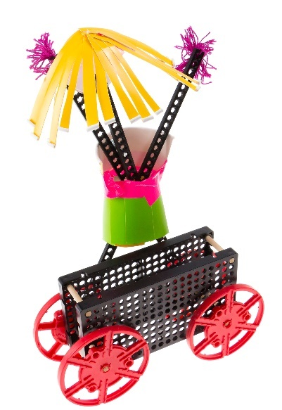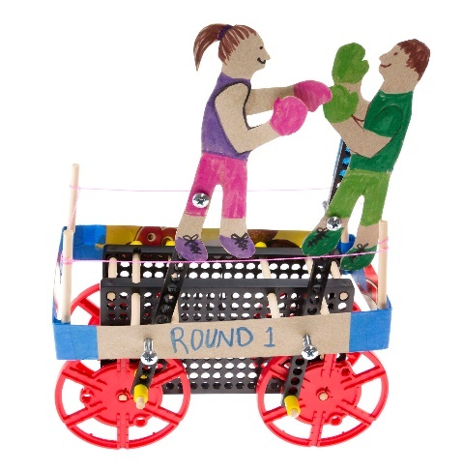

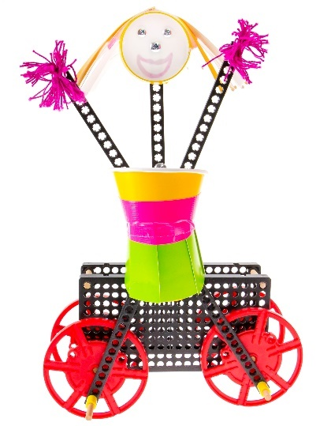

Boxers go up and down,  
forwards and backwards

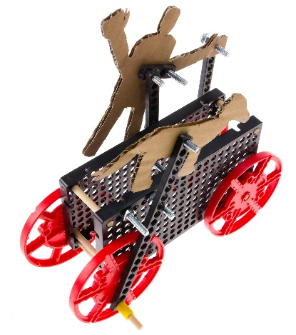

Girl does jumping-jacks   
and head goes from side-to-side

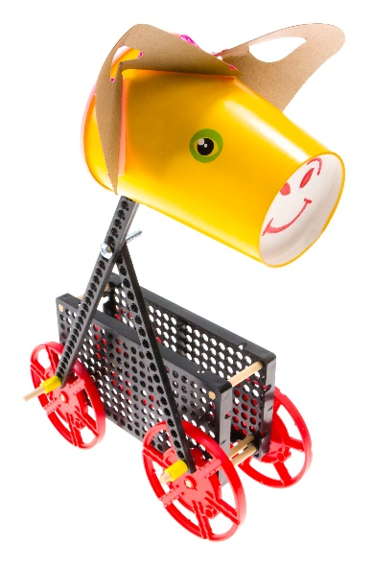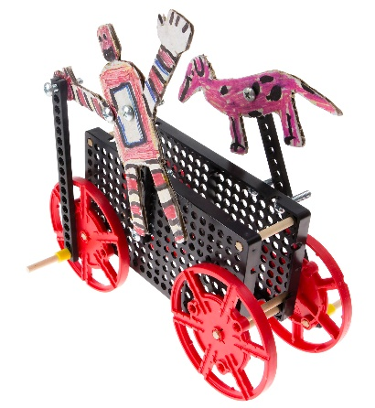

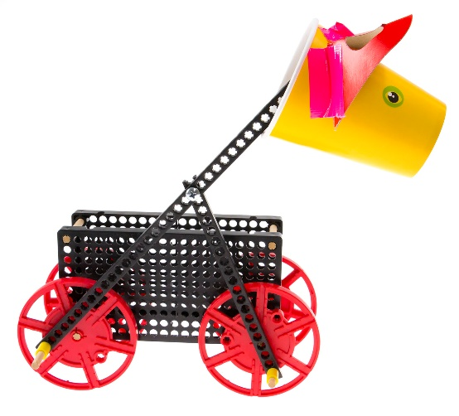

Robot pivots and dog runs

Giraffe runs and moves head