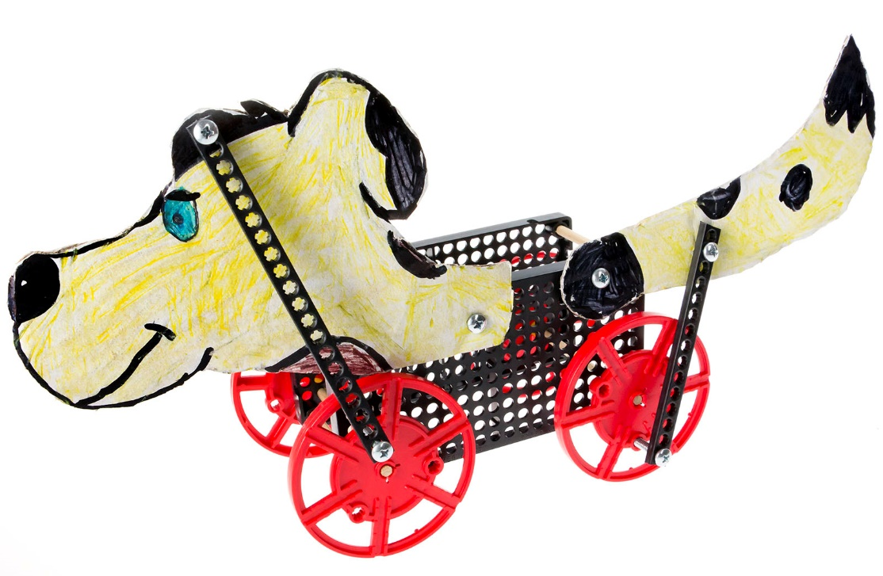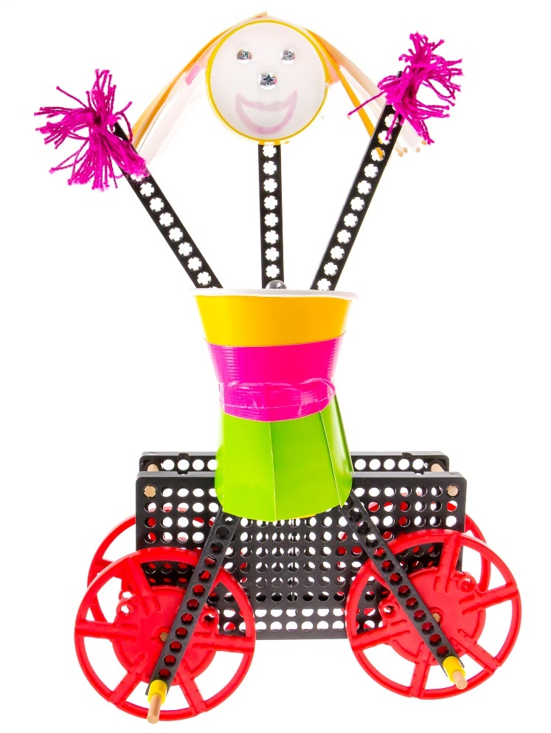

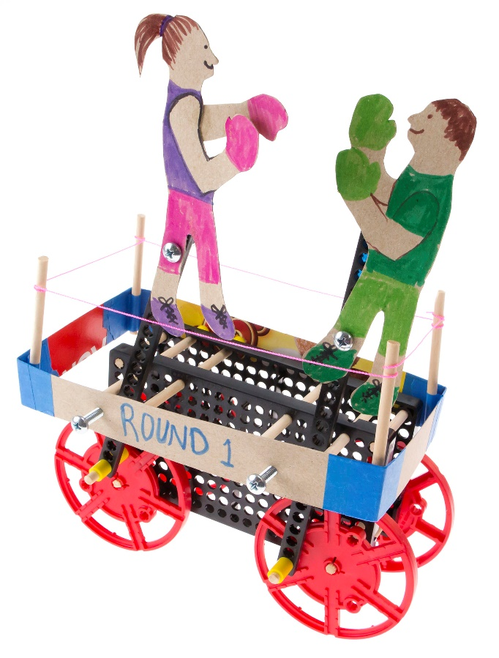

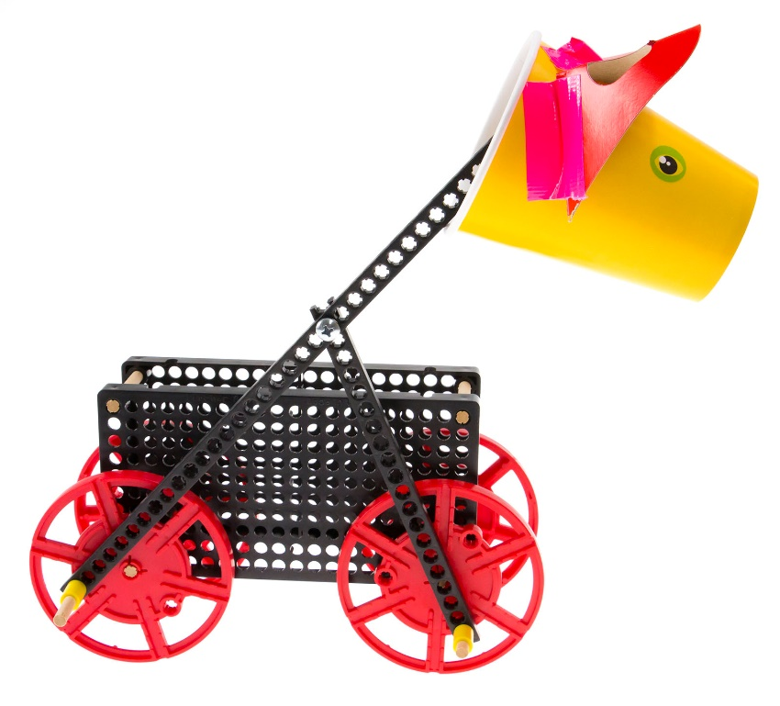



**WARNING!**Small Parts, Choking Hazard,   
For ages 7 and Up.   
Use Only with Adult Supervision.



Gather these components for your pull/push toy.   
Extra components are included to help you to create your own unique design.

|  |  |  |  |
| --- | --- | --- | --- |
|  |  |  |  |
| [**3 - Strips**](https://teachergeek.com/products/rubber-band-racer?variant=344648175) | **[5 - Dowels](https://teachergeek.com/products/rubber-band-racer?variant=344648175)**  [300mm (12in)](https://teachergeek.com/products/rubber-band-racer?variant=344648175) | [**2 - Hole Plates**](https://teachergeek.com/products/rubber-band-racer?variant=344648175) | [**4 - Wheels**](https://teachergeek.com/products/rubber-band-racer?variant=344648175) |
|  |  |  |  |
| **[8 - Screws](https://teachergeek.com/products/rubber-band-racer?variant=344648175)**  [25mm (1in) #10](https://teachergeek.com/products/rubber-band-racer?variant=344648175) | **[4 - Nuts](https://teachergeek.com/products/rubber-band-racer?variant=344648175)**  [#10](https://teachergeek.com/products/rubber-band-racer?variant=344648175) | **[1 - Slide Stop](https://teachergeek.com/products/rubber-band-racer?variant=344648175)**  [10cm (3in)](https://teachergeek.com/products/rubber-band-racer?variant=344648175) |  |



This isn’t a kit. You’re going to really build (*cut, ream, screw*) your Toy.   
Here are tools you’ll need to get started. They can be shared by up   
to four groups at a time.

* *[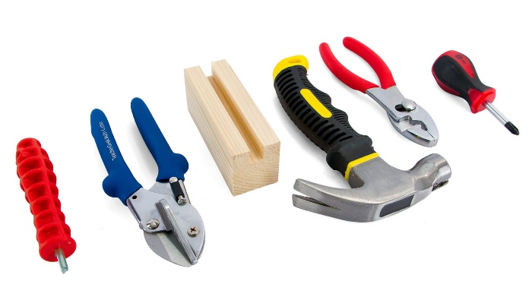](https://teachergeek.com/products/easy-engineering-tool-set?variant=344866731)***TeacherGeek Reamer**
* **TeacherGeek** [**Multi-Cutter**](https://teachergeek.com/products/1823-81)
* **Tapping Block** -Optional
* **Small** [**Hammer**](https://teachergeek.com/products/stubby-claw-hammer)
* **Pliers** -Optional

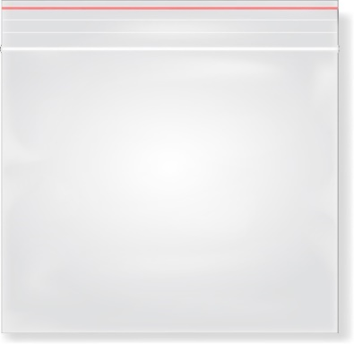

**Tip:** Save all your materials (even what you cut off). Keep them in a bag. They can be used later.

* **Philips** [**Screwdriver**](https://teachergeek.com/products/stubby-2-screwdriver)

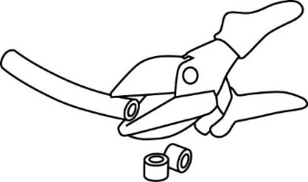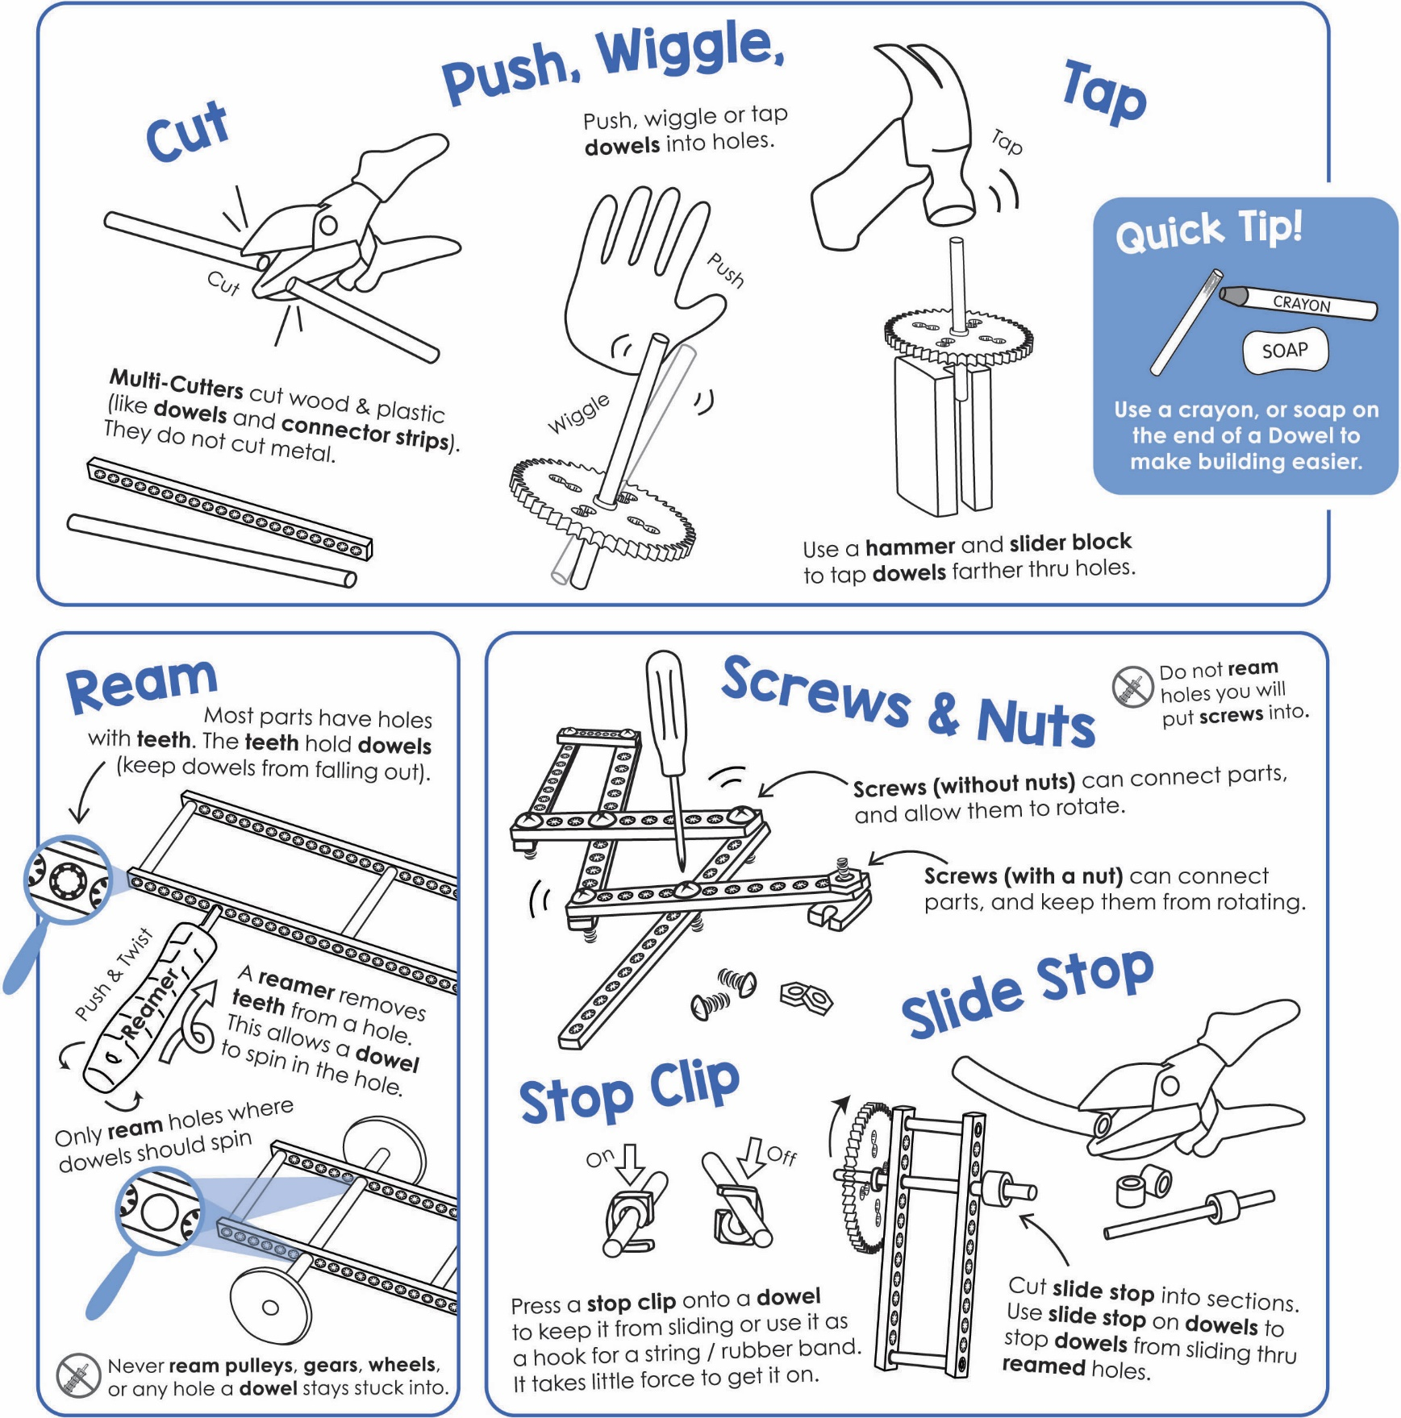

Get individual tools, or the complete  
**TeacherGeek / Maker Tool Set**   
[Single SKU 1823-24](https://teachergeek.com/products/easy-engineering-tool-set?variant=344866731)  
Class Set [SKU 1823-85](https://teachergeek.com/products/easy-engineering-tool-set?variant=344866731)



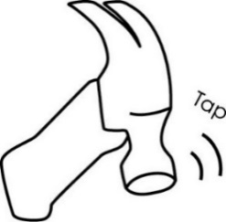



**Tap or push** the **dowels** **into** an upside-down **hole plate**.

**Cut** **four** **10cm** (4in) **dowels**.

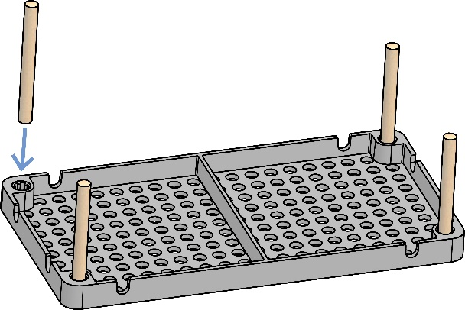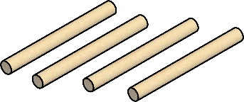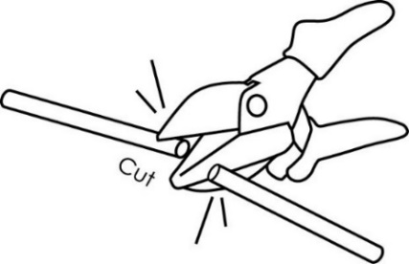

10cm (4in)

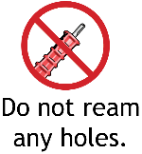

****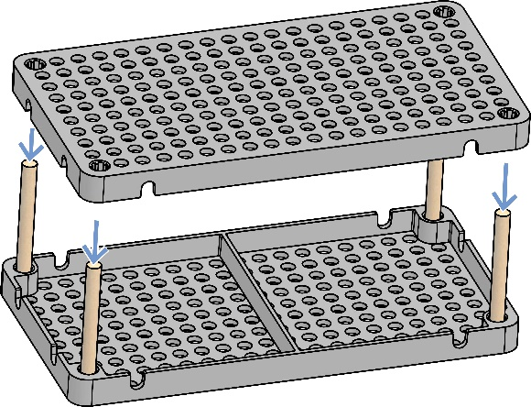

**Congratulations!**

Your **frame** is done.

**Tap or push** a **hole plate**

**onto** the **dowels**.

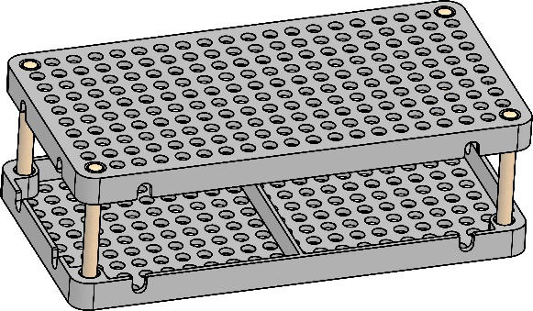



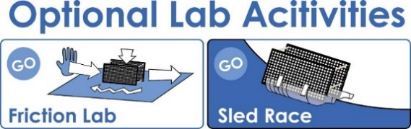

Documents at **teachergeek.com/learn**

If you are going to do the optional Sled Race, it’s now time.

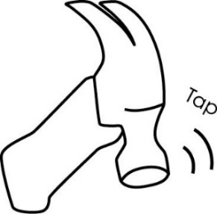



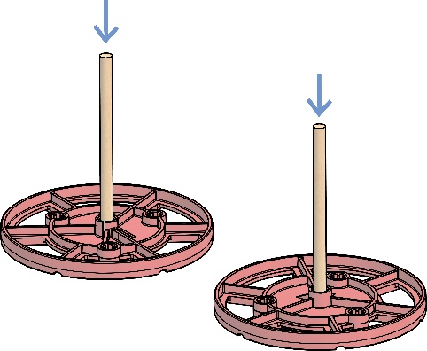****

**Push or tap** the two dowel **axles** into **wheels**.

**Cut two** **13cm** (5in) **dowels**. These will become **axles** for your wheels.

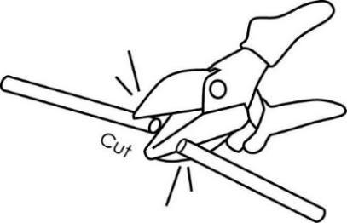

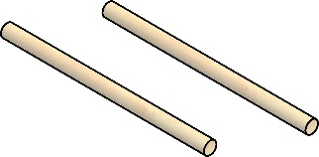



13cm (5in)



A) **Cut two 3cm** (1in) **dowels**.

B) **Push or tap** the **dowels into   
 wheels**, as shown.

**Place** the **axles** **into** the **frame**.

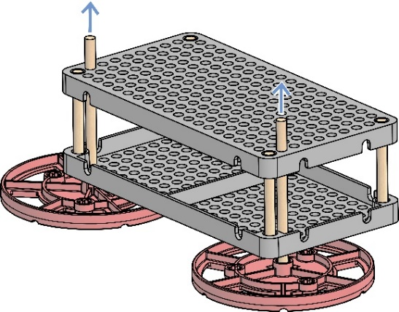

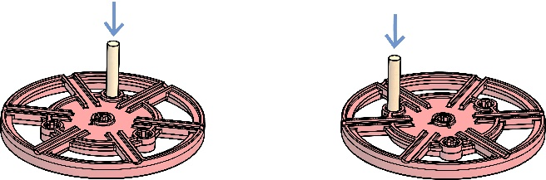

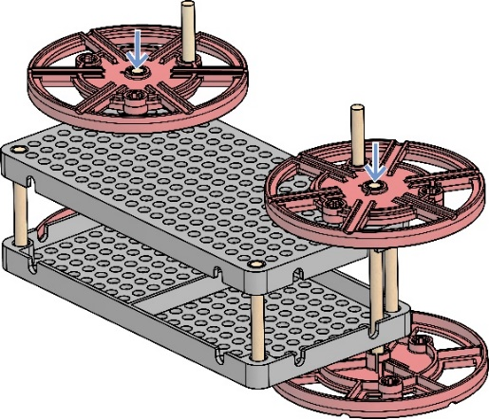

**Congratulations!** Your toy can roll. Give it a push.

Push or tap two **wheels** onto the other side of the **axles**.

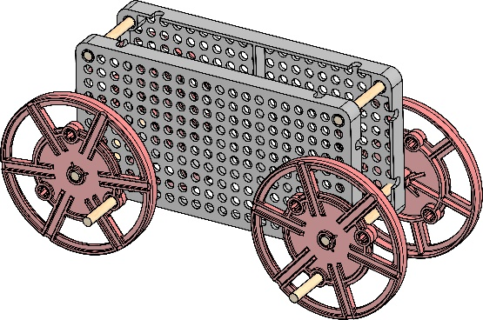

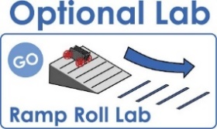

If you are going to do the optional Ramp Roll Lab, it’s now time.

Documents at **teachergeek.com/learn**

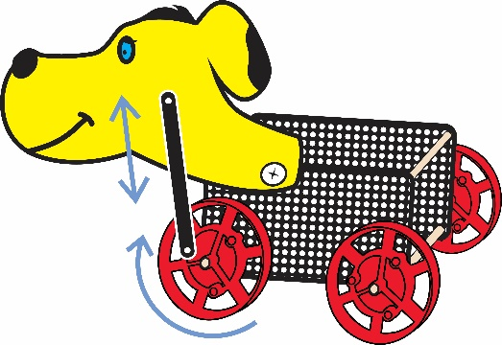

**Linkages** are mechanisms which

allow force or motion to be

directed where it is needed.

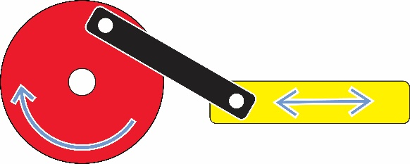

**Rotary Motion** (spinning wheel)

**Linkage**

**Reciprocating Motion** (back and forth)

Linkages can be used to change:

* The direction of motion
* The type of motion
* The size of a force



**Cut** one **strip in half**.



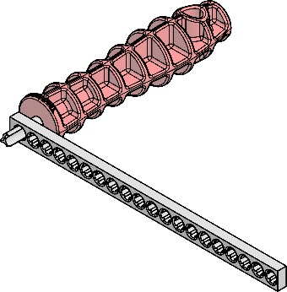A) **Gather** the **two half strips** (from Step #9), and **two full strips**. B) **Ream one end hole** on **each strip**.





**Cut** **two 1cm** (1/2in) **slide stop** sections.

**Attach** a **half strip to** a **wheel**, as shown.Make sure the dowel goes through the **reamed** **hole** in the strip.Use **slide stop** to keep the strip from falling off.

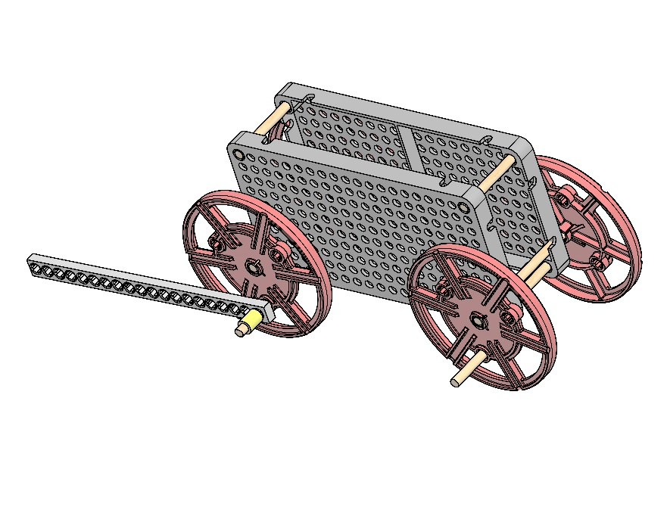



**Roll** the toy frame on a table or floor. **Notice** the **motion of linkage** (strip).

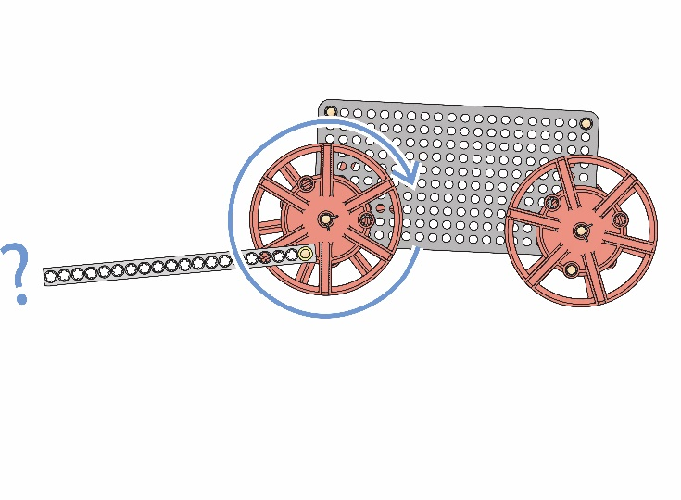



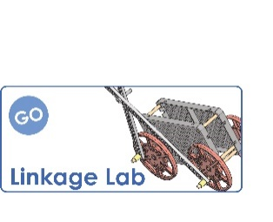

Documents at **teachergeek.com/learn**

If you are going to do the optional **Linkage Lab**, it’s now time.



**Experiment** by creating and testing **different linkage** **mechanisms**.   
Add another linkage. Connect linkages together. Here are a few examples:

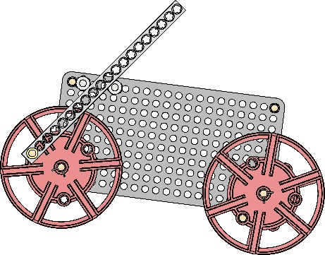

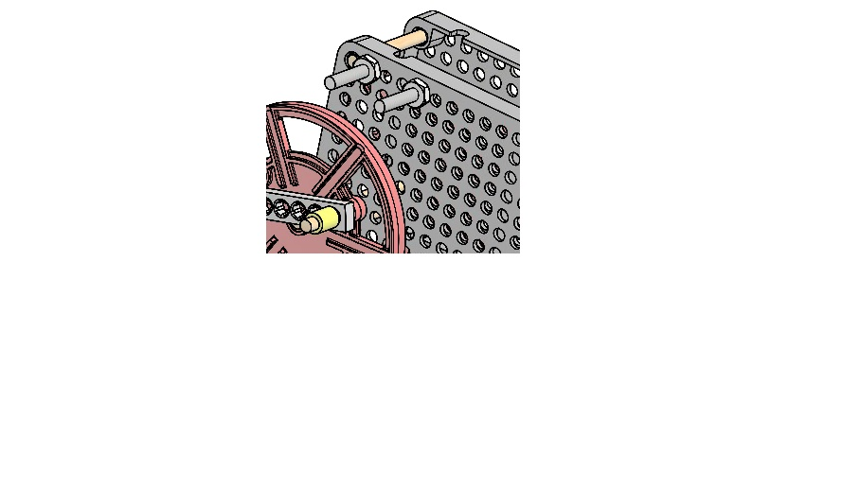

Use **two screws** & **nuts** to hold the linkage upright

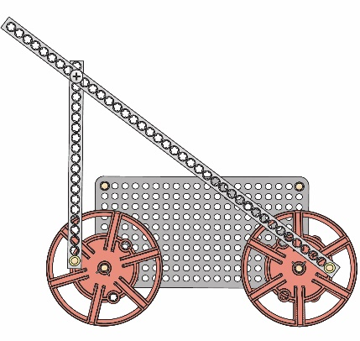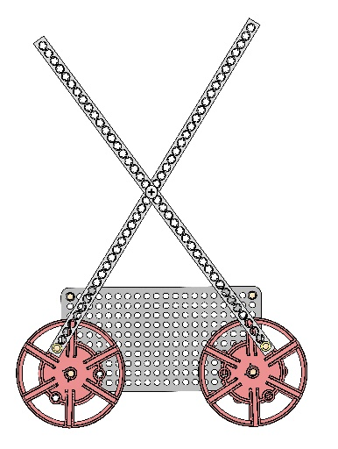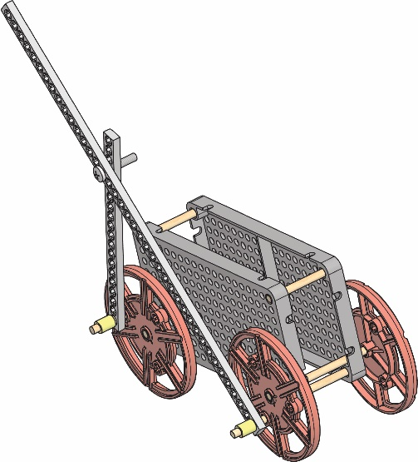

Use a section

of **slide stop**, to

**attach** another

**strip** to a wheel.

Make sure the

dowel goes through the **reamed** strip **hole**.



**Create** a **joint** by **turning** a **screw** **through** the **linkages**. **Do not ream** the linkage (strip) holes. They should be able to rotate.



You have been hired by the Geek Baby Company to design and prototype a new pull/push toy. The toy should have features that move when it is rolled.

**Criteria:** (things your design can not, or must, do or be)

The toy should:

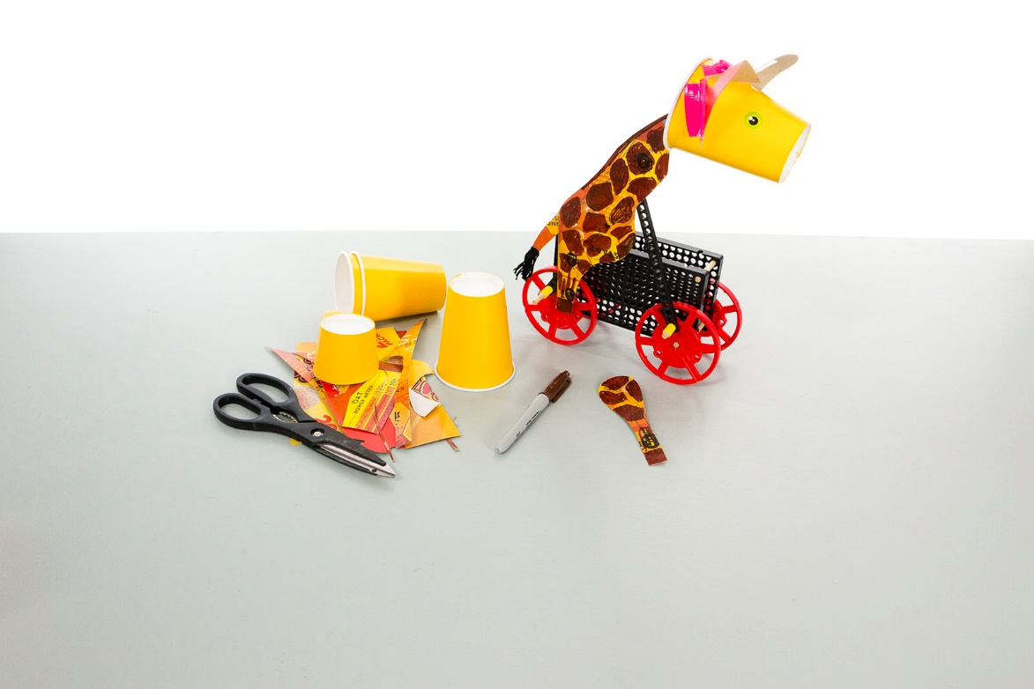

Use recycled packaging, tape, markers, and other materials to make your toy “good looks”.

**Materials:**

* Be fun and innovative
* Use TeacherGeek wheels & linkages
* Function properly and reliably
* Be easy to use
* Be decorated with recycled and other materials (*stickers, markers)*
* Be given a name

**Engineering Design Process:**

You will be using the Engineering Design Process. What does that mean? Your design is never finished (it can always be improved). There is no such thing as a perfect design.

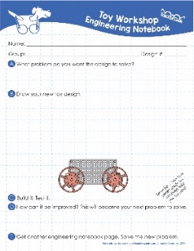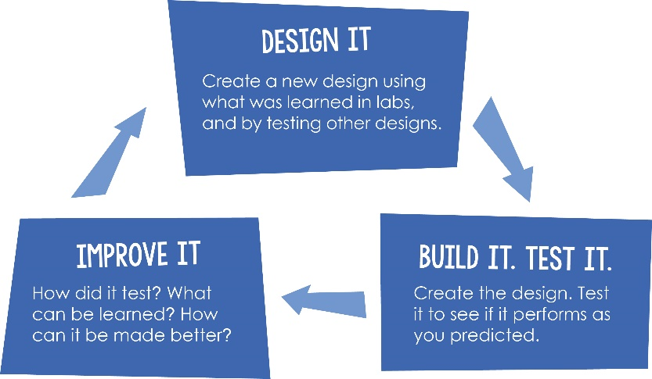

Fill out a new *Engineering Notebook* page each time you design/redesign your push/pull toy.

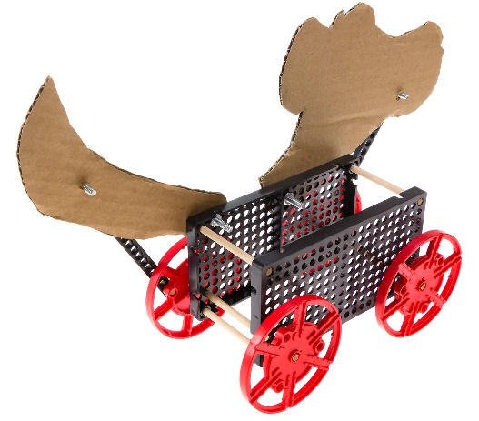

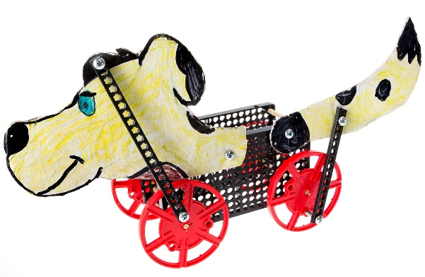

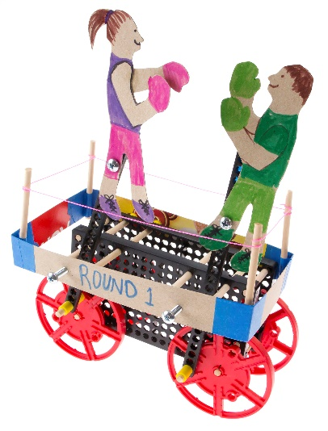

Dog bobs head and wags tail

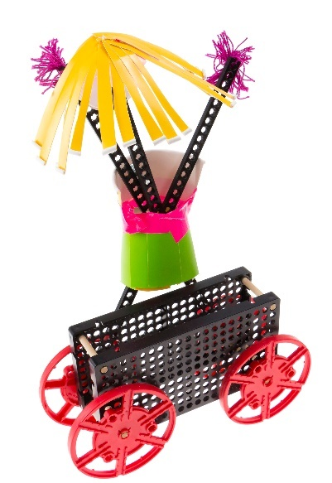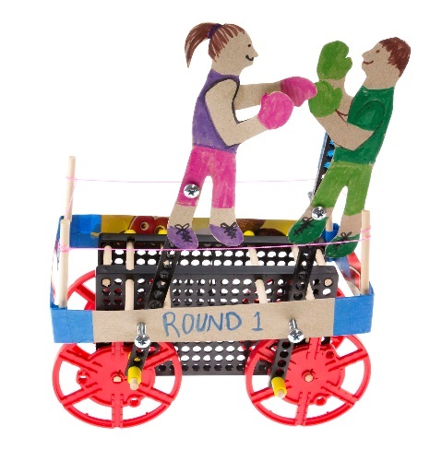

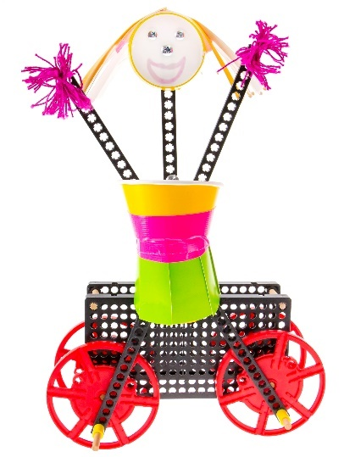

Boxers go up and down,  
forwards and backwards

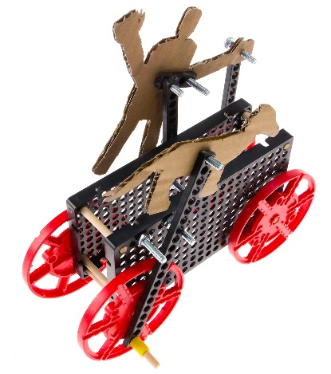

Girl does jumping-jacks   
and head goes from side-to-side

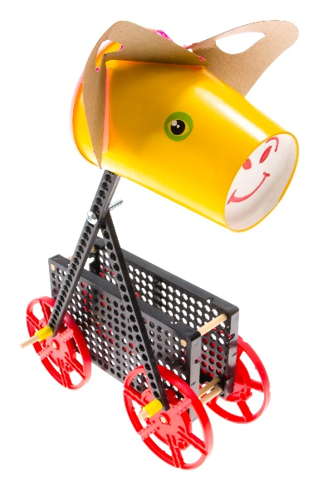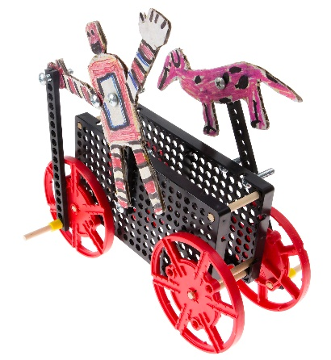

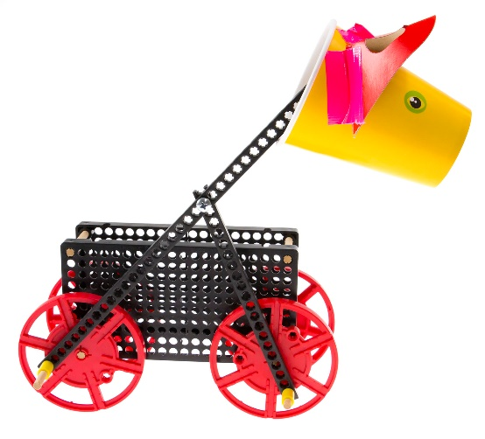

Robot pivots and dog runs

Giraffe runs and moves head