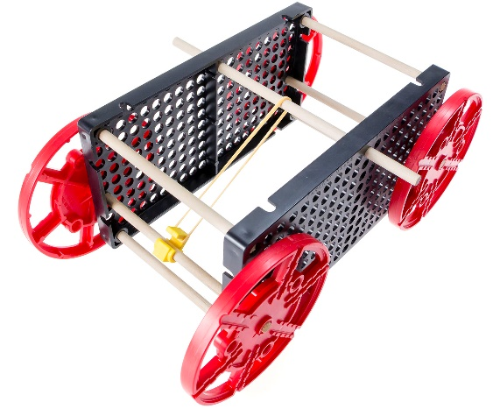

  
**THINKING AHEAD** *What happens when you   
change the shape of your   
racer’s body?*

Download Documents and get your supplies at[teachergeek.com](https://teachergeek.com/)

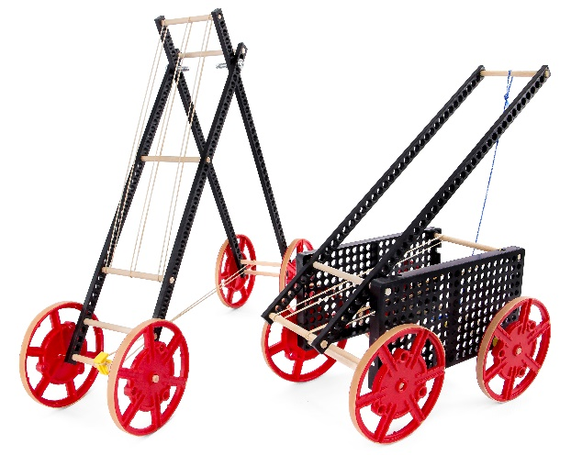 **Recommended Age level:**

Activity Age Level: 9-18

Lab Age Level: Grades 4-12

Recommended Group Size: 3-4



Engineer a Rubber Band Racer that can roll the fastest or farthest on ramps of   
different materials. Start by building the example Rubber Band Racer in the **Build Guide**.   
Learn about forces and concepts like torque and friction by completing the optional **Labs**.   
Then, design and build your own Rubber Band Racer to compete in **Engineering Challenges**.



What’s unique about this, and other TeacherGeek activities?

This is a **True STEM/Engineering** activity. It allows kids to:

* *Tinker and experiment*
* *Grow understanding through experimentation and labs*
* *Isolate variables and utilize the scientific method*
* *Apply math and science concepts*
* *Create their own unique designs to become innovators.*

Every project turns out different, and evolves with their understanding. When you create a project using TeacherGeek, the data works (it’s usable). This allows  
kids to apply the math and science, see the results,   
and experience “I-get-it” moments (understanding   
*why* they need the math/science and *what* it does).

Adapted from Bloom’s Taxonomy



**Make It Your Own:** The documents for this activity are available in   
**PDF** and **Microsoft Word format**. If you wish to edit a document,   
simply download the Microsoft Word format.



**Next Generation Science Standards:**

**Forces & Interactions**

* **K-PS2-1:** Plan & conduct an investigation to compare the effects of different strengths or different directions of pushes & pulls on the motion of an object.
* **K-PS2-2:** Analyze data to determine if a design solution works as intended to change the speed or direction of an object with a push or a pull.

**Energy**

* **4-PS3-1: Use evidence to construct an explanation relating the speed of an object to the energy of that object.**
* **4-PS3-3: Ask questions and predict outcomes about the changes in energy that occur when objects collide.**

**Motion and Stability: Forces and Interactions**

* **MS-PS2-1: Apply Newton's Third Law to design a solution to a problem involving the motion of two colliding objects.**
* **MS-PS2-3: Develop a model to describe that when the arrangement of objects interacting at a distance changes, different amounts of potential energy are stored in the system.**
* **MS-PS3-4: Plan an investigation to determine the relationships among the energy transferred, the type of matter, the mass, and the change in the average kinetic energy of the particles as measured by the temperature of the sample.**
* **MS-PS3-5: Construct, use, and present arguments to support the claim that when the motion energy of an object changes, energy is transferred to or from the object.**

**Engineering Design**

* **K-2-ETS1-1:** Ask questions, make observations, and gather information about a situation people want to change to define a simple problem that can be solved through the development of a new or improved object or tool.
* **K-2-ETS1-2:** Develop a simple sketch, drawing, or physical model to illustrate how the shape of an object helps it function as needed to solve a given problem.

**Learning Outcomes**

As a result of this challenge, students will have:

* Engineered, constructed and tested a rubber band powered vehicle
* Measured distance and calculated speed
* Tested and refined their designs
* Communicated their design process and results

**ITEEA Standards:**

* The Designed World (16)
* The Nature of Technology (1, 2)
* Design (8, 9, 10)
* Abilities for a Technological World (11, 12)

**National Science Standards:**

* **Content Standard B, Physical Science**. Students shall develop an understanding of properties of objects and materials (K-4); motions and forces (5 -12).
* **Content Standard F, Science in Personal and Social Perspective**. Risks and benefits; science and technology in society (5-8)
* **Content Standard A, Science as Inquiry**. As a result of these activities, students should develop abilities necessary to do scientific inquiry (K-12)
* **Content Standard G: History and Nature of Science**. Science as human endeavor (K-4); history of science (9 -12).



* **Force**: a push or pull upon an object.
* **Friction**: resistance of motion between two objects.
* **Energy**: is the ability to do work.
* **Kinetic Energy**: an object in motion.
* **Potential Energy**: an object held in a position (at rest) has potential energy.
* **Gravity:** A force that attracts an object to the center of the earth.
* **Mechanical Advantage**: trading force for distance.
* **Precision**: the closeness of two or more measurements to each other.
* **Accuracy**: how close a result comes to the “true value” (previously known standard).
* **Distance**: how far apart two objects are.
* **Speed**: how quickly something is moving, or being done.
* **Terrain**: the ground, and the characteristics of how it looks, feels and responds.



Below is the list of “ingredients” you’ll need for each Advanced Rubber Band Racer build.

|  |  |  |  |  |
| --- | --- | --- | --- | --- |
|  |  |  |  |  |
| [**6 - Connector Strips**](https://teachergeek.com/products/rubber-band-racer?variant=344648175) | **[8 - Dowels](https://teachergeek.com/products/rubber-band-racer?variant=344648175)**  [300mm (12″)](https://teachergeek.com/products/rubber-band-racer?variant=344648175) | [**2 - Hole Plates**](https://teachergeek.com/products/rubber-band-racer?variant=344648175) | [**4 - Wheels**](https://teachergeek.com/products/rubber-band-racer?variant=344648175) | [**2 - Stretch Tires**](https://teachergeek.com/products/rubber-band-racer?variant=344648175) |
|  |  |  |  |  |
| **[4 - Screws](https://teachergeek.com/products/rubber-band-racer?variant=344648175)**  [#10 1″](https://teachergeek.com/products/rubber-band-racer?variant=344648175) | **[4 - Nuts](https://teachergeek.com/products/rubber-band-racer?variant=344648175)**  [#10](https://teachergeek.com/products/rubber-band-racer?variant=344648175) | **[1 - Slide Stop](https://teachergeek.com/products/rubber-band-racer?variant=344648175)**  [100mm (3″)](https://teachergeek.com/products/rubber-band-racer?variant=344648175) | [**1 - Stop Clip**](https://teachergeek.com/products/rubber-band-racer?variant=344648175) | [**10 - Rubber Bands**](https://teachergeek.com/products/rubber-band-racer?variant=344648175) |



This isn’t a kit. You’re going to really build (cut, ream, screw) your Racer.   
Here are tools you’ll need to get started.   
They can be shared by up to 4 groups at a time.

* *[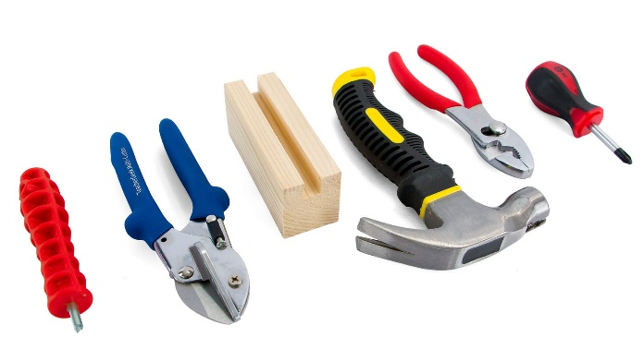](https://teachergeek.com/products/easy-engineering-tool-set?variant=344866731)***TeacherGeek Reamer**
* **TeacherGeek** [**Multi-Cutter**](https://teachergeek.com/products/1823-81)
* **Tapping Block** - Optional
* **Small** [**Hammer**](https://teachergeek.com/products/stubby-claw-hammer)
* **Pliers** - Optional



**Tip:** Save all your materials (even what you cut off). Keep them in a bag. They can be used later.

* **Philips** [**Screwdriver**](https://teachergeek.com/products/stubby-2-screwdriver)

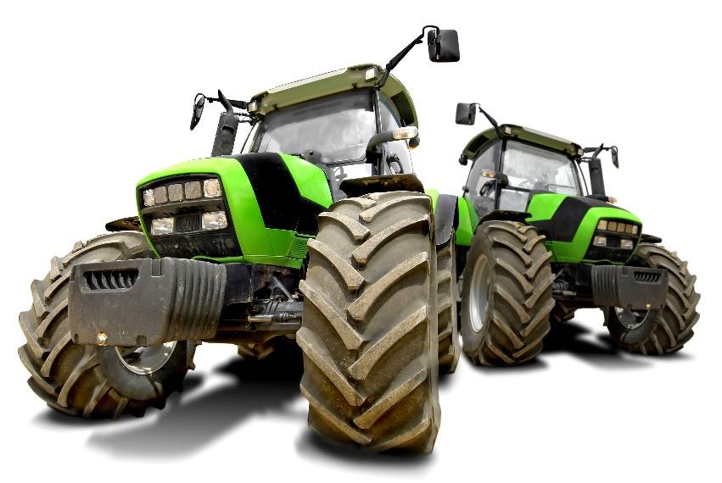



Did you know cars come in all shapes and sizes, each design serving a different purpose? A race car needs plenty of acceleration and   
a light-weight body for quick turns down the track. Industrial vehicles, like these tractors, travel over rocky **terrain** to tend crops.   
Their tire surface increases **traction** (grip).

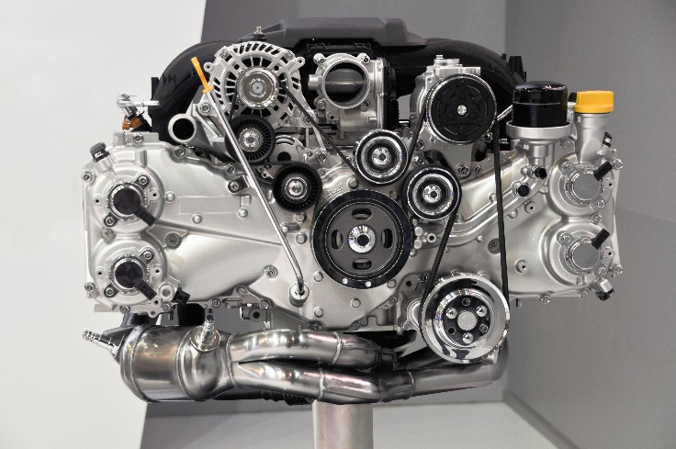

Cars weigh a lot more now than they did in the past. The average new car weighed 3,221 lbs. in 1987 but by 2010, that average was over 4,000 lbs. They require more **force** to get moving. One way to increase this “push” is through **torque**.

This twisting force causes **rotation**, which powers the crankshaft. There’s torque in your **Rubber Band Racer** too – the twist of the rubber bands.

Not all vehicles are lifting giant loads however.  
Some just need to get from here to there, as quickly as possible. Formula One racers use high  **speeds** to traverse the **distance** of their track.  
  
One of the fastest legal cars in the world, the **Hennessey Venom GT**, can go up to 270 mph. *That takes quite a few rubber bands!*





Pick and choose which resources will work for your design.  
Available as links below, or at [teachergeek.com/learn](https://teachergeek.com/blogs/projects).

**Rubber Band Racer Documents**

* Classroom Overview - This is it (you’re reading it).
* **Build Guide - Required**
  + [Basic Build Guide](http://teachergeek.org/rubber_band_basic_build_guide.pdf)– Required
    - During this step you will make the *Example Rubber Band Racer*.
  + Advanced Build Guide([Grades 2-6 version](https://teachergeek.org/rubber_band_advanced_build_guide_elementary_v1.0.pdf) or [Grades 7-12 version](https://teachergeek.org/rubber_band_advanced_build_guide_secondary_v1.0.pdf))– Required
    - During this step you will make the *Example Rubber Band Racer*.
* **Lab Activities -** **Optional**
  + [Forces & Friction Lab](http://teachergeek.org/force_friction_lab.pdf) – Optional
    - Students investigate forces and friction.
  + [Ramp Roll Lab](http://teachergeek.org/ramp_roll_lab.pdf)– Optional
    - Students test their racers and traction without wheels.
* **Design & Engineering Challenges - Optional**
  + [Sled Race Challenge](http://teachergeek.org/sled_race_challenge.pdf)
    - Slide down a ramp and travel the farthest distance.
  + [Long Shot Challenge](http://teachergeek.org/long_shot_challenge.pdf)
    - Redesign your racer to go as far as possible.
  + [Sprint Challenge](http://teachergeek.org/sprint_challenge.pdf)
    - Redesign your racer to break a speed record, or win a race
  + [Target Challenge](http://teachergeek.org/target_challenge.pdf)
    - Redesign your racer to accurately reach a target distance.
* **Immersive Challenge Presentation – Optional**
  + [Mars Rescue Mission Presentation](https://teachergeek.org/Rubber%20Band%20Racer%20Mars%20Scenario.pptx)
    - A fully immersive set of engineering and design challenges inspired by NASA’s Mars Rover Expeditions.

**Rubber Band Racer Videos**

* [TeacherGeek Rubber Band Racer Build](https://youtu.be/nBq4Vij7lvo)—Youtube Video

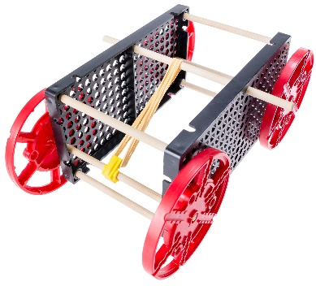[](https://teachergeek.com/blogs/projects/sail-car-activity)

There are many optional Labs for Rubber Band Racers.   
Links in the Build Guide indicate when during the building process

these Labs and Challenges can be completed, if you want to.  
Once finished, you can download the Target or Racer Challenges   
and [Engineering Notebook](http://teachergeek.org/engineering_notebook.pdf) sheets to take your designs to the next level.   
Documents are available as links below or at [**teachergeek.com/learn**](https://teachergeek.com/blogs/projects/wiggle-bots).

**Build Guide — Required**

During this step you will create the components of your example Rubber Band Racer. Links throughout the Build Guide indicate optional Labs and Challenges to test your creation at various points of the Design Process. The Basic and Advanced Build Guides correspond to the Rubber Band Racer set purchase of your choice.  
[Download the Basic Build Guide](http://teachergeek.org/rubber_band_basic_build_guide.pdf)[Download the Advanced Build Guide](http://teachergeek.org/rubber_band_advanced_build_guide.pdf)

**[](http://teachergeek.org/wind_lift_LS_build_lab_3-12.pdf)**

**Lab Activities — Optional**

**Forces & Friction Lab**

This Lab allows students to explore the impact of force and friction upon   
their racer frames. Through experimentation and observation, they will apply   
forces through pushing, pulling, blowing and any other method they can brainstorm.

**Instructions:**

* + Discuss the following concepts with your students.   
    Ask them to provide describe, define, and/or give examples for each:
    - Force
    - Friction
    - Gravity
    - Newton’s First Law
    - Hypothesis
  + Distribute Lab sheets. Explain the lab procedure and let them get to work.

[Download the Forced & Friction Lab](http://teachergeek.org/force_friction_lab.pdf)

**Ramp Roll Lab**

Students experiment with potential and kinetic forces as they roll their racers down a ramp. They will note the nature of work and how gravitational potential is altered by changes in height and mass, as well as note graphing correlations and relationships.

**Instructions:**

* + Discuss the following concepts with your students.   
    Ask them to describe, define, and/or give examples for each:
    - Work
    - Potential/Kinetic Energy
    - Gravity
    - Variance
  + Discuss the concept of graphing. Why do we organize data? What is the nature of variance and consistency in graphing?
  + Distribute Lab sheets. Explain the lab procedure and let them get to work.

[Download the Ramp Roll Lab](http://teachergeek.org/ramp_roll_lab.pdf)

**Engineering Challenges - Optional**  
Engineering Challenges work by immersing students in the Engineering Design process. Learn more about the Engineering Design Process on the next page.

[*Download the Engineering Notebook Sheets*](http://teachergeek.org/engineering_notebook.pdf)

**Sled Race Challenge**

Create a sled that will slide down the ramp and travel the farthest distance.   
Attach different materials to the bottom to explore the effects of friction.

**Long Shot Challenge**

*You may win by a long shot.* Redesign your racer to go as far as possible.   
Then, experiment by adding mass and noting the impact it has on acceleration.

**Target Challenge**Redesign your Rubber Band Racer to roll towards and stop on, a target distance. Students will learn about force, distance and accuracy as they aim for the bullseye!

**Sprint Challenge**

*Ready, Set, Go!*Redesign your racer to break a speed record, or win a race.

[Download the Rubber Band Racer Engineering Challenges](https://teachergeek.com/blogs/projects/rubber-band-racer)

**Immersive Challenge Presentation - Optional**  
Immersive Challenges allow your design to solve real world engineering problems.   
Be transported into exciting scenarios from the surface of Mars to the deepest reaches   
 of the ocean, utilizing the design and engineering process all the while.

**Mars Rescue Mission** Immerse yourself in an Engineering Challenge inspired by NASA's Mars Rover expeditions and design scenarios. Your racer is a Mars Rover, attempting to successfully land, navigate   
and transport specimens on the alien planet's surface.   
  
[Download the Mars Rescue Mission Challenge Presentation](https://teachergeek.org/Rubber%20Band%20Racer%20Mars%20Scenario.pptx)

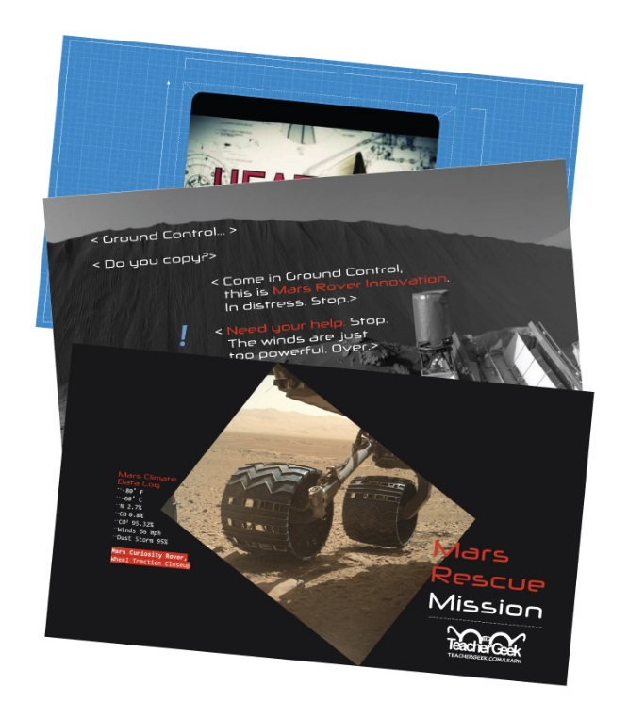



Do you have a challenge to solve? Is there something you want to invent, fix or improve? You do? Excellent…   
the **Engineering Design Process** is exactly what you need.

Inventing, fixing, improving… these are really ways to create a solution to a problem. A problem can be as complicated as creating a way to live on Mars, or as simple as stopping a door from squeaking. You are reading this because you have a problem to solve: to create the fastest or most accurate,   
Rubber Band Racer. The Design Process will help you solve it. Here’s how it works:



**What is the problem (what needs to be solved/made better)?**

The Design Process helps you solve a problem. Therefore you need to start the   
Design Process by identifying a problem. In this activity, your problem is either to   
create a Rubber Band Racer that can roll down a ramp the fastest or slowest.

After constructing your first Rubber Band Racer and going through the initial   
Design Process, your problem may change. Your next problem might be to make the   
Rubber Band Racer accurately stop on a target, or win in a sprint against other racers.

There is no perfect design, so there is no end to the Design Process.   
You can always identify a new problem (a way to make your Racer better)   
and go through the Design Process again.

**Research: How have others solved, or attempted to solve this problem?**

If you are going to solve the problem, you better know what you are doing.   
After identifying the problem, look at how others have solved, or tried to solve it.  
Look around your class, search the library and internet, or ask other people.

**What are the constraints (things your design cannot, or must, do or be)?**

It would be great if you could solve this problem any way you want, with anything you want. The truth is… you can’t! You have these things called “constraints” which limit what your design can do, can’t do, must be, or can’t be (How confusing is that?). Constraints could be resources like time or materials. They could also be rules, such as the size or material of the blades. You need to identify the constraints to your problem before you can solve it.



**Brainstorm, sketch and describe possible solutions (different ideas that might solve the problem).**

This is a fun part. You can brainstorm, or use another process, to come up with as many possible solutions to your problem as possible. Consider your problem, constraints and research while generating possible solutions. Do not judge, or pick, your best solution at this point. Just write as many down as you can.   
**Note:** whacky/unique ideas sometimes lead to wonderful new design solutions.   
Be super creative, and original!

**Choose the best solution. Circle it. Why do you think it is best?**

Ok - now it’s time to judge. Pick what you think will be the best solution to your problem. Make sure it fits the constraints. It’s ok to feel sorry for all the possible solutions that didn’t get picked. They were good ideas too…



**Draw the solution you choose. Include the details you will need to create it.**

Neatly sketch the design you choose (the one you are going to build).   
The sketch should include details and descriptions about how it will work, or be built.



**Build the solution you planned.**

Is this the step you have been waiting for? You finally get to build the solution to your problem (the new design). Have fun! Take the time to make it properly.

**Test it.**

Test your solution (new design). How does it work? Does it go fast down the track?   
Make small adjustments to optimize it (to try and make this design solution work best). **Make observations. Record results.**

Pay close attention while testing your solution. Write down what happened   
(the racer tipped over, the wheels slowed or gained speed, the bands were too loose).   
You will use this information to make your Rubber Band Racer even better.



**Did you solve the problem?**

Look at the test results. Reflect on your observations.   
Did your solution solve the problem as you had planned?

**Yes? Great! Identify a new problem (a way to make your design even better).**

There is no perfect design (yep... your design can still be improved).   
Identify another problem that will make your Rubber Band Racer even better.   
Grab another Engineering Notebook Sheet and try to solve it.

**No? That’s OK. What did you learn that can help solve it in a new/different way?**

You learn more from failures than you do from successes. The best solutions come from/after failures (ideas that didn’t work). Most inventions do not work the first time around the Design Process. Learn from what didn’t work. Grab another Engineering Notebook Sheet and try to solve the problem a different way.



Fill in a TeacherGeek Engineering Notebook Sheet (front and back)  
every time you go around the Design Process. Keep your Notebook Sheets.   
Assemble them into an Engineering Notebook at the end of the project.

[*Download the Engineering Notebook Sheets*](http://teachergeek.org/engineering_notebook.pdf)

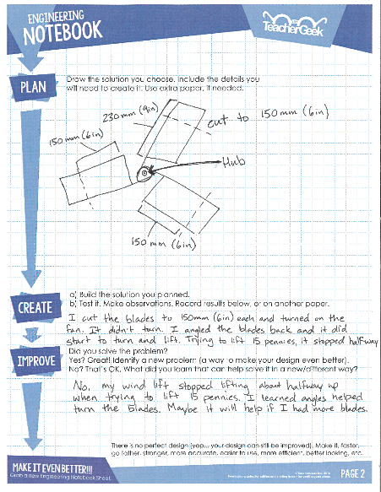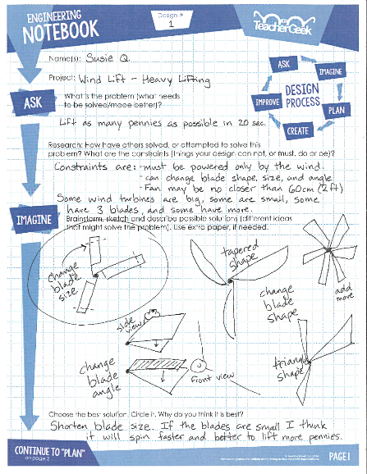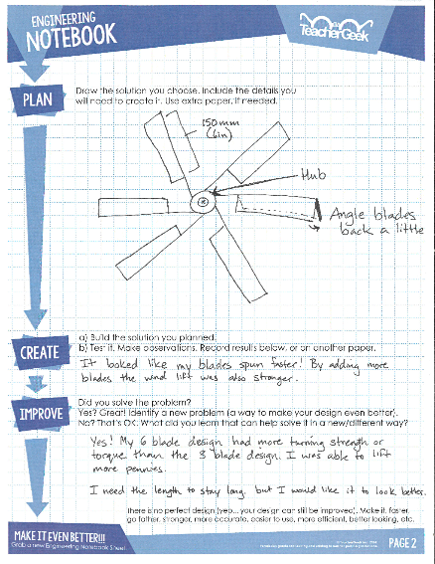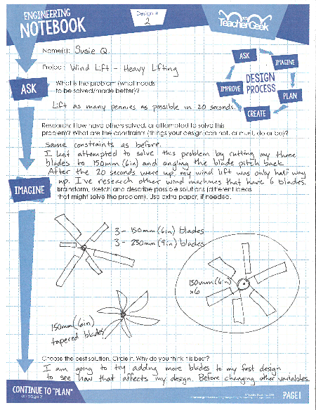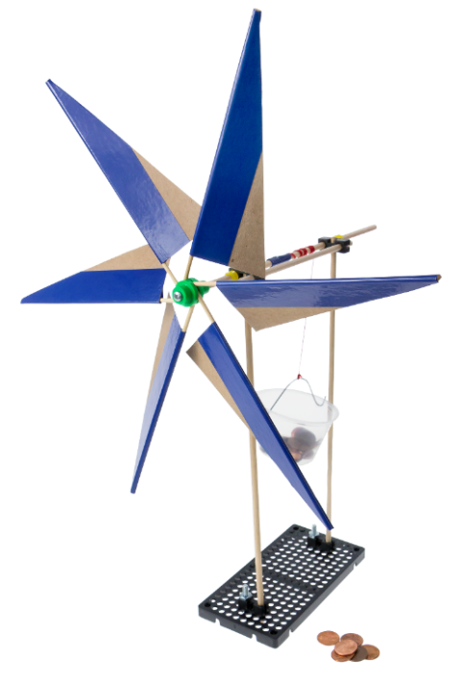

***Question*** *Do you need to fill out a new Engineering Notebook Sheet for small changes or tweaks to an existing design?*

*Nope… just record what you did on the current Notebook Sheet.*