

***Snap!***

**The Challenge:** Redesign your vehicle  
 to go ***as fast*** as possible  
 in a mousetrap race.







**Challenge Supplies:**Mousetrap vehicle, ruler, tape,   
a flat 3 m (9.8ft) long area of floor

**3 meters long**



***Woosh!***

**Difficulty:** Easy-Medium

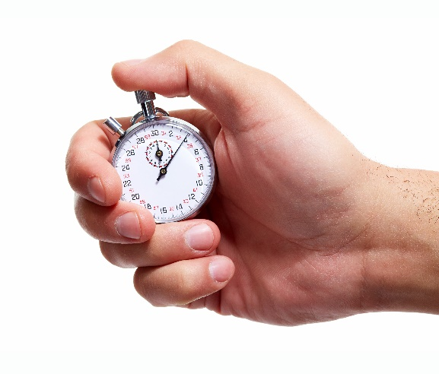

**Ways to Play:**How fast can your vehicle race down the track?  
Redesign it to go as fast as possible. Use a stopwatch   
to time the speed down a 3-meter track. Compete   
against yourself, or other racers for the fastest time!  
*See who can cross the finish line first!*

*For those competitions   
with more than two racers,   
try using an “****elimination bracket****”.*



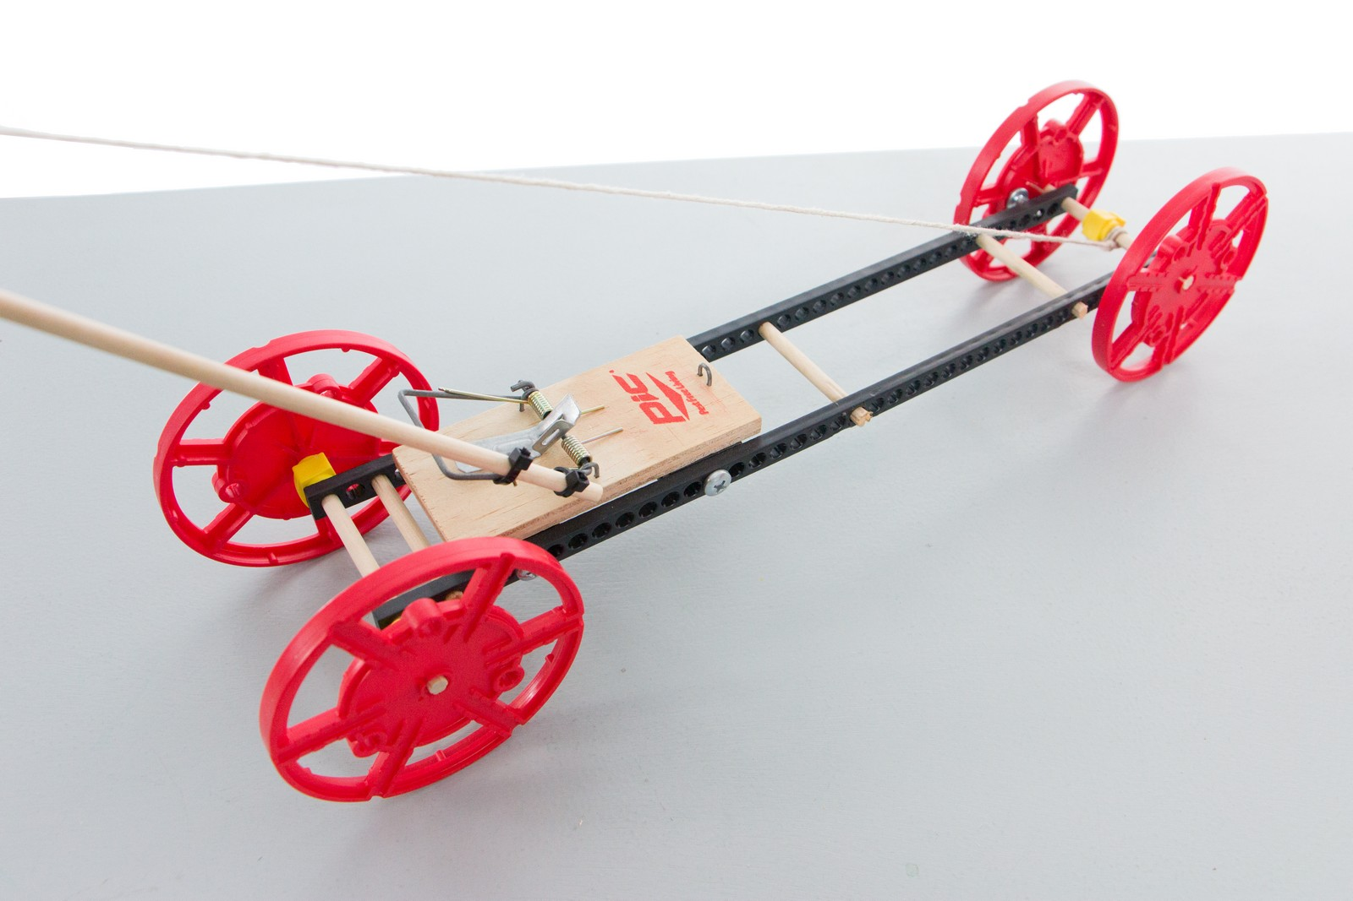



**Before you start…** Make sure you have built   
a **Mousetrap Vehicle** for use on this challenge.

Documents & supplies at teachergeek.com/learn



**Page 1**



***Say cheese!***

*The time from building and   
re-designing your vehicle   
to the start of the competition.*

**Constraints:** (rules and limits for your design)

**Allowable Materials**  
• TeacherGeek components  
• Recycled food packaging  
• Other available materials   
 (wood, plastic, etc.)

**Geometry**  
•At the start of the competition,   
 vehicles must fit within a   
 50cm x 50 cm x 50cm area.

**Function**• Your vehicle’s wheels must   
 begin behind starting line.  
• Measure the distance the   
 vehicle travels to its front wheels.



**Time Limit:**You will have ____________to complete the challenge.

Fill in how much   
time you have



|  |  |  |  |  |  |  |
| --- | --- | --- | --- | --- | --- | --- |
|  | **Speed: The Time It Takes to Race Across A 3-Meter Track** | | | | | |
| **Vehicle or Design Name** | **Run #1** | **Run #2** | **Run #3** | **Run #4** | **Run #5** | **Run #6** |
|  |  |  |  |  |  |  |
|  |  |  |  |  |  |  |
|  |  |  |  |  |  |  |
|  |  |  |  |  |  |  |
|  |  |  |  |  |  |  |
|  |  |  |  |  |  |  |
|  |  |  |  |  |  |  |
|  |  |  |  |  |  |  |

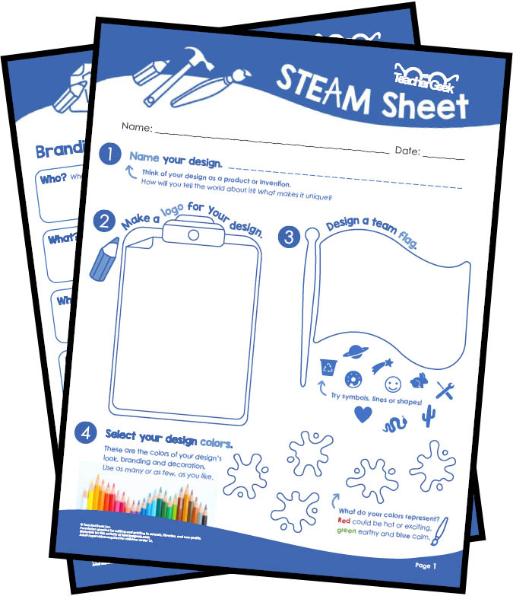

**Customize & Brand Your Vehicle With The   
STEAM Sheets** at teachergeek.com/learn

**You will be using the Engineering Design Process.**   
What does this mean? Your design is never finished -   
it can always be improved! By testing and adding   
and redesigning, truly innovative ideas are born.   
Remember – there’s no such thing as a perfect design.

**Page 3**

Name: _________________________________________________________ Set: __________

|  |  |  |  |  |  |  |  |  |  |  |  |
| --- | --- | --- | --- | --- | --- | --- | --- | --- | --- | --- | --- |
|  |  |  |  |  |  |  |  |  |  |  |  |
|  |  |  |  |  |  |  |  |  |  |  |  |
|  |  |  |  |  | **Revolutions/Time Ratio** |  |  |  |  |  |  |
|  |  |  |  |  |  |  |  |  |  |  |  |
|  |  |  |  |  |  |  |  |  |  |  |  |
| 10m  9m  8m  7m  6m  5m  4m  3m  2m  1m |  |  |  |  |  |  |  |  |  |  |  |
|  |  |  |  |  |  |  |  |  |  |  |  |
|  |  |  |  |  |  |  |  |  |  |  |  |
|  |  |  |  |  |  |  |  |  |  |  |  |
|  |  |  |  |  |  |  |  |  |  |  |  |
|  |  |  |  |  |  |  | Revolutions to Wind Wheel/Mouse Trap Snap  (Independent Variable) |  |  |  |  |



Time Down the Track

(Dependent Variable)