

**Time Limit:** Two-minutes

**The Challenge:** Engineer your Judo-Bot to knock over an opponent or push them out of the arena.

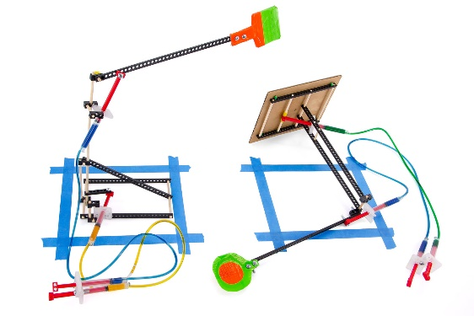

*Push!*

**Difficulty:** Easy-Medium

**Challenge Supplies**

* Two (or more) assembled Judo-Bots
* Extra TeacherGeek components
* Arena materials (tape, chalk)
* Recycled or found materials
* TeacherGeek tools
* Timer
* Ruler

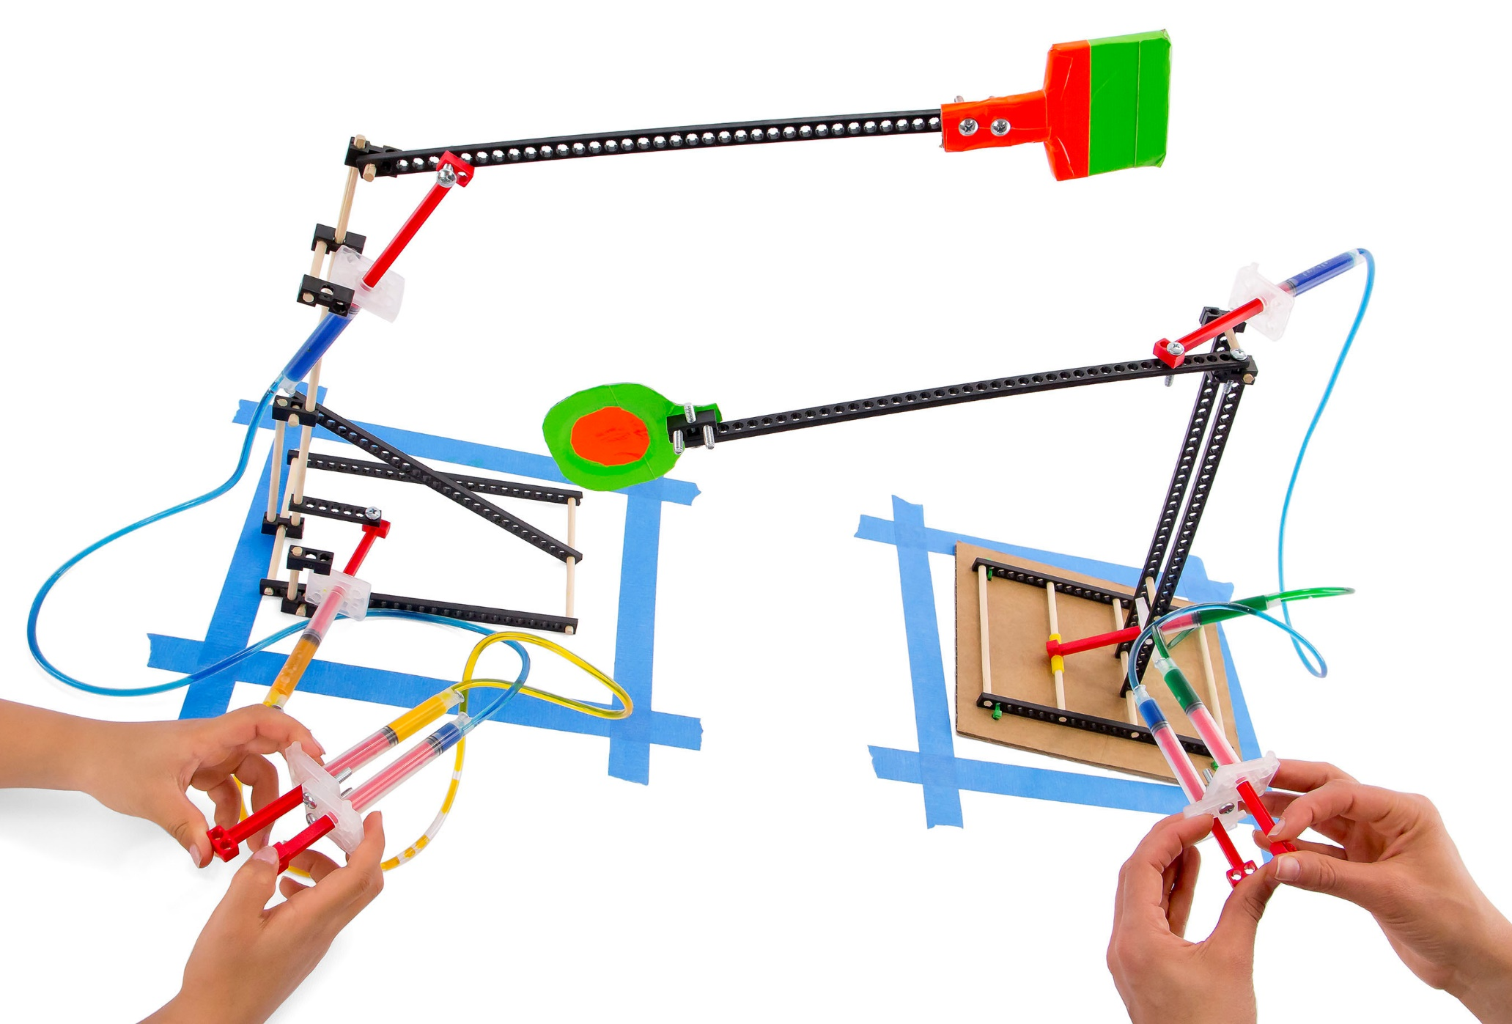



**End Effector**



**Tip:** Build a **base**   
to stabilize your   
Judo-Bot.

These are *example* Judo-Bots.   
You can make them *so much* better. Engineer your bot for combat with different **bases**   
and **end effectors**.

**Clay**





18 cm (7”)

35 cm (14”)

18 cm (7”)



**Arena**



***Place Judo-Bot Here***

***Place Judo-Bot Here***

Judo-Bots need an arena   
for combat. It consists of   
two rectangles marked on   
a flat surface. Use **tape** or   
**chalk** to outline, as shown.





Use **hydraulic power** to battle your **Judo-Bots**.



**B.**

***K.O!*** Knocking an opponent over is an *immediate win!*

Start with the bot’s lever arms not touching, nor extending over the opponent’s arena edge.

Place your Judo-Bot inside the **arena**,(no portion of the base should be outside the rectangle).

*No Touching!*

**A.**



**B.**



***Battle for Two Minutes!***

**C.**

*Knocked-Over!*

**C.**

If the opponent’s base is outside the arena by   
the end of two-minutes, they lose on default.

**D.**



**E.**

Both bots in-bounds and upright by the end of two-minutes? **It’s a draw!**



**Note:** If both bots are “*out-of-bounds*”   
after two-minutes, measure with a ruler   
to determine which is further from the arena’s edge. Shortest distance wins!

**D.**



*Out-of-Bounds*

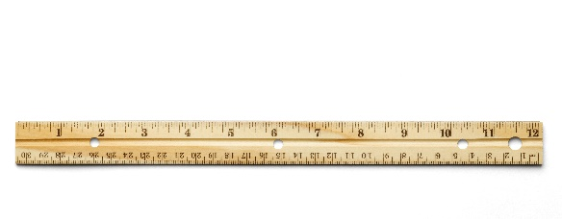



Fail to follow these constraints?  
***Disqualification!***

(rules and limits for your design)

* Only **hydraulic power** may be used to move and control the Judo-Bot.
  + Hydraulic lines may not be pushed or pulled to move the bot – just **pistons**.
* The **base** may not be anchored (taped, screwed, bolted) to the arena surface.
* The weight of the Judo-Bot and components may not exceed **250 grams**.
* Additional materials should be brought in for Judo-Bot designs, if they are:
  + TeacherGeek Components
  + Found & Recycling Bin Materials
  + Teacher Approved
  + Non-Hazardous (no sharp edges, harmful chemicals, etc.)
* You will have _____________________ to complete your design challenge.



Fill in how much   
time you have



*The time from building and   
re-designing your Judo-Bot   
to the start of the competition.*

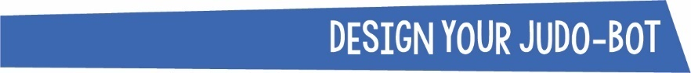

**Base**

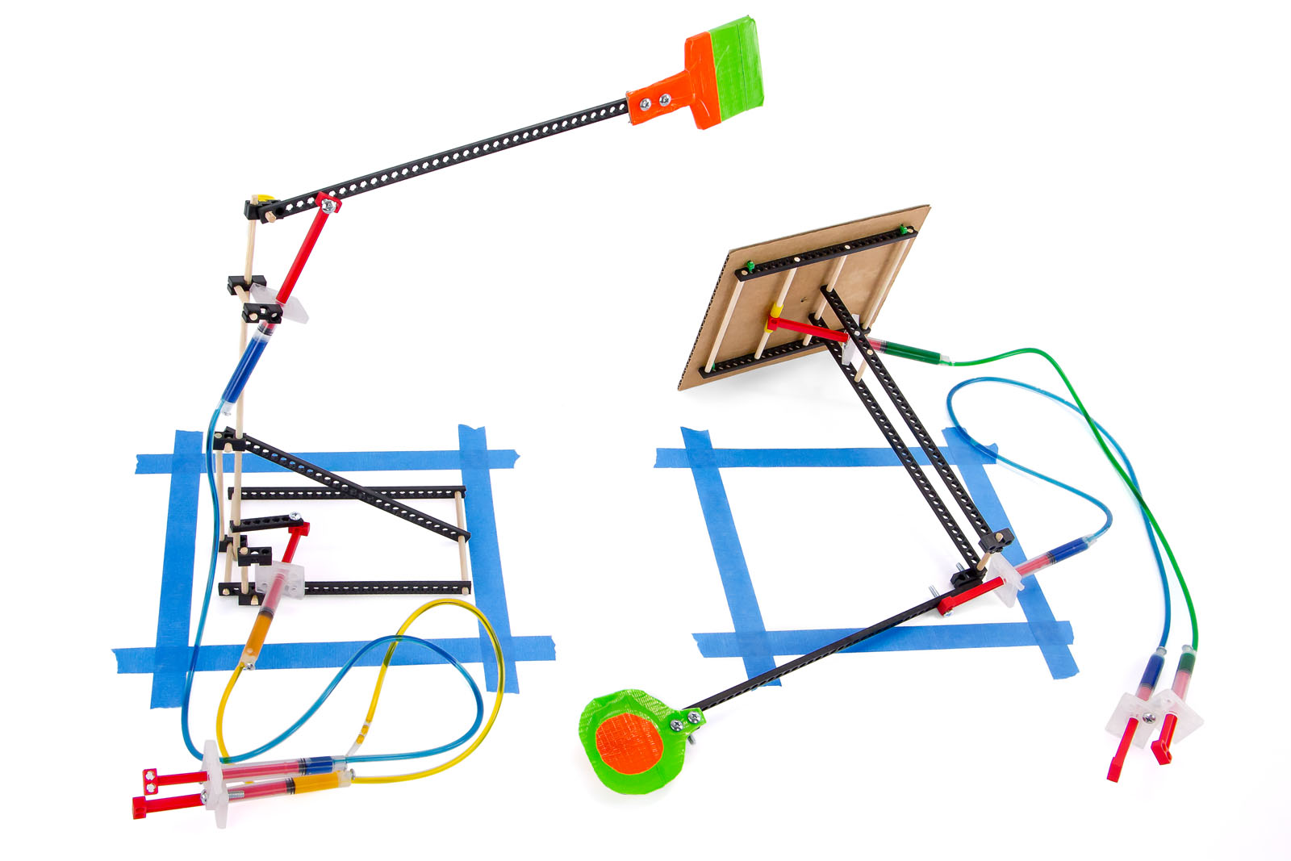

**Twist  
Ties**

**Base**

**How Will You Stabilize Your Judo-Bot?**  
The example Judo-Bot **base** is light and easy to tip-over.   
Its footprint (dimensions) should not exceed 18 cm x 35 cm.  
You can design your base to be any size – but consider:

**Big** bases provide   
**more support**, yet   
are closer to the   
arena edge.



**Small** bases are   
**less stable**, but further from the arena edge.

*T-T-Tip!*

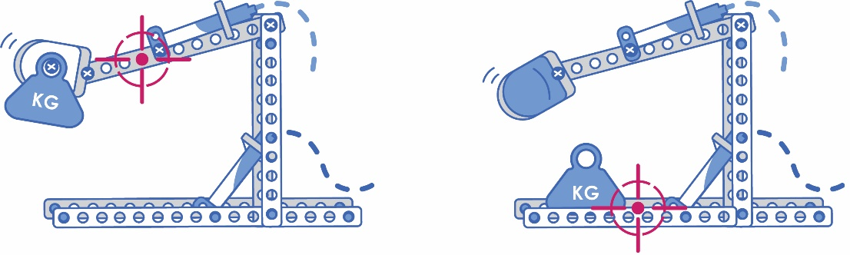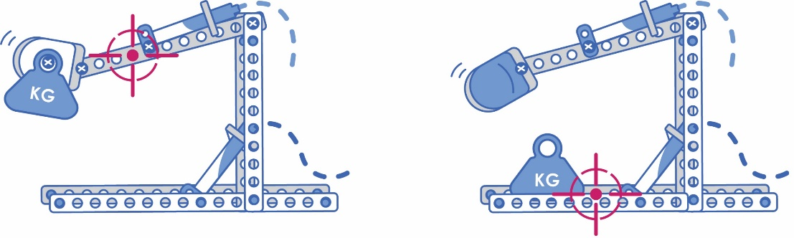

***Lowering*** the center of gravity   
by placing more weight on the   
base makes bots more stable.

**High Center of Gravity**

***Raising*** the center of gravity   
with heavier end effectors   
makes the bot unstable.   
A top-heavy arm is great   
for whacking opponents!

**Center of Gravity**  
The center of gravity is the point   
where your bot is **equally balanced**.  
  
The **maximum weight** of your Judo-Bot   
should not exceed 250 grams (0.5 lbs).  
*Where will you place your weight?  
Will you use heavy or light materials   
for your base and end effector?*

**Low Center of Gravity**



**Fulcrum  
(Pivot Point)**

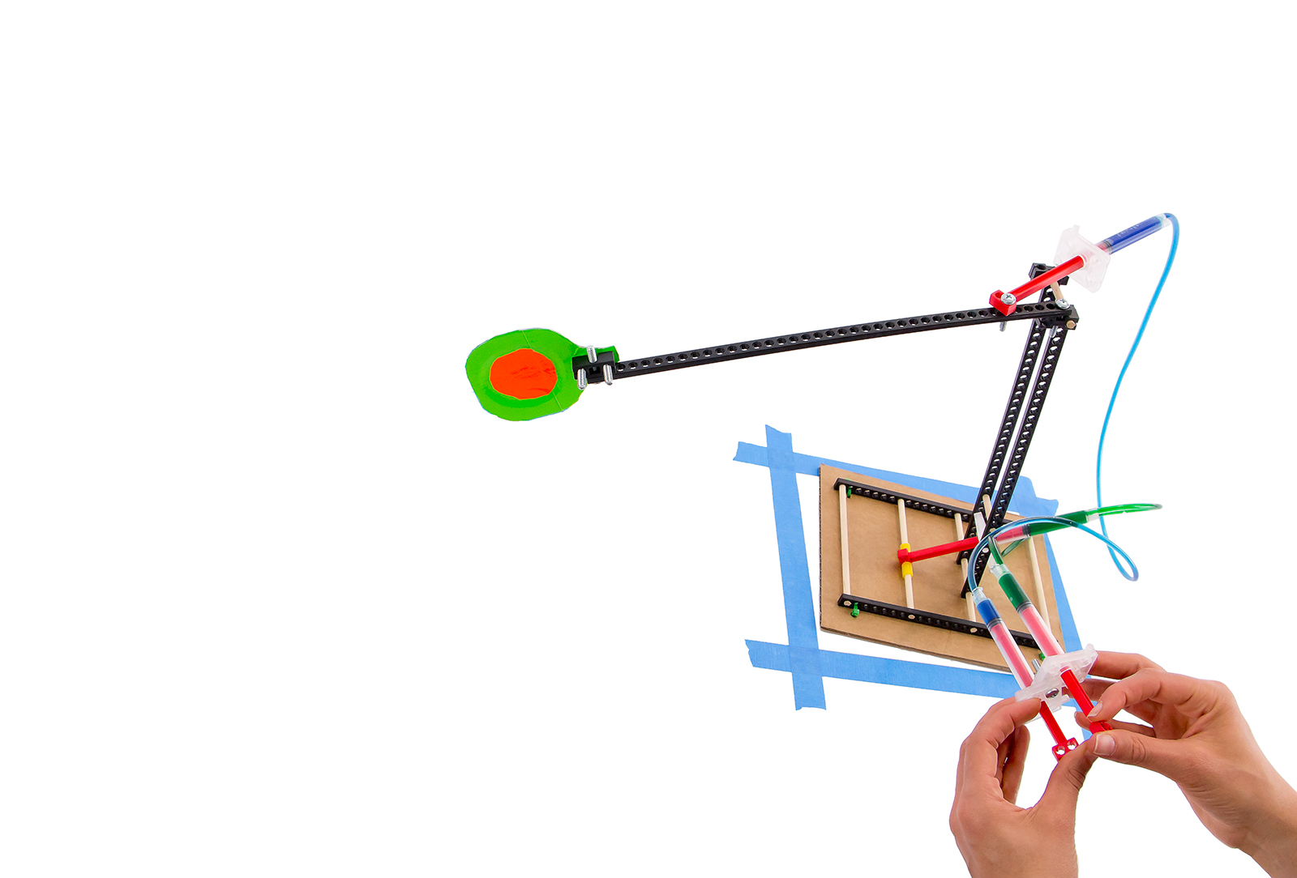

**Trading Force for Distance**  
Your Judo-Bot uses more than hydraulic power to move – **levers** allow you to trade ***force*** for ***distance*** in battle.

**Distance  
(Lever Arm)**



**Mechanical  
Advantage**

**Output Force  
Input Force**

**=**

**End   
Effector**



**Output Force  
(Motion of the Arm)**

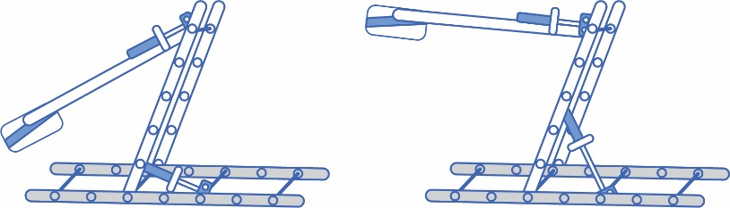

Reposition the base’s cylinder as **low** on   
the upright as possible.  
Is the effort it takes to move the upright **easy** or **difficult**?

**Try It Out!**

Reposition the base’s cylinder as **high** on   
the upright as possible.  
Is the effort it takes to move the upright **easy** or **difficult**?



**Input Force  
(Control Panel)**

*Use blocks, screws, tape   
and hole punchers to   
attach your end effectors.*

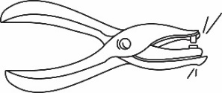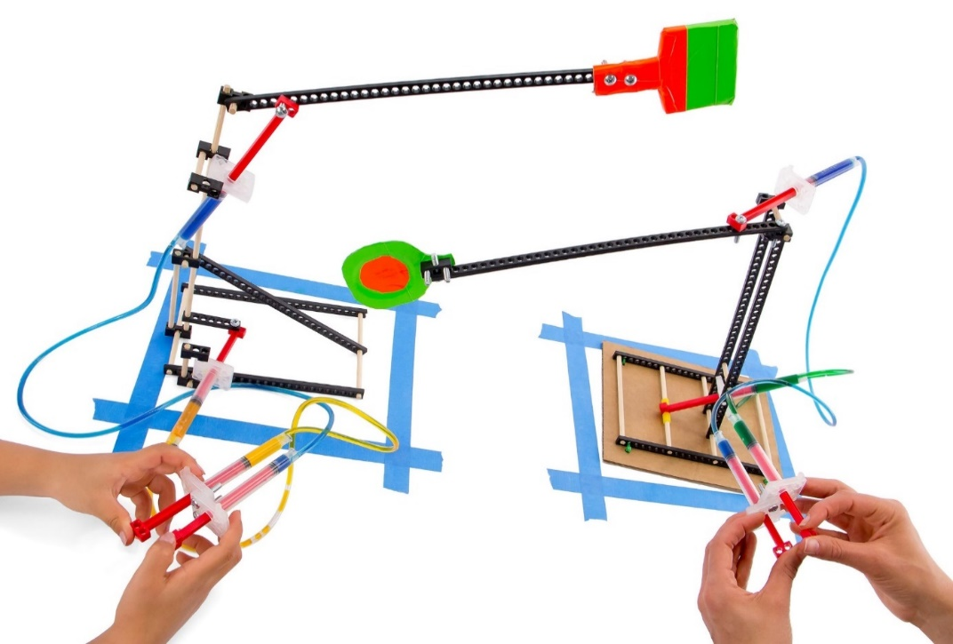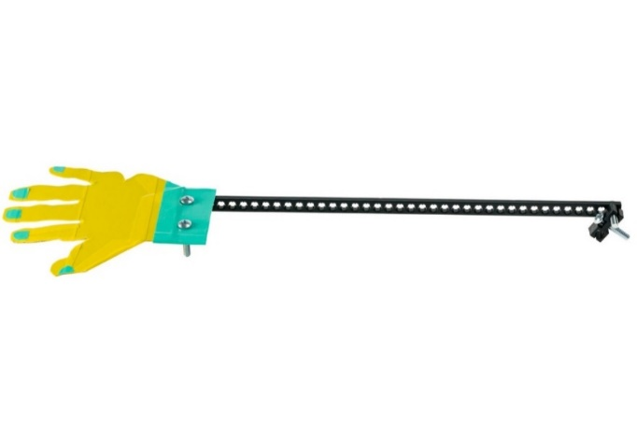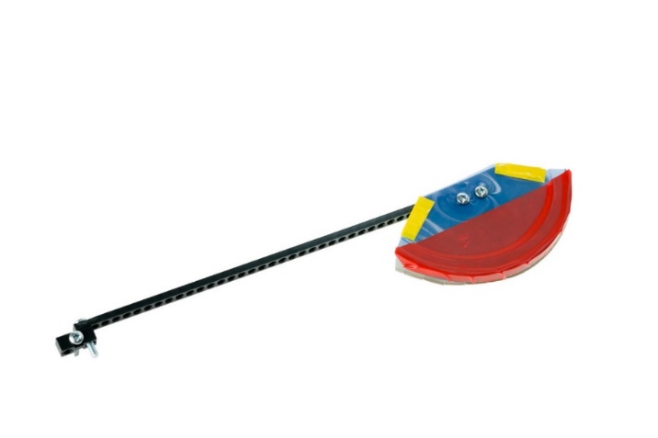

*Push!*

*Tip!*

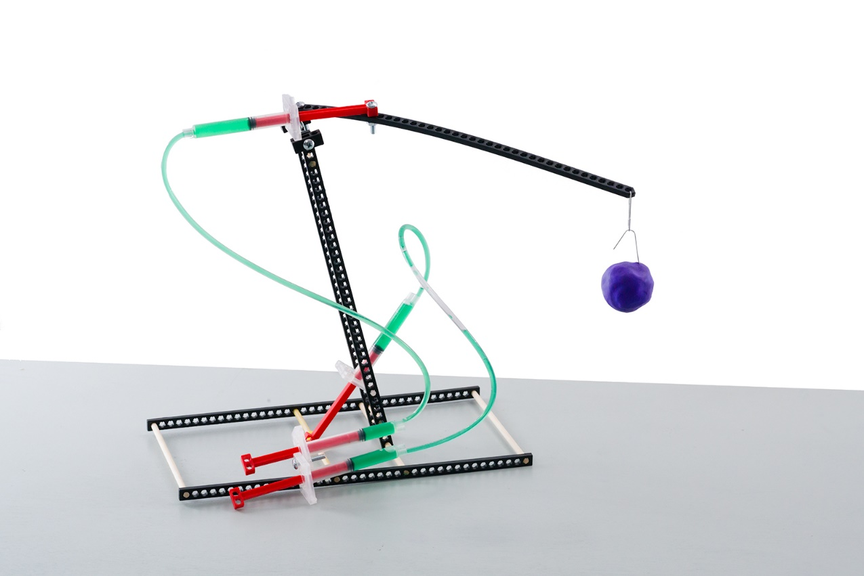

*Whomp!*



*Teachers* ***initial*** *here when students are finished:*



**Base**

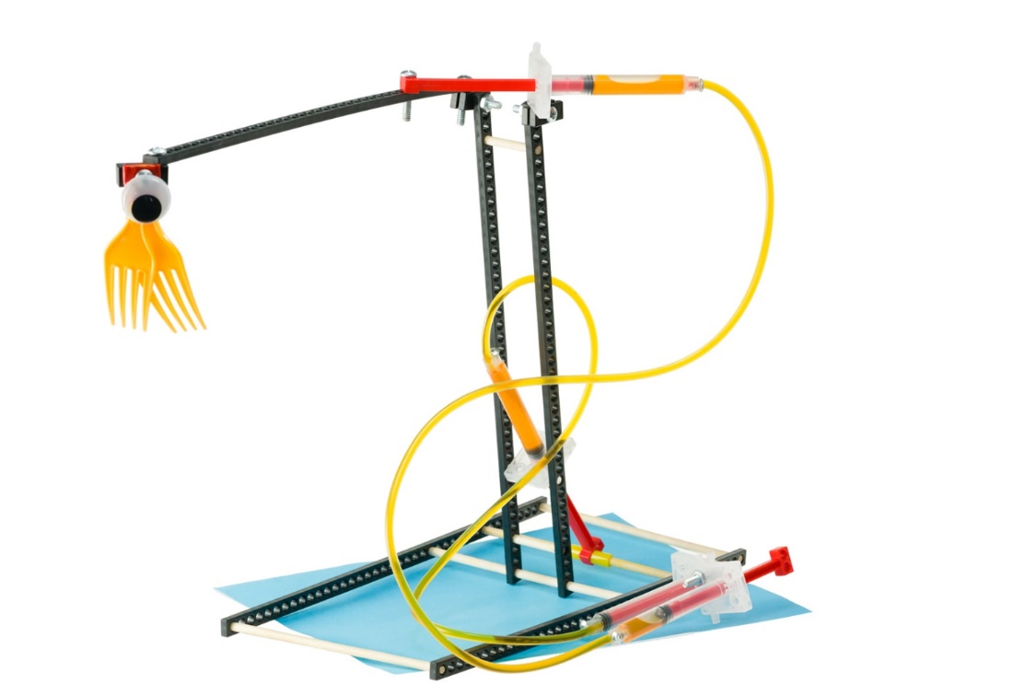

**Hydraulic   
System**

**Lever Arm**

**End   
Effector**



An **end effector** is the device or   
tool at the end of your lever arm.   
Its design changes how your   
Judo-Bot can battle – slapping,   
pushing, gripping, and swinging.   
Use found or recycling bin materials.

*Try Styrofoam,   
old cardboard,   
paper, plastic,  
TeacherGeek  
components*





Tally your design’s wins + losses in the chart below. Record notes for the engineering process.

|  |  |  |  |
| --- | --- | --- | --- |
| **Judo-Bot Tally Sheet: Points Scored** | | | |
| **Group Names** | **Win!** | **Lose!** | **What happened?** [e.g. How did you win or lose? What parts of your design changed? How would you redesign your Judo-Bot for future competition?] |
|  |  |  |  |
|  |  |  |  |
|  |  |  |  |
|  |  |  |  |
|  |  |  |  |
|  |  |  |  |
|  |  |  |  |
|  |  |  |  |
|  |  |  |  |
|  |  |  |  |



**The Engineering Design Process:**

You will be using the **Engineering Design Process**. What does that mean?   
Your design is never finished! It can always be improved. Fill out a new *Engineering Notebook* page each time you design/redesign your **Judo-Bot**.



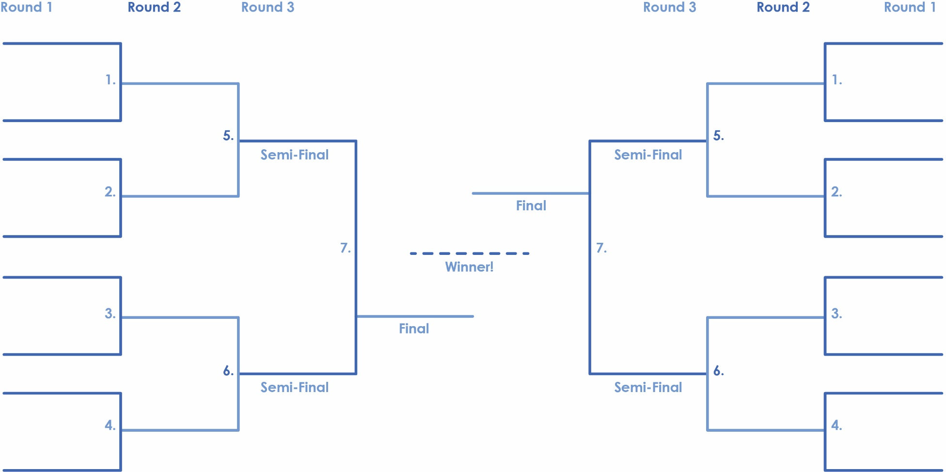

**TeacherGeek   
Intercontinental   
Championship Belt**.

Use an elimination tournament **bracket** for class competition.   
This bracket can fit sixteen  
Judo-Bot teams or designs.