Name(s): **_______________________________________________________________________**



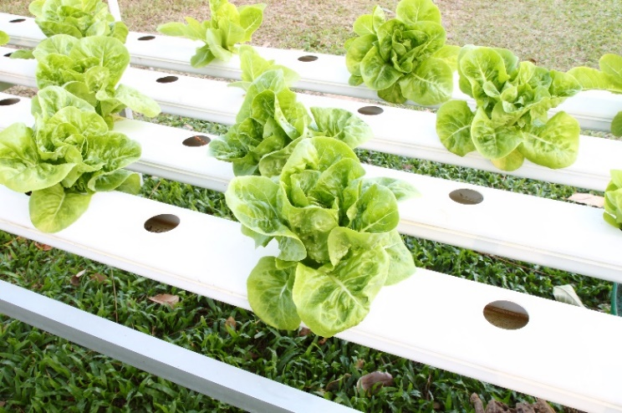  
  
Plants can grow in more than just soil. **Hydroponic** (water) and **Aeroponic**   
(air or mist) based systems have existed since the Hanging Gardens of Babylon. **William Frederick Gericke** promoted   
the value of soil-free agriculture in   
1929, coining the term from the Latin:  
**Hydro** *(water*) **+** **Ponic** *(work).*

**Soil Free, Care Free?**

Hydroponic crops are grown **bigger, faster** and in **less area** than a   
traditional field could yield. They can be grown indoors, underground,   
at high elevations or even on board the International Space Station.

Maintaining a hydroponic system can be costly however, and requires **engineering** to ensure **water**, **nutrients** and **oxygen** are always available.

1. List two reasons a farmer would use a Hydroponic System:

1. _____________________________________________________________
2. _____________________________________________________________



2. Why are Hydroponic Systems so important for space travel?   
 **Hint:** It takes about seven months to reach Mars. How would you eat?

_________________________________________________________________  
 _________________________________________________________________  
 _________________________________________________________________

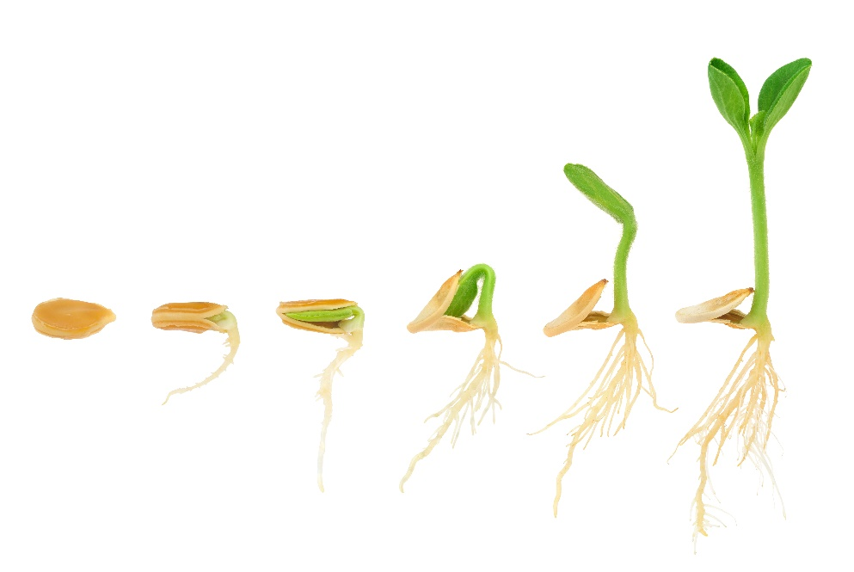 **Light**

**Carbon Dioxide**

**Oxygen**

**Water**

**Nutrients**

**Macronutrients**: Nitrogen, Phosphorus and Potassium. Plants absorb more of these than any other nutrient.

**Micronutrients**: Plants require less   
of these, including: boron, calcium, copper, iron, magnesium, and zinc.

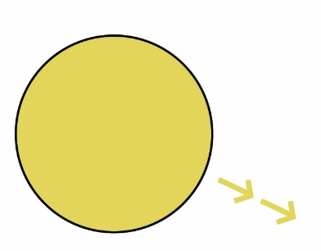 **Photosynthesis:** the process used by plants to convert   
 “*light energy*” into “*chemical energy*”.  
   
 This light energy, often from the sun, is stored in   
 carbohydrates and sugars synthesized (combined) from   
 **Carbon Dioxide** and **Water**. Then, **Oxygen** is released as waste.  *You enjoy the products of photosynthesis in food and in the air we breath!*

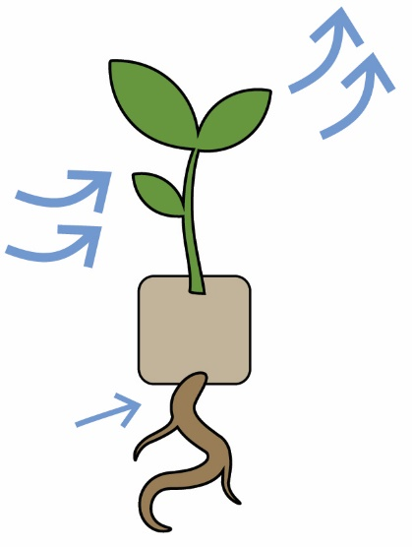

**D**

1. Match the components of the photosynthesis process below:  
     
   Light Energy: 󠄀

Water H2O:

Oxygen O2:

Carbon Dioxide Co2:

**Micronutrients**: Plants require less   
of these, including: boron, calcium, copper, iron, magnesium, and zinc.

Oxygen O2:

Carbon Dioxide Co2:

**A**

**B**



**C**

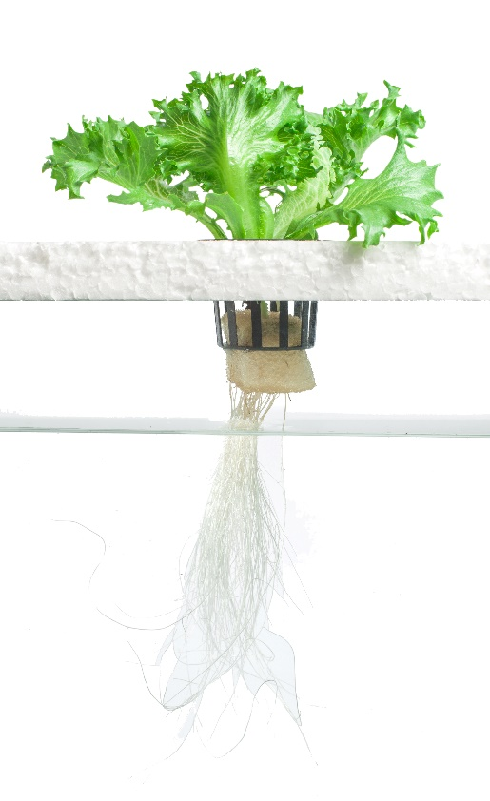

***Light***

**Growing Media**

Plants grown in **Hydroponic Systems**   
need only light, water, nutrients, and   
a growing medium (such as rockwool, coconut fiber, old wool socks or perlite).



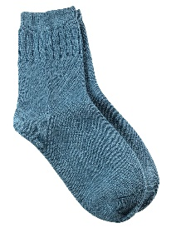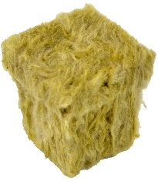

*Cotton*

*Socks*

***Nutrients***

***Water***

*Rockwool*

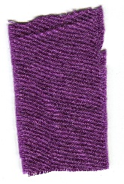



*Towel*

**Growing Medium  
Light  
Water  
Photosynthesis   
Carbon Dioxide**

**Growing Medium  
Light  
Water  
Photosynthesis   
Carbon Dioxide**

**Chemical  
Sugars  
Oxygen  
Proteins  
Soil**

***Growing   
Medium****Rockwool*

***Recovery   
Drip System****Portion Cup*

***Nutrient  
Solution****Tubing Drip*

***Nutrient  
Solution****Tubing Drip*

***Growing   
Medium****Rockwool*

***Reservoir****Adjusted  
Cylinder*

*your cylinders to add   
 and remove water   
 throughout the day?*

**Complete the following sentences:**  
*Words may only be used once.*

4. Hydroponic Systems use __________ for growing plants in place of _________.

5. Plants convert _________ energy from sunlight into _________ energy, which   
 is stored in carbohydrates and ___________ for future use. This process of   
 __________________ produces ____________ as a waste product.   
  
6. Hydroponic Systems use a ____________________ like rockwool or perlite.

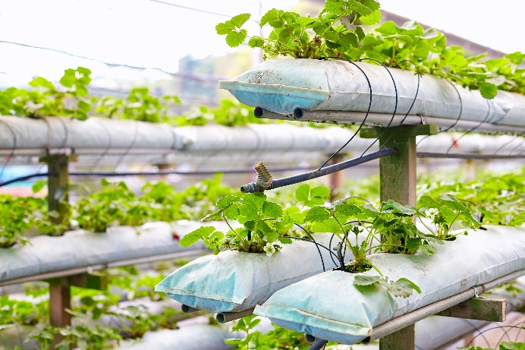



**Drip Systems** are the most used hydroponic system in the world. An automated system uses a **timer** and **pump** to drip **nutrient solution** through a small tube into the base of the plant’s **growing medium**.

**Recovery Drip System:** excess nutrient solution run-off is collected for re-use.  
**Non-Recovery System:** excess nutrient solution run-off is not collected.

7. Why does your **Micro Hydroponic Drip System**  
 not need an automated pump to work?  
 **Hint:** What force causes mass to fall?  
 _______________________________________________  
 _______________________________________________

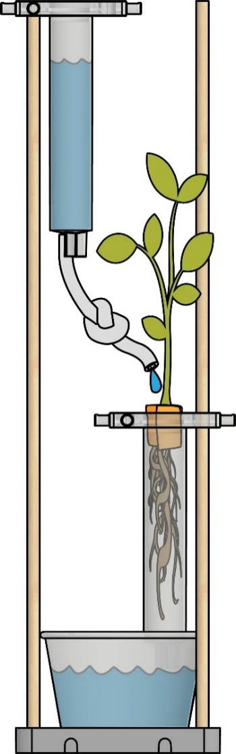

***Growing   
Medium****Rockwool*



***Recovery   
Drip System****Portion Cup*

***Nutrient  
Solution****Tubing Drip*



8. Discuss and compare the environmental impact of   
 (A) **Recovery** and (B) **Non-Recovery Drip Systems**?  
  
 **A** ____________________________________________  
 ____________________________________________  
 ____________________________________________

**B** ____________________________________________  
 ____________________________________________  
 ____________________________________________

**Acid Rain:** rainfall made **acidic**(a **pH** less than 7) due to **pollution**   
in the earth’s atmosphere from   
 the burning of **fossil fuels** like coal.

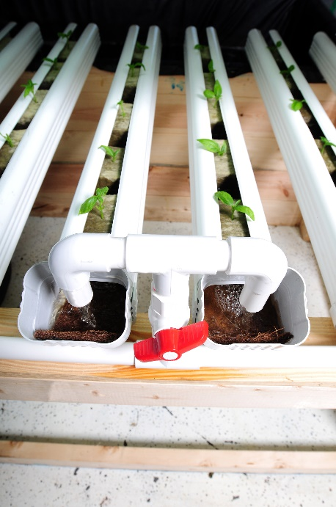

**Flood and Drain** Systems (also known as **Ebb & Flow**,   
or **Dutch Buckets**) work by temporarily flooding   
the plant’s grow tray with **nutrient solution**, then   
draining the solution back into the **reservoir**.   
This is normally done with a **submerged pump** on   
a timer, and works well with gravel or **rockwool**.

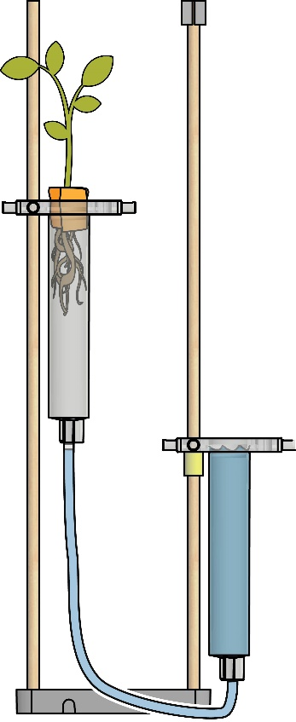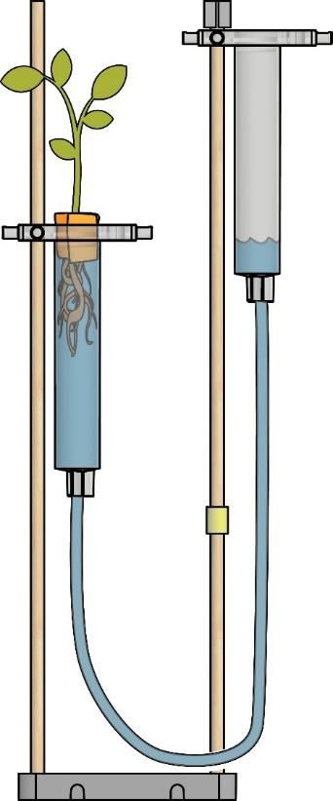

***Nutrient  
Solution****Tubing Drip*

***Growing   
Medium****Rockwool*



***Reservoir****Adjusted  
Cylinder*



In most **Flood & Drain** systems, the **reservoir**   
is lower than the **hydroponic system**, allowing **nutrient solution** to drain, recovered   
then through **gravity**.

*How can you adjust   
 your cylinders to add   
 and remove water   
 throughout the day?*



**Flood**

**Drain**



9. Ancient agriculture used the **flooding** of rivers such as the Tigris or Nile to   
 create a fertile **silt** (nutrient solution) for crops. Why was the engineering   
 of **dams** to control and **drain** this water so important?   
 _____________________________________________________________________  
 _____________________________________________________________________  
 _____________________________________________________________________



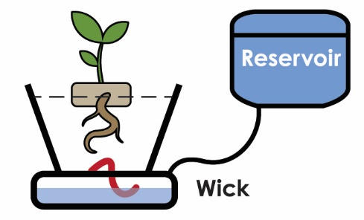

**Wick System:** A **wick** is used to draw the **nutrient solution** from   
a reservoir-fed dish, up into the **growing medium**   
(perlite, vermiculite or coconut fiber).

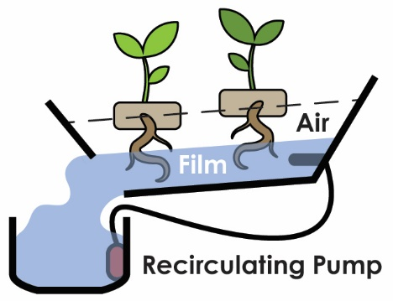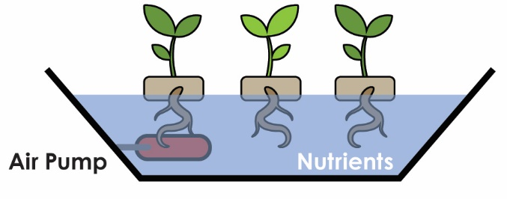 **Deep Water Culture (DWC):**The simplest active system. The plants float   
directly on the **nutrient solution**, as an **air pump**  
supplies **oxygen** to the roots. Best for lettuce.  
 *How could you add an air pump  
 to your own hydroponic system?*  
 **Nutrient Film Technique (NFT):**The **nutrient solution** (film) is pumped into the angled   
**tray** (through a tube) and recirculates over the dangling   
roots, draining back into the **reservoir**. The constant   
flow of film requires no **growing medium** other than **air**.   
Plants are often sensitive to interruptions in flow cycles.

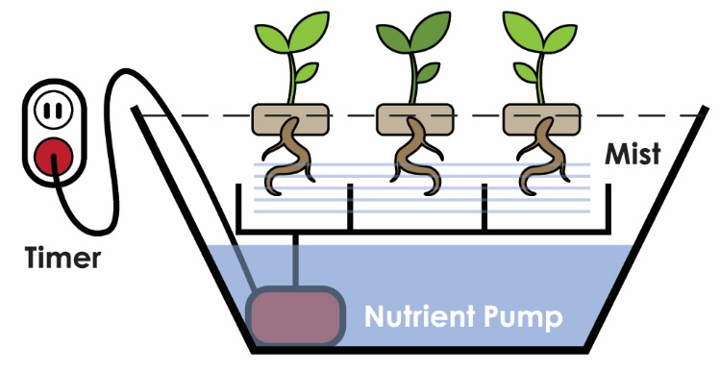 **Aeroponic Systems:** The most high-tech system. Like the N.F.T.   
system, the **growing medium** is primarily **air**.   
The roots dangle, **misted** with timed **nutrient   
solution** every few minutes. They will dry out   
rapidly if the mist cycles are ever interrupted.

7. Name a disadvantage of relying on an automated hydroponic system?  
___________________________________________________________________________  
___________________________________________________________________________

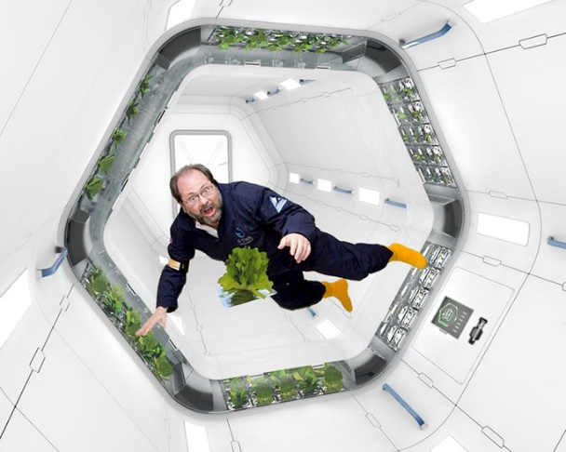**

Would you live on Mars? Questions like these were once the realm of science fiction; no longer!   
Space travel is possible, yet **constraints** persist.   
*How would we grow food in zero-gravity?*   
 **The Unique Challenges of Growing Food in Space**

* Zero-Gravity
* Soil-Free
* Artificial Light Source
* Limited Surface Area

15. Plants need **surface area** to expand their root systems and grow.   
 How can **hydroponic systems** adapt to limited surface area?  
 **Hint:** Think of your cylinders. Are they vertical? Horizontal?  
 ________________________________________________________________  
 ________________________________________________________________  
 ________________________________________________________________  
 ________________________________________________________________

16. Without soil, plants aren’t limited by which direction they grow.   
 This is a huge advantage in **weightlessness**. Briefly describe which   
 type of **hydroponic system** you believe would work best in the small   
 quarters of the International Space Station? The dark terrain of Mars?  
 ________________________________________________________________  
 ________________________________________________________________  
 ________________________________________________________________  
 ________________________________________________________________

**

*“Lacking soil, you need some sort of substrate...  
I considered using an old shirt or sock but decided   
the Russian supplied toilet paper was best…It consisted   
of two layers of coarsely woven gauze. It [made] a   
wonderful sprouter,… [retained] water well and the seeds can be anchored under the gauze weft...”*   
– **ISS Science Officer** Don Pettit, November 2002

  
**Ideal Space Plants Would Be:**

* Need little water
* Need few nutrients
* Low maintenance
* Yield plenty of oxygen
* Short
* Grow quickly in low light
* Have few inedible parts
* Resist disease
* Need little water and few nutrients
* Need little maintenance
* Yield a lot of oxygen



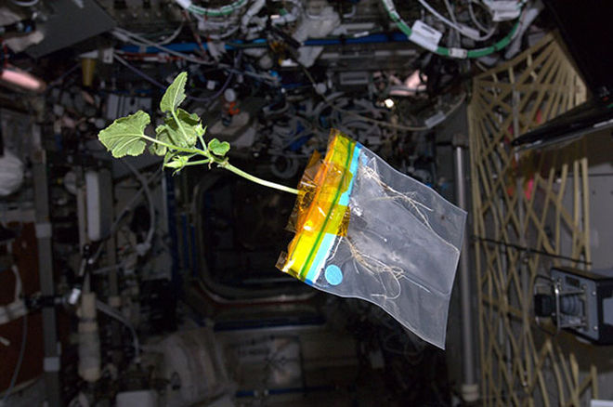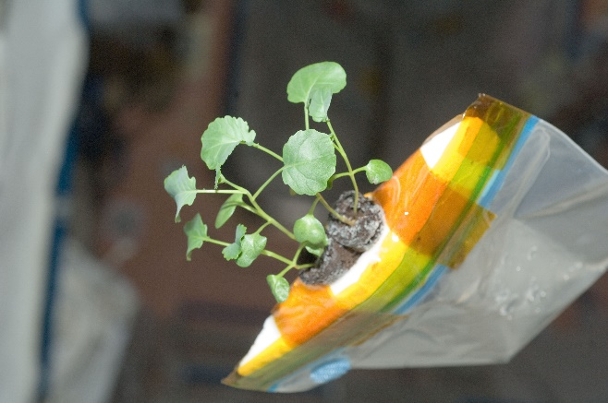20. Would the seeds used in your **Hydroponic System** be *ideal* space plants?  
 Why or why not? _____________________________________________________  
 _____________________________________________________________________  
 _____________________________________________________________________  
 _____________________________________________________________________  
 _____________________________________________________________________

*Don Pettit’s  
Space Zucchini*



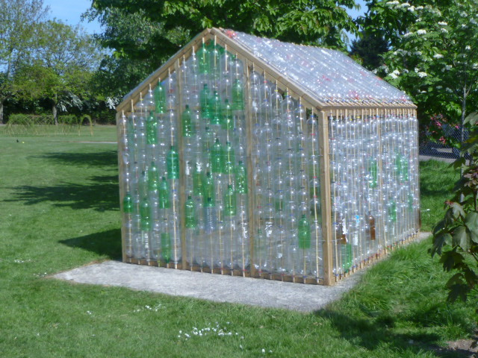

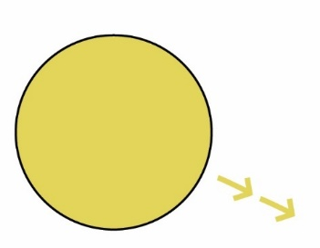**Greenhouse:** an enclosed glass or transparent building for gardening, allowing in **sunlight**, while also trapping **heat** inside.

**Light Energy**

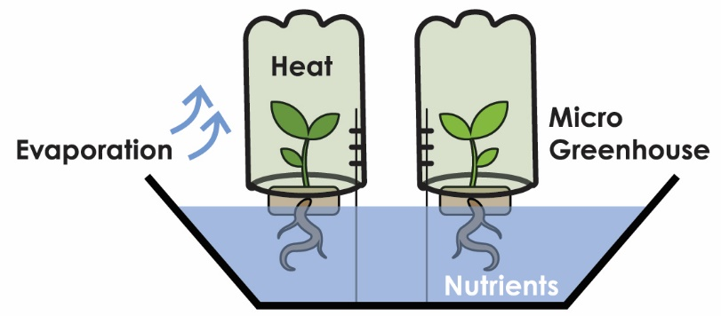

**Recycling With Purpose***Greenhouses are built out  
of all sorts of things. Plastic soda bottles make great materials to trap heat.*



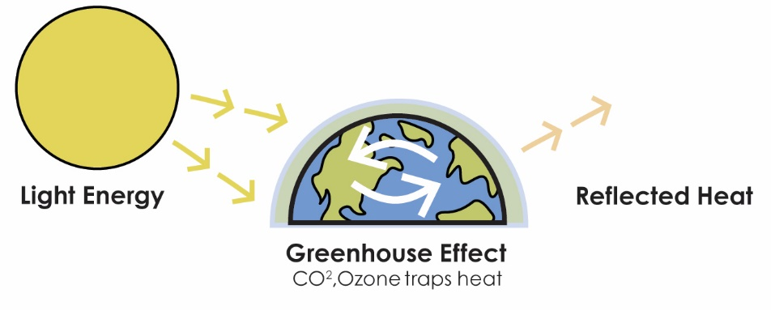**Greenhouse Effect:** The earth’s **atmosphere** acts like a giant greenhouse. **Greenhouse Gases** (water vapor, carbon dioxide, methane, ozone)   
absorb and trap heat, preventing the planet from freezing.

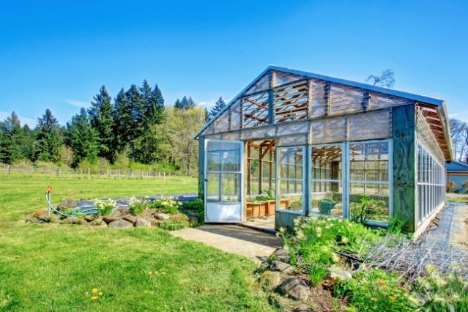  
 **Earth needs a careful balance –**   
 too many greenhouse gases could   
 make the climate too hot (due to **pollution**,   
**deforestation** and the burning of **fossil fuels**).



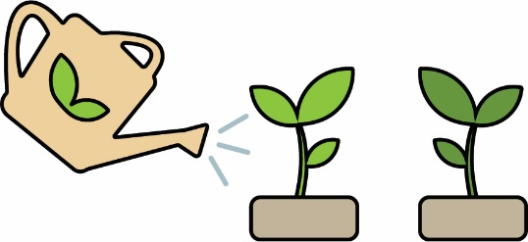

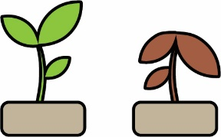**Independent Variable:** The thing you change   
in the experiment, to test how it affects the DV.  
There should only be one IV for each experiment.  
  
 **Dependent Variable:** the thing being tested and  
measured as a result of the IV. There should only  
be one DV for each experiment.  
  
 **Control:** Things that should not change in an experiment.  
There can be many controls for each experiment.



What variables can you change in your Micro Hydroponic System?  
 *(e.g. Light, Growing Medium)* ____________________________________

**____________________________________**

**____________________________________**

 **____________________________________**

What things may change as a result of these Independent Variables?

*(e.g. Height, Plant Color)* **____________________________________**

**____________________________________**

**____________________________________**

 **____________________________________** What things would be controls in your Micro Hydroponic System?

*(e.g. Type of Seed Planted)* **____________________________________**

**____________________________________**

**____________________________________**