



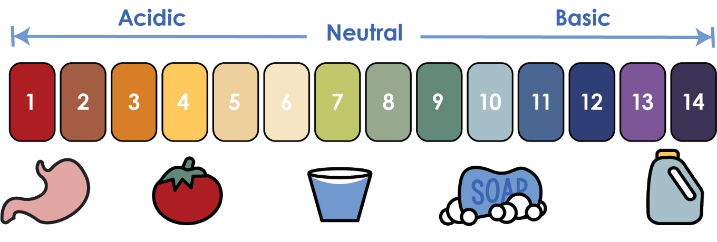

**pH (Potential of Hydrogen):** scale measure of the hydrogen ion concentration   
 in a fluid, from **acidic** to **neutral** (water) to **basic**.

**Use the above pH chart to answer the questions:**

1. What is the difference between an **Acid** and a **Base**?   
 ________________________________________________________________

2. If water has a pH of 7, that makes it a(n) _______________?

3. Lemon Juice has a pH of 2. That would make it a(n) _______________?

4. If a fluid turns **green** after a **universal indicator** is added,   
 then its pH tends _____________. If it turns **red**, its pH tends ___________.

5. If an acid and a base mix equally, it can produce a(n) ____________ fluid.  
 **HINT:** Acids and bases can “cancel” each other out in fluids.  
  
  
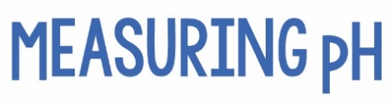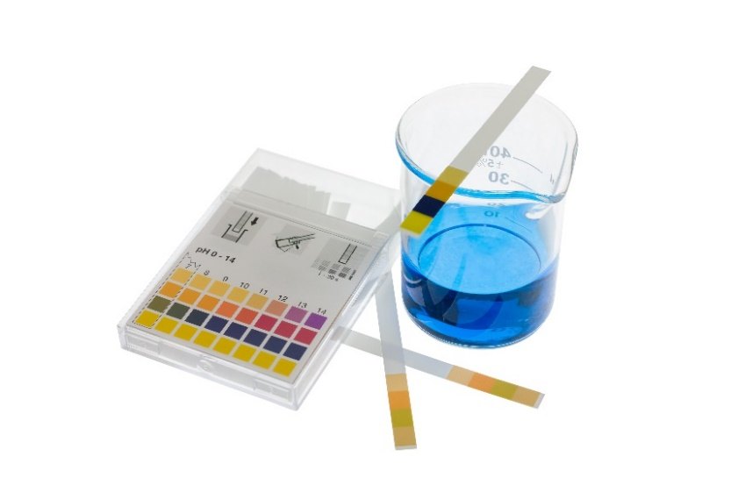  
  
 **Indicator Technique:**Use a **pH test kit**. Special **pH** **indicator paper** is   
dipped or soaked in the test fluid (such as your  
**nutrient solution**) and the resulting color can be  
compared to the standard colors of the **pH chart**.

*This technique is* ***subjective*** *(based on tester’s opinions)*  *giving it a “higher margin of error” (misreading the pH).*

*pH Test Kit*

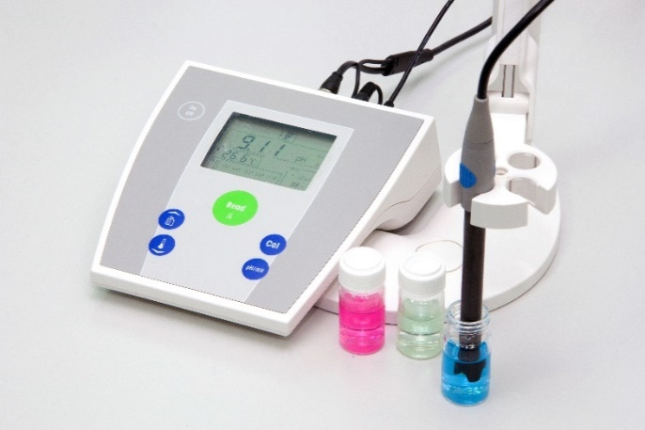 **Digital pH Meter & Probe Technique:**Favored by scientists, digital measurement   
uses a **pH meter** and **pH probe**. The probe   
is placed in the **test fluid**, and **electrodes** respond to the liquid. The meter shows the difference in **voltage**, determining the pH.   
*This technique is expensive, but more****accurate*** *(closer to the true value).*

*pH Meter & Probe*

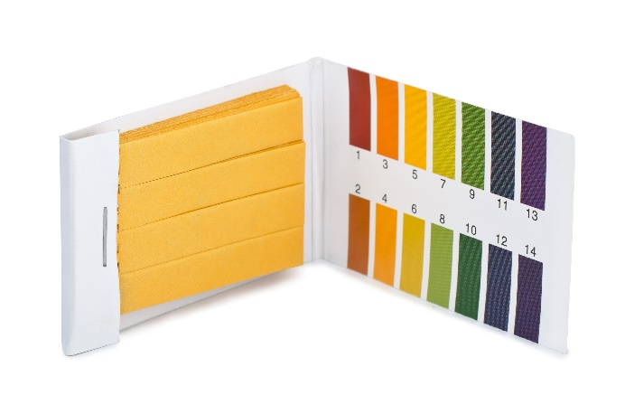 **Litmus Strip Technique:**

**Litmus Strips** contain either an **acid** (red) or **base** (blue). When dipped or soaked, the red strips turn blue if the **test fluid** is basic, and the blue strips turn red if they interact with an acid.   
*This technique is cheap and portable, but  
less* ***accurate*** *(closer to the true value).*

*Litmus Strips*

 *Which pH technique would be best for your hydroponic system?*



**Objective:** Determine the pH of common household fluids.   
 How accurate will your **hypothesis** (prediction) be?  
  
**Procedure:**

* Do not swallow or taste any of the test fluids.
* Wash your hands prior to handling pH or Litmus Strips
* You may bring in fluids to test, if the liquids are:
  + Teacher Approved
  + Non-Hazardous (no sharp edges, harmful chemicals, etc.)

**Challenge Supplies:**

* pH Test Kit or Litmus Strips
* A variety of fluids to test (lemon juice, bleach)
* Container or cup for fluids
* Disposable gloves (optional)

**Teacher’s Note:** *this lab activity can be completed without a   
pH testing method too! Have students predict whether common   
household fluids are* ***acidic****,* ***basic*** *or* ***neutral*** *and then compare  
their hypotheses to the scientific standard results (included).*

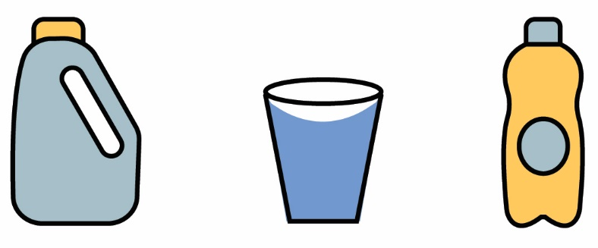



Name(s): ____________________________________________________   
 Set: _____________

Record the pH test results for each fluid. Feel free to add your own.

|  |  |  |  |  |  |
| --- | --- | --- | --- | --- | --- |
| **Fluid** | **Hypothesis** | **pH Test #1** | **pH Test #2** | **pH Test #3** | **pH Test #4** |
| Distilled Water |  |  |  |  |  |
| Tap Water |  |  |  |  |  |
| Lemon Juice |  |  |  |  |  |
| Liquid Hand Soap |  |  |  |  |  |
| Vinegar |  |  |  |  |  |
| Laundry Detergent |  |  |  |  |  |
| Tomato Juice |  |  |  |  |  |
| Light Colored Soda |  |  |  |  |  |
| Coffee |  |  |  |  |  |
| Bleach |  |  |  |  |  |

|  |  |  |  |  |  |
| --- | --- | --- | --- | --- | --- |
| **Fluid** | **Hypothesis** | **pH Test #1** | **pH Test #2** | **pH Test #3** | **pH Test #4** |
|  |  |  |  |  |  |
|  |  |  |  |  |  |
|  |  |  |  |  |  |
|  |  |  |  |  |  |
|  |  |  |  |  |  |
|  |  |  |  |  |  |
|  |  |  |  |  |  |
|  |  |  |  |  |  |
|  |  |  |  |  |  |
|  |  |  |  |  |  |
|  |  |  |  |  |  |

Set: ____  
 Name(s): ______________________________________________________

Record the pH measurement of your **Nutrient Solution**.   
At the same time, every day (or a similar interval),   
test the fluid and chart data on the graph below.  
*Did the pH change over time? Stay the same?   
How did it compare to a* ***control*** *(tap water)?*

14  
13

12

11

10

9

8

**7**

6

5

4

3

2

1

**Basic**

**The pH of Nutrient Solution Over Time**

|  |  |  |  |  |  |  |  |  |  |  |  |
| --- | --- | --- | --- | --- | --- | --- | --- | --- | --- | --- | --- |
|  |  |  |  |  |  |  |  |  |  |  |  |
|  |  |  |  |  |  |  |  |  |  |  |  |
|  |  |  |  |  |  |  |  |  |  |  |  |
|  |  |  |  |  |  |  |  |  |  |  |  |
|  |  |  |  |  |  |  |  |  |  |  |  |
|  |  |  |  |  |  |  |  |  |  |  |  |
|  |  |  |  |  |  |  |  |  |  |  | **Neutral** |
|  |  |  |  |  |  |  |  |  |  |  |  |
|  |  |  |  |  |  |  |  |  |  |  |  |
|  |  |  |  |  |  |  |  |  |  |  |  |
|  |  |  |  |  |  |  |  |  |  |  |  |
|  |  |  |  |  |  |  |  |  |  |  |  |
|  |  |  |  |  |  |  |  |  |  |  | **Acidic** |
| Day 1 | Day 2  Daily Nutrient Solution pH Measurement  (Independent Variable) | Day 3 | Day 4 | Day 5 | Day 6 | Day 7 | Day 8 | Day 9 | Day 10 | Day 11 | Day 12 |

pH Scale

|  |  |
| --- | --- |
| **Fluid** | **Standard pH** |
| Distilled Water | 7 (neutral) |
| Tap Water | Varies (6-8)  (neutral) |
| Lemon Juice | 2  (acidic) |
| Liquid Hand Soap | 9-10 (basic) |
| Vinegar | 2  (acidic) |
| Laundry Detergent | (7-10)  (neutral-basic) |
| Tomato Juice | 4  (acidic) |
| Light Colored Soda | 2.5 (acidic) |
| Coffee | 2 (acidic) |
| Bleach | 12.6 (basic) |
| Milk | 6.5 (acidic) |

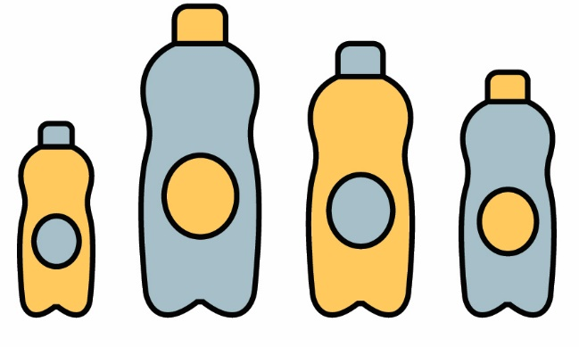

**Soda Pop Challenge – Optional**

**Challenge:** Does the brand of soda pop   
 affect its pH measurement?

**Constraints:**

* Do not swallow or taste the soda pop
* You may bring in soda pop to test, if:
  + Teacher Approved
  + Non-Hazardous

**Challenge Supplies:**

* pH Test Kit or Litmus Strips
* A variety of soda pop (cola, seltzer)
* Container or cup for fluids

**Bonus:** After taking pH measurements,   
 drop a tarnished **penny** in each   
 soda sample and wait a week.   
 Observe the penny’s changes,  
 and record the pH again.  
 *Did the soda’s color* ***correlate*** *(relate) to its pH measurement?*

