Macronutrients: plants need a balanced NPK Ratio to thrive.
Potassium (K)
- amino acids
- carbohydrates
Phosphorus (P)
- stems
- roots
- flowers
Nitrogen (N)
- leaf growth
- leaf color
- chlorophyll synthesis

Micronutrients: plants also require other nutrients, including:
calcium (Ca), magnesium (Mg), and sulfur (S)
boron (B), zinc (Zn), copper (Cu), and iron (Fe.)

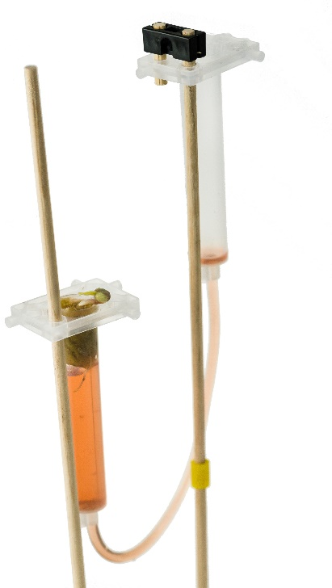
Feed Me, Seymour!
Nutrients in soil are easily exhausted. Hydroponic Systems, however, have the benefit of “feeding” plants directly.
This reduces waste, concentrating nutrients for specific purposes, such as added Phosphorus for brighter blooms.
- What macronutrient would you add to the
NPK ratio to maximize leaf growth? _____________
- How quickly your plants flower? ________________
- How strong your roots grow? ___________________

Using commercial solutions (FloraMicro, FloraGro) or your own mixes,
determine the NPK Ratio of the solution. Certain brands contain more
of one element; note this and develop a formula (independent variable)
to best aid an aspect of the plant’s growth (dependent variable).

Example: A formula with more Nitrogen (N) will cause my plant to
grow more leaves than the control (water-only formula).
Record your ratio percentages, pH levels and observations.
Then, plot your plant’s progress graphically to observe changes over time.
Note: Experimenting with DIY Nutrient Solutions,
such as used tea bags or recycled fish tank water,
is encouraged, but be warned! Adding your own
substances could potentially hurt the plant.

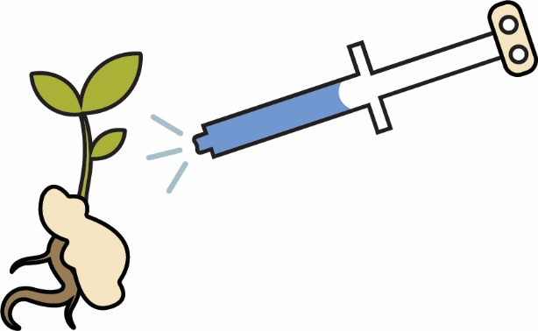
Lab Supplies:
- Micro Hydroponic System
- Planted seedling in growing medium
Quick Tip:
Use a cylinder or
eye-dropper to better measure
out the solution.
- Nutrient Solution(s)
- pH Test Kit or Litmus Strips – optional
- Container or cup for fluids
- Disposable gloves - optional

Name(s): ______________________________________________________________________
Set: _____________
Record the height, pH and growth observations each day,
along with the NPK Ratio percentage in the nutrient solution.

Day | NPK Ratio | Height | pH | Leaf & Flower  Growth | Observations
1
2
3
4
5
6
7

8
9
10
Set: ____
Name(s): _______________________________________________________
Plot the height of your plant on the graph below.
NPK Ratio %: ____________________________________
The Effect of Nutrient Solution on Plant Height Over Time

Plant Height
(Dependent Variable)

15cm
14cm
13cm
12cm
11cm
10cm
9cm
8cm
7cm
6cm
5cm
4cm
3cm
2cm
1cm

Day 1 | Day 2 | Day 3  Daily Plant Measurement  (Independent Variable) | Day 4 | Day 5 | Day 6 | Day 7 | Day 8 | Day 9 | Day 10 | Day 11 | Day 12 | Day 13 | Day 14

Name(s): ________________________________________________________________
Draw and Record your Growth Observations below.
Add to your Engineering Notebook.

How many leaves grew on the stem? What was the width of the flowers?
Did they all bloom the same color?

