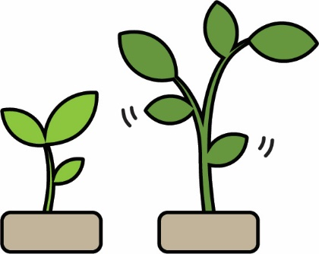

**Challenge:** Engineer your Hydroponic System   
 to grow the tallest, healthiest plant.  
  
**Constraints: (rules and limits for your challenge)**

* You must use a TeacherGeek Hydroponic System in your design.
* Plants may be grown only in the barrel – roots must stay contained.
* Plants may be watered only through the tubing or system.
* You may bring in materials for your system design, if they are:
  + Teacher Approved
  + Non-Hazardous (no sharp edges, harmful chemicals, etc.)
* This challenge will take place over a set amount of time.
  + You have _____________________ hours/days/weeks.

**Challenge Supplies:**

* 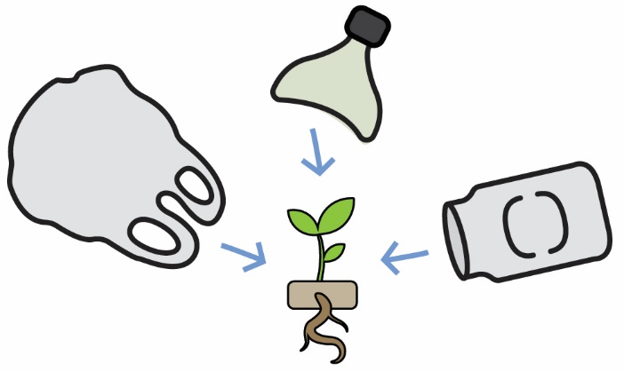Micro Hydroponic System
* Planted seedling in growing medium
* pH Test Kit or Litmus Strips - optional
* Container or cup for fluids
* Ruler, Tape, Scissors, Glue, String
* Spray Bottle for misting – optional
* Found/Recycled Materials



**The Engineering Design Process:**

You will be using the **Engineering Design Process**. What does that mean?   
Your design is never finished (it can always be improved). There is no   
such thing as a perfect design. Fill out a new *Engineering Notebook*   
page each time you design/redesign your **Hydroponic System**.



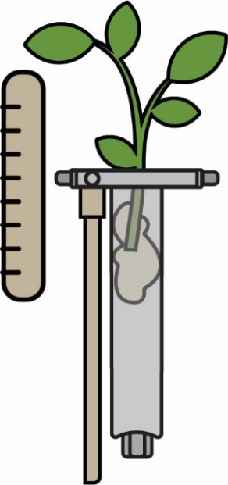

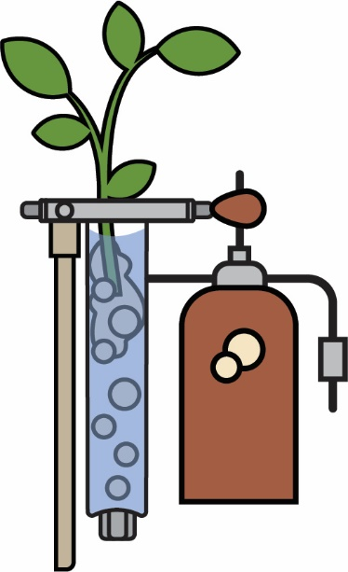**To Such Great Heights**See who can grow the tallest plant in a set amount of time.   
Determine the **independent variable** you wish to change for   
each design. Perhaps the nutrient solution will be **aerated** or   
contain more **macro-nutrients**, or the drip system will use a   
longer length of tubing. Measure the plant height at the same   
time each day. Use a graph to plot changes over time.  
 **Phototropism:** the movement of plants towards a light source.  
*Does the light source change the direction of plant growth?*

**Pump It Up**Hydroponic Systems often use an **air pump** for water **aeration**  
(putting **oxygen** in water) and recirculation. Design your own  
micro air pump from **check valves**, **t-connectors** and **tubing**.  
Observe and record your plant’s height, leaf color, and **pH**.  
Graph, and compare with a non-aerated plant as a **control**.   
*Can you adjust your pump to only push out air?  
Can you adjust your pump to only draw water up?*

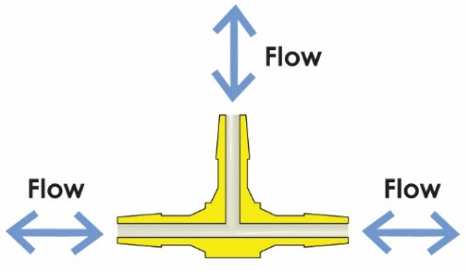

**Check Valves:** allow **fluid** flow  
(liquid or gas) in one direction.

**T-Connectors:** allow fluid to flow between three **ports** (openings).

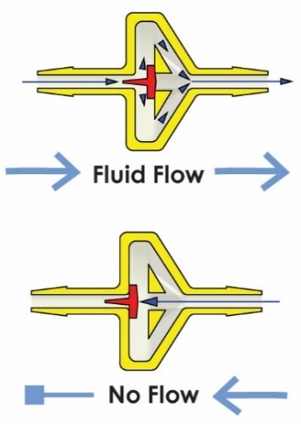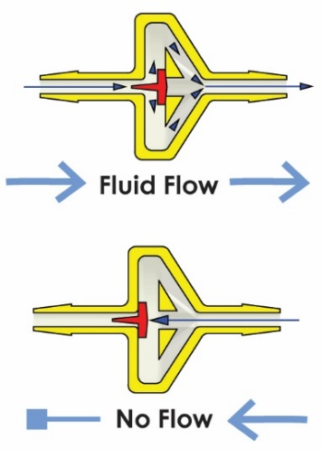



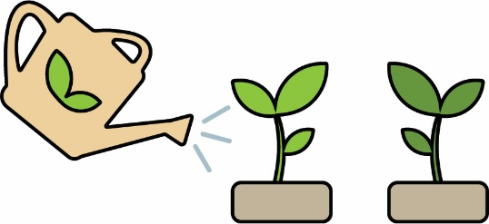

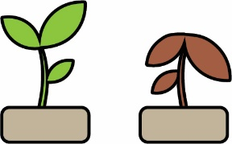**Independent Variable:** The thing you change   
in the experiment, to test how it affects the DV.  
There should only be one IV for each experiment.  
  
 **Dependent Variable:** the thing being tested and  
measured as a result of the IV. There should only  
be one DV for each experiment.  
  
 **Control:** Things that should not change in an experiment.  
There can be many controls for each experiment.



What variables can you change in your Micro Hydroponic System?  
 *(e.g. Light, Growing Medium)* ____________________________________

**____________________________________**

**____________________________________**

** ____________________________________**

What things may change as a result of these Independent Variables?

*(e.g. Height, Plant Color)* **____________________________________**

**____________________________________**

**____________________________________**

** ____________________________________** What things would be controls in your Micro Hydroponic System?

*(e.g. Type of Seed Planted)* **____________________________________**

**____________________________________**

**____________________________________**

 Set: ____  
 Name(s): _______________________________________________________

Plot the height of your plant on the graph below.  
Your **independent variable** for this design is:  
_________________________________________________

**The Change in Plant Height Over Time**

Plant Height

(Dependent Variable)

15cm

14cm  
13cm

12cm

11cm

10cm

9cm

8cm

7cm

6cm

5cm

4cm

3cm

2cm

1cm

|  |  |  |  |  |  |  |  |  |  |  |  |  |  |
| --- | --- | --- | --- | --- | --- | --- | --- | --- | --- | --- | --- | --- | --- |
|  |  |  |  |  |  |  |  |  |  |  |  |  |  |
|  |  |  |  |  |  |  |  |  |  |  |  |  |  |
|  |  |  |  |  |  |  |  |  |  |  |  |  |  |
|  |  |  |  |  |  |  |  |  |  |  |  |  |  |
|  |  |  |  |  |  |  |  |  |  |  |  |  |  |
|  |  |  |  |  |  |  |  |  |  |  |  |  |  |
|  |  |  |  |  |  |  |  |  |  |  |  |  |  |
|  |  |  |  |  |  |  |  |  |  |  |  |  |  |
|  |  |  |  |  |  |  |  |  |  |  |  |  |  |
|  |  |  |  |  |  |  |  |  |  |  |  |  |  |
|  |  |  |  |  |  |  |  |  |  |  |  |  |  |
|  |  |  |  |  |  |  |  |  |  |  |  |  |  |
|  |  |  |  |  |  |  |  |  |  |  |  |  |  |
|  |  |  |  |  |  |  |  |  |  |  |  |  |  |
| Day 1 | Day 2 | Day 3  Daily Plant Measurement  (Independent Variable) | Day 4 | Day 5 | Day 6 | Day 7 | Day 8 | Day 9 | Day 10 | Day 11 | Day 12 | Day 13 | Day 14 |

Name(s): ______________________________________________________________________  
Set: _____________

Record the height and pH measurement of your aerated plants.   
Grow a non-aerated plant as a control.

|  |  |  |  |  |  |
| --- | --- | --- | --- | --- | --- |
| **Group Name** | **Design #1** | **Design #2** | **Design #3** | **Design #4** | **Control** |
|  |  |  |  |  |  |
|  |  |  |  |  |  |
|  |  |  |  |  |  |
|  |  |  |  |  |  |
|  |  |  |  |  |  |
|  |  |  |  |  |  |
|  |  |  |  |  |  |
|  |  |  |  |  |  |
|  |  |  |  |  |  |
|  |  |  |  |  |  |