

Or ripe plum,   
firm tofu block,  
clay figure or   
fragile object

**Breaking fast…with *breakfast?***  
Using your rubber band racer, ferry an egg from **Target A** to **Target B** *without* cracking it.  
Keeping your egg safe also requires **speed** -  
*will you deliver brunch on time?*

K



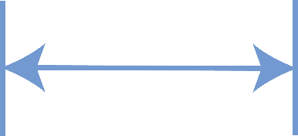

**Target B**

**Before you start…** Make sure you have built a **Rubber Band Racer** for use on this challenge.

Documents & Supplies at: **teachergeek.com/learn**

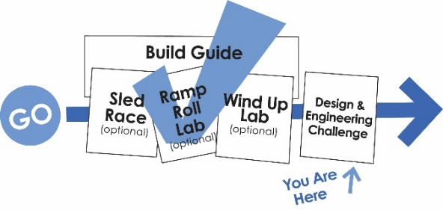

**You Are   
Here**

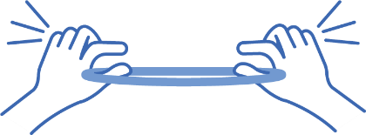

*Tension*

**Kinetic Friction** =thefriction   
force between two objects   
when one or both, are moving.



Cotton, Tape,   
 Styrofoam



Experiment with materials to protect your egg.  
Remember, your racer must move with only   
the **stored (potential) energy** in its rubber bands.

K



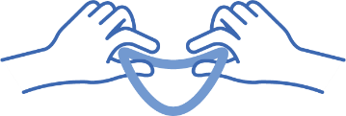

*Static*

**Static Friction** =the friction force   
between two unmoving objects  
(tension or potential energy.)

Your racer has **traction** (friction) between its wheels and the floor. How can you reduce this **resistance**?



**Challenge Supplies:**  
Racer (from Build Guide), yardstick,  
fragile object, stop watch, target materials, recycling bin materials

*Wax, latex,  
rubber bands,   
change traction*



(rules & limits for your design)

**Difficulty:** Hard

0

**Allowable Materials:**  
• TeacherGeek components  
• Recycling bin materials  
• other available materials:  
 (e.g. wood, 3D printing, plastic)

Fill in how much time you have   
to complete this challenge

**Teacher’s Note:**  
Find more information on setting up targets and running this challenge   
in the Racer Classroom Overview.

**Ground Rules:**  
• Distance must be measured at front wheel(s)  
• Must use at least two TeacherGeek wheels

**Time Limit:** ____________________



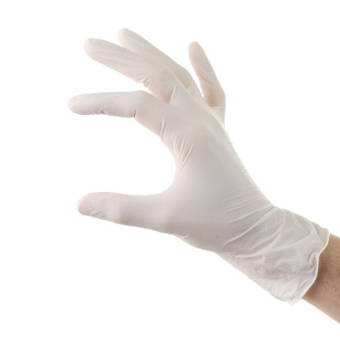



* Compare with *Science Olympiad’s* “Scrambler” Event



The time it takes the racer to travel from the **0.5-meter** line   
to the **8.5-meter**   
line (or target).



Measured from the tip of the egg to the center of the target/finish line.

**Did your egg   
fall or break?**   
Multiply score by two.  
  
**Did your racer leave the lane or touch   
the lane barrier?**  
Multiply score by two



Mark your run time, distance score & whether the egg breaks or remains intact.

Name: _________________________________________________________ Set: __________



|  |  |  |  |  |  |  |  |
| --- | --- | --- | --- | --- | --- | --- | --- |
| **Design**  **Or Group** | **Trial #1** | | **Trial #2** | | **Trial #3** | | **Final Score**  **(Averaged)** |
| **Distance** | **Time in seconds** | **Distance** | **Time in seconds** | **Distance** | **Time in seconds** |
|  |  |  |  |  |  |  |  |
| **Broken?** | | **Broken?** | | **Broken?** | |
|  |  |  |  |  |  |  |  |
| **Broken?** | | **Broken?** | | **Broken?** | |
|  |  |  |  |  |  |  |  |
| **Broken?** | | **Broken?** | | **Broken?** | |
|  |  |  |  |  |  |  |  |
| **Broken?** | | **Broken?** | | **Broken?** | |
|  |  |  |  |  |  |  |  |
| **Broken?** | | **Broken?** | | **Broken?** | |



Use a **ramp** or launcher   
mechanism to propel   
your racer out   
the gate!

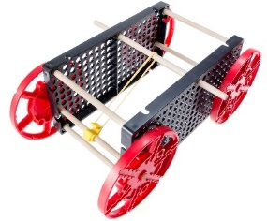

**Barrier Materials:** Mark your track with tape, string, cardboard, wood planks

