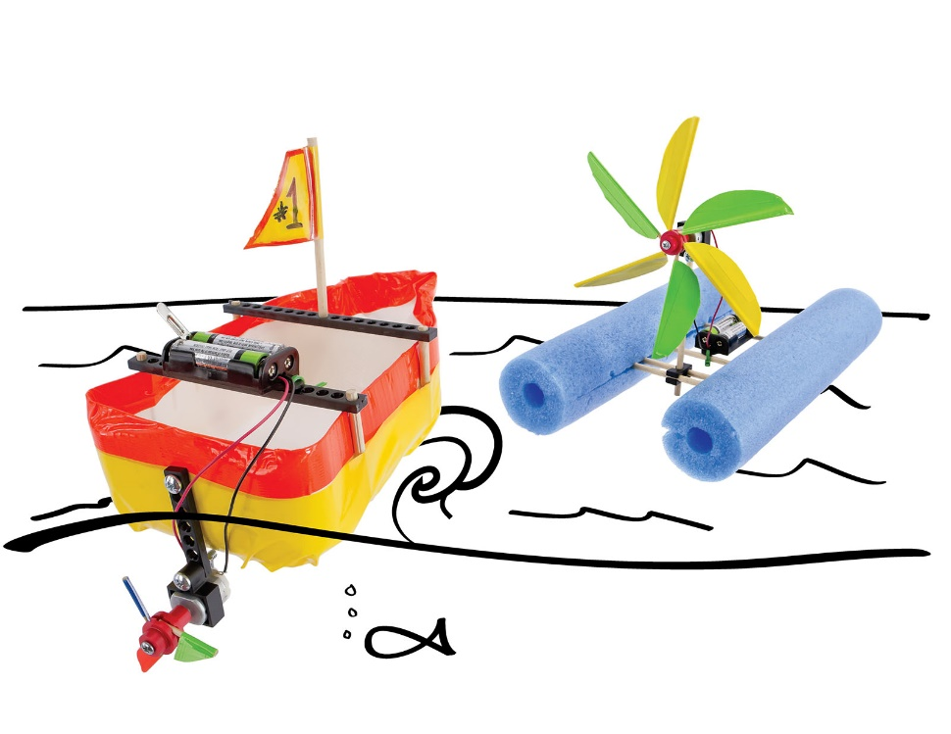

Redesign your boat build to race   
across a body of water the ***fastest***.

**Before you start…** Make sure you have built   
an example **Boat** for use on this challenge.

Documents & supplies at teachergeek.com/learn

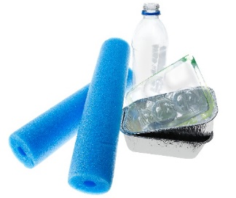

**Boat Build**

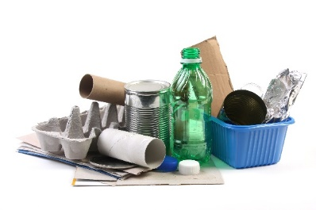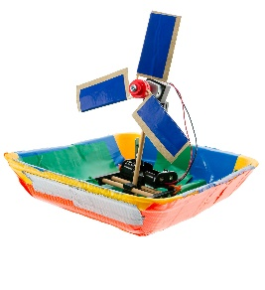

**Recycling  
Materials**

**Floating  
Materials**



**Stopwatch**



Fill in how much   
time you have



*The time from building and   
re-designing your boat to   
the start of the competition.*

(rules & limits for your design)

* The boat must be powered by a **motor** or the **wind** during the race.
  + The boat must not be pushed or pulled by your hand.
* The boat must remain right-side-up when crossing the finish line.
* Additional materials may be brought in for boat designs, if they are:
  + TeacherGeek components
  + Found & Recycling Bin materials
  + Teacher Approved, Non-Hazardous
* You will have _______________ to complete this design challenge.

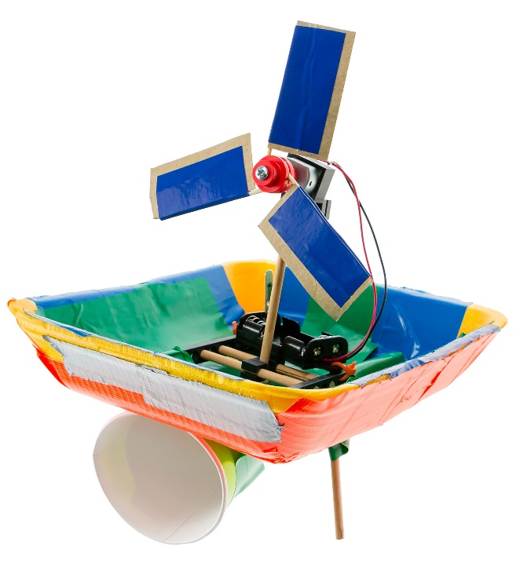

**Speed Boat Regatta**Enter your boats in a regatta (boat race), competing for speed, with a stopwatch.   
The first boat to cross the finish line, *wins*.  
*What materials can you add or create to make your boat faster, or sail in a straight line?*



*If the boat moves too far   
off course (out-of-bounds), you’re out!*

*Use sticks, poles, string or fishing wire to mark the finish line of the regatta course.*



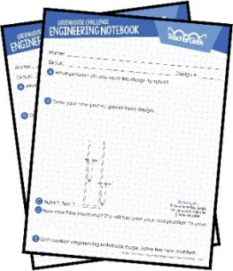

**Carry That Weight**Design a boat that can carry the most weight   
from one point to another. Use objects of **consistent**   
(regular) weight such as **golf balls** or bean bags.   
Race three times – adding more weight each trial.  
*If the boat takes on water or sinks, you’re out!*

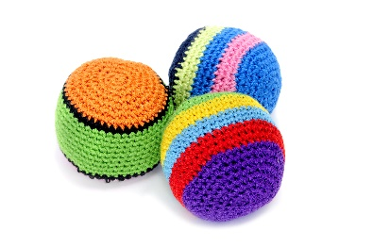

**Engineering Notebook***Use engineering notebook pages to go through the Design Process. Sketch ideas, take notes and use them to compete in challenges!*  
*Find at* ***teachergeek.com/learn***