

*Houston, we’ve had a problem here…*

**In 1970, three astronauts launched for the moon   
in a tiny Apollo CSM capsule. They never landed.**  
An oxygen tank exploded, crippling the craft’s **(command module)** electricity, light and water   
as poisonous **CO2** filled the cabin. **Apollo 13** was 200,000 miles from Earth and running out of time.

K

* Find more information on space engineering, visit nasa.gov/mission_pages

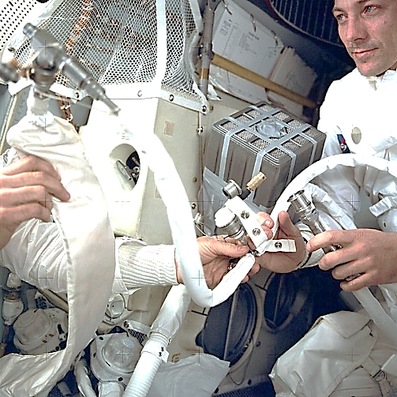

**NASA engineers had a problem – keeping the   
crew alive for over 36 hours prior to safe re-entry.**   
They were limited by time, the minimal supplies onboard the spacecraft, and increasing CO2.  
   
Astronaut **John Swigert** had to somehow adapt a square scrubber cartridge to fit a round lunar CO2 scrubber – square pegs, in round holes, in *space*!

K



NASA’s “Mailbox Rig”





The **Engineering & Design Process** was key   
to saving the day in the Apollo 13 mission.  
Using a mix of found and recycled materials (including socks!), the “**mailbox rig**” came from the minds of ground control engineers, *brainstorming*, *testing* and *improving* a design.  
 *The crew returned safely to Earth on   
April 17, 1970, six days after launch.*



“Challenge Supplies”



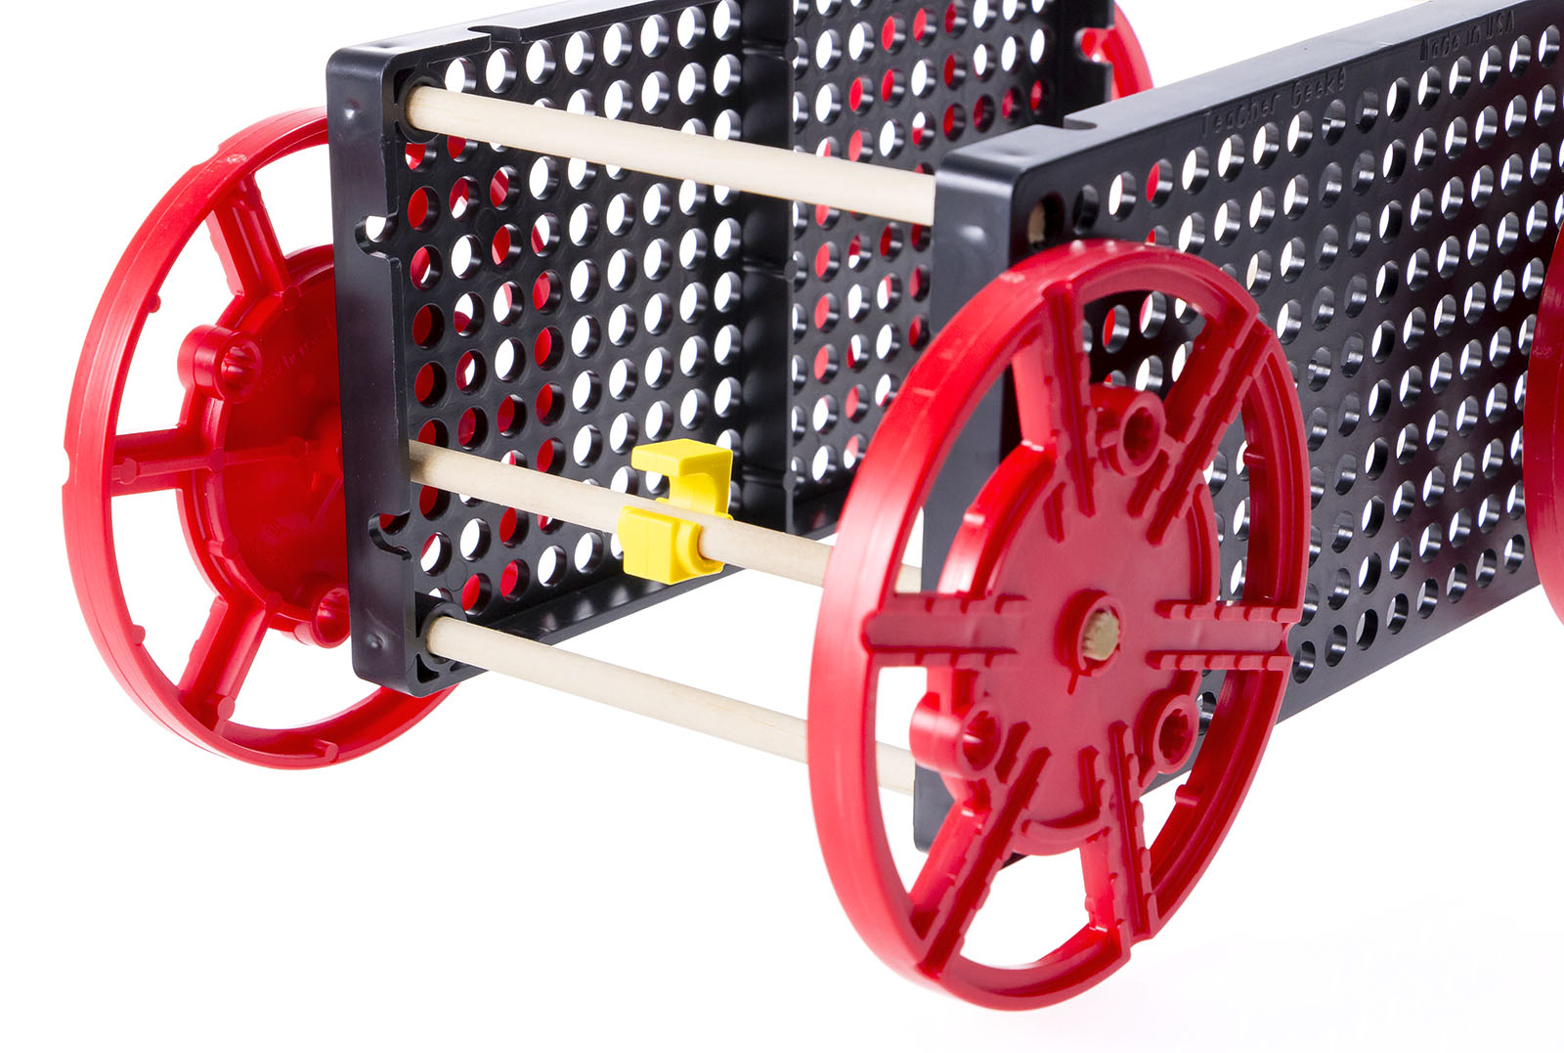

*What will I build?*



Create your own **“mailbox rig racer”** from limited supplies, to compete in a target challenge.

K

**Before you start…** Make sure you have built a **Rubber Band Racer** for use on this challenge.

Documents & Supplies at: **teachergeek.com/learn**

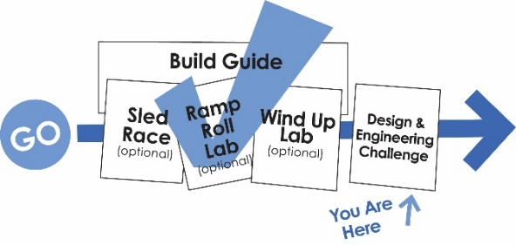

**You Are   
Here**









**Using ONLY the supplies on the table, construct a racer that can hit a target.**   
This racer will not be like your example –   
it’s unique, your own “mailbox rig racer!”   
Use an **engineering notebook page** to brainstorm, test and improve your design.

K



Only use the tools provided, if any.



Latex changes the traction (friction)



(rules & limits for your design)

Fill in how much time you have   
to complete this challenge

**Teacher’s Note:**  
Find more information on setting   
up and running this challenge   
in the Racer Classroom Overview.

**Time Limit:** ____________________



**Difficulty:** Medium - Hard

0





Are you faster than a NASA engineer?



**Page 3**



Name: ________________________________________________

Design #: __________

What is the problem your racer needs to solve or make better?

**Research.** How did the engineers of Apollo 13 think about and solve this problem?   
What are the constraints (things your design cannot, or must, do or be)?

**Brainstorm.** Sketch and describe possible solutions or different   
ideas that might solve the problem. Use extra paper, if needed.

**Choose the best solution.** Circle it. *Why do you think it’s the best?*



Date: __________



**Page 3**





There is no perfect design, or true failure. Successful failures show you how to improve!  
Make it faster, go farther, stronger, more accurate, easier to use, more efficient, better looking, etc.  
Fill out a new Engineering Notebook page each time you redesign your rubber band racer.

.

**Did you solve the problem?**Yes? Great! Identify a new problem (a way to make your design even better).  
No? That’s okay. What did you learn that can help solve it in a new/different way.

.

**Draw the solution you chose.** Include the details you will need to create it.   
Use extra paper, if necessary.

.

**Build it.** Build the racer you planned.  
**Test it.** Make observations. Record results below, or on another paper.

.



**Page 4**